<http://www.smashingapps.com/2011/11/15/50-photoshop-tutorials-for-high-quality-photo-editing.html>

**Simple Image Retouching in Photoshop**

This tutorial will teach you a simple technique to enhance the colors of your image making it more vivid and alive. The image is going to be retouched using Layer Blending Modes and a slightly visible Gaussian Blur. After applying the retouch method, your image will look like the example shown below

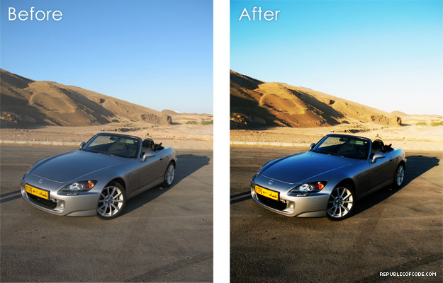

Start off by opening the image you want to retouch in Photoshop. I used [this](http://www.republicofcode.com/tutorials/photoshop/retouch/1.jpg) raw image directly from my camera, you are free to practice this tutorial using if you want to get exactly similar results as the ones shown here.

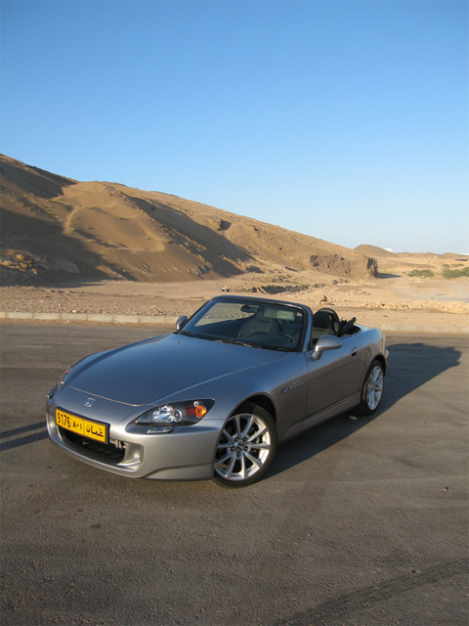

Once you have the image opened, go through to Image>Adjustments>Curves. The curves window will open, as you can see in the screenshot below, there are two square markers on the field, each marker is created by clicking on a spot on the grid, these marks can even be dragged across the grid. Create two markers in the same position shown below.

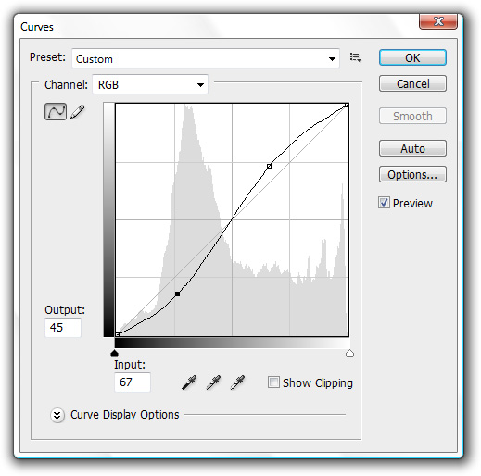

After applying the curves, your image will look like this.

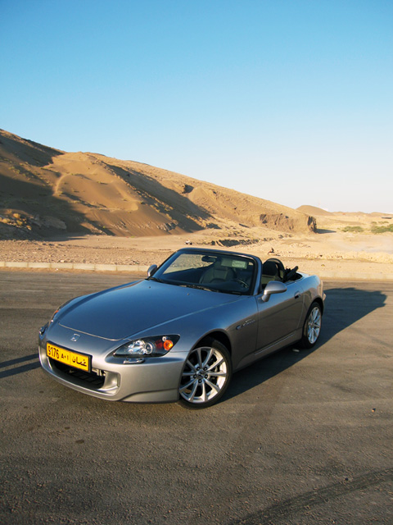

Go through Layer>Duplicate Layer, a small window will pop up for you to choose a new name for your duplicated layer, click OK to proceed.

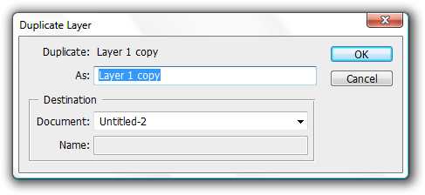

From your Layers Panel, choose the recently duplicated layer and change its Blending Mode into Soft Light.

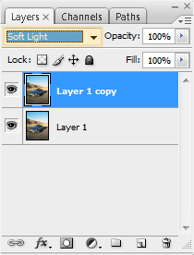

Your image will now look like the this

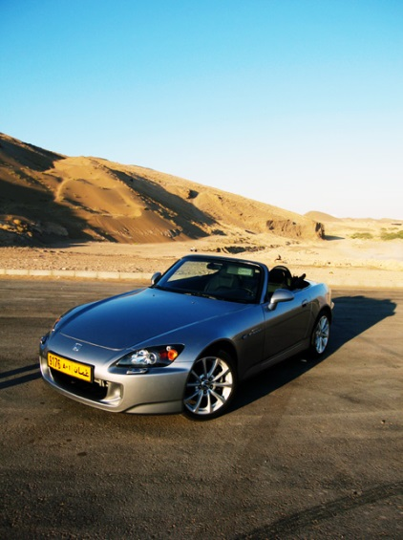

Go through Layer>Duplicate Layer once again and this time give the recently duplicated layer a Gaussian Blur by going through Filters>Blur>Gaussian Blur of 10 px.

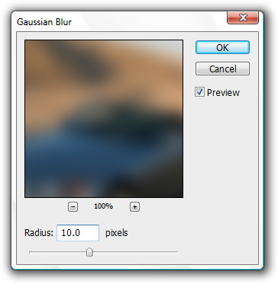

From the Layers Panel, give the blurred layer an Overlay blending Mode and change its Opacity to 20%.

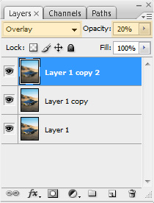

Your image will now look like the this

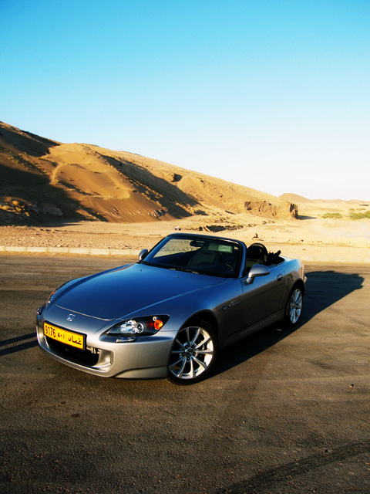

Go through Layer>Duplicate Layer one more time and change the recently duplicated layer's Blending Mode into Color Dodge.

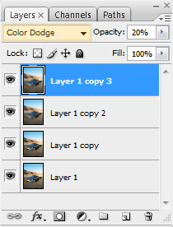

Your final image is going to look like the sample below, you can rollover it to see the original raw image for comparison.

[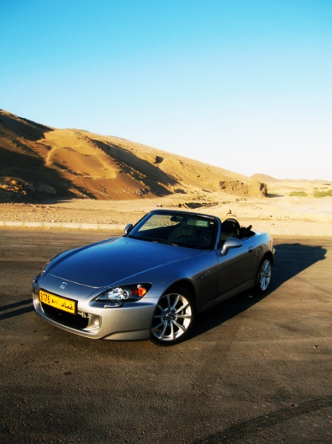](http://www.republicofcode.com/tutorials/photoshop/retouch/)

[**Movie Like Sunset**](http://www.icanbecreative.com/movie-like-sunset-in-photoshop-tutorial.html)

I have always been impressed by the surreal, peaceful lightings sunset of scenic places I see in films. Unfortunately, I do not get to see them in real life.In this tutorial I'm going to show you how to create a piece of romantic movie like sunset in Photoshop. This tutorial is made to show some very cool Photoshop techniques that beginners can quickly pick up.

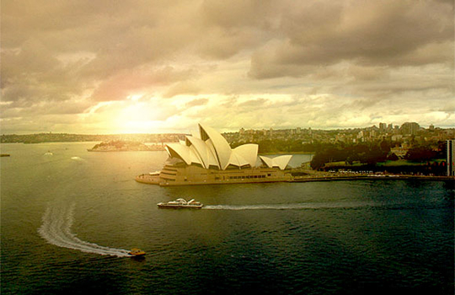

**Preparation:**

You will need an image similar to this. Preferably, one which you can clearly see the skyline.

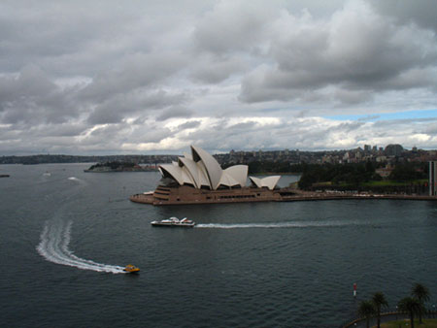

**Step 1**

Use soft brush (opacity 10%, black colour), and paint 1 to 2 times below the sky area. Then using the same brush opacity, change the colour to #ad651a and go over the sky area (you may use a lighter colour, but try not to make it go any darker). You will have something similar like the image below.

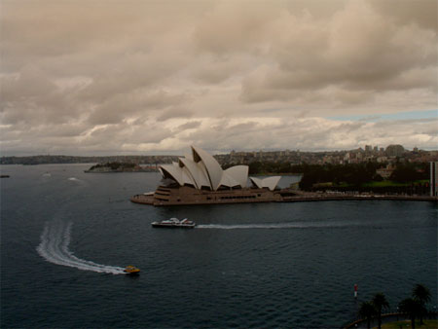

**Step 2**

Now click on the icon beside the quick mask. This will create a new fill or adjustment layer. Choose Curves and adjust the graph to the picture below.

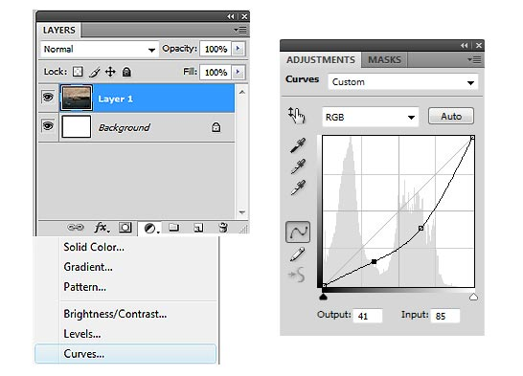

Result after adjustment of curves:

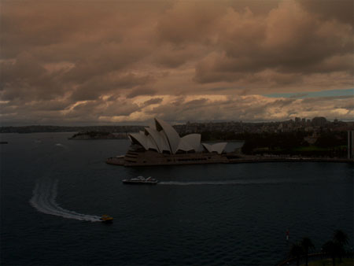

**Step 3**

Add a new layer below the Curves layer, Set foreground colour to Black. Fill it with Black (Alt+Backspace).

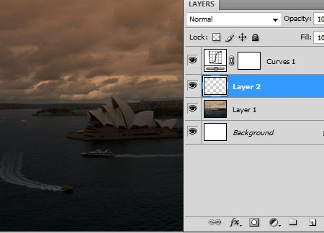

Bring down the opacity of the Black filled layer to about 60% (so that you know where to place the lens flare in the image). Go to Filter > Render > Lens Flare. Adjust to the settings below.

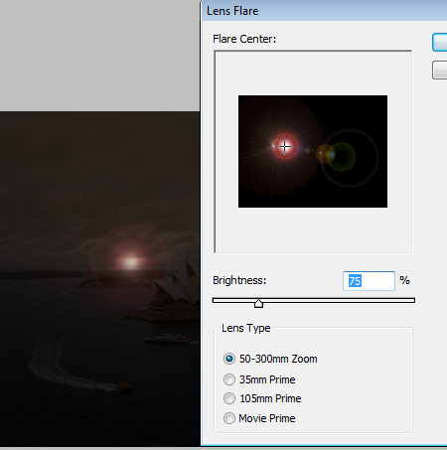

**Step 4**

Go to Filters > Blur > Gaussian Blur. Radius 10 pixels.

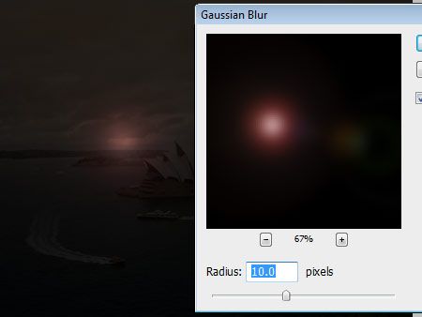

Bring the opacity level of the Black layer up to 100%.

Now, we are going to create light rays from the flare.

Choose Soft Round Brush with the color #ffe01a, opacity 10%. Start brushing down from the point of the flare, keep brushing down until you have something like this.

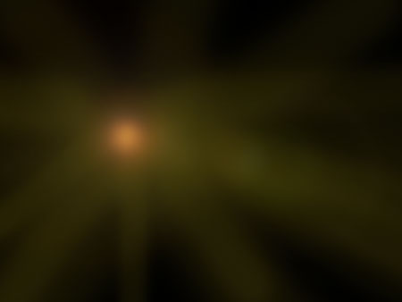

Go to Blending Mode > Linear Dodge (Add).

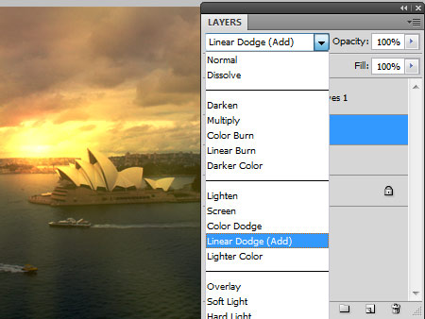

**Step 5**

Duplicate the layer and change blending mode to Screen. Bring the opacity down of the layer to about 40%. This is what you will get.

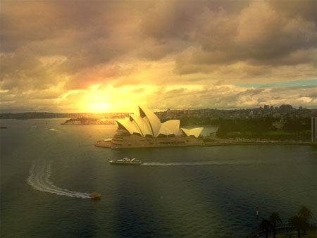

If you think the image is still too dark, you may duplicate it again and adjust its opacity level.

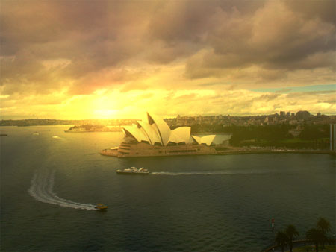

Using the same brush colour #ffe01a, opacity 10% or lesser, work on the skyline area, so that the lighting is blend in nicely. You may also use the eraser tool to erase some light on the opera house (if it gets too washed out).

**Step 6**

We are almost there. Select the whole canvas (Ctrl + A), Edit > Copy Merged (Shift + Ctrl + C), Open a new canvas (Ctrl + N), Paste the image on this new canvas (Ctrl + V).

We are now going to fix the blue portion at the right hand side of sky.

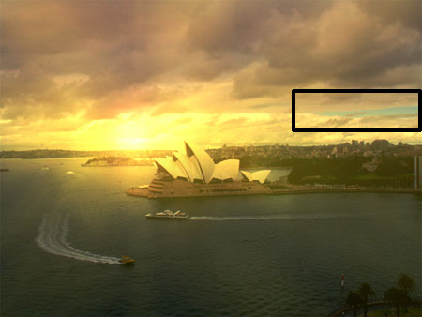

Use the Lasso Tool, Feather: 2 Px. Select the above the blue part of the sky. Copy (Ctrl + C) and Paste (Ctrl +P).

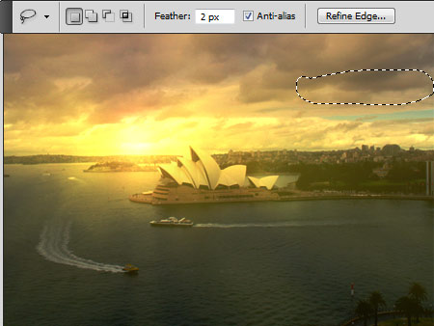

This will cover the blue patch in the sky.

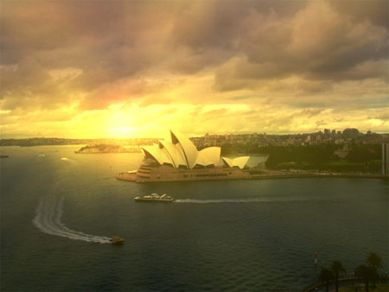

You may wish to adjust the Levels, Curves and Colour Balance on the final image like what I have done below.



**Conclusion**

And we're done! I hope you enjoyed this tutorial, but most of all, I hope you learned something useful. Whether it's just a new way to do something you already knew how to do a different way, or a whole new skill. I hope you took something away from this tutorial. Thanks for reading and keep practicing!

# Create a Nature Inspired Photo Manipulation in Photoshop

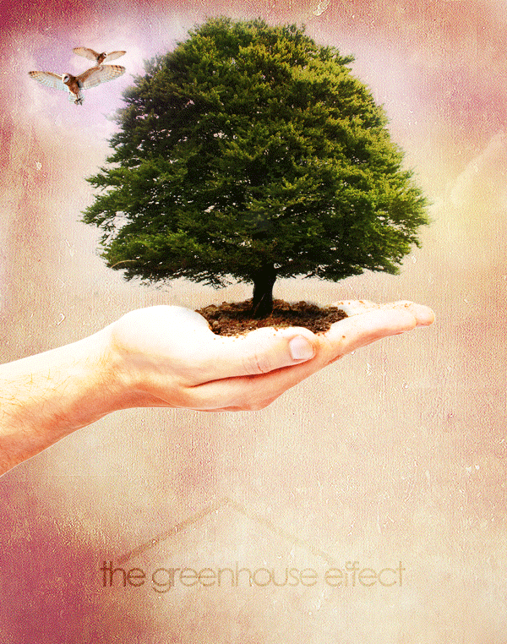

Today, we will demonstrate how to combine several images to create a nature inspired photo manipulation. Let's get started!

* **Tutorial Assets**
* [Owl](http://www.sxc.hu/photo/588070)
* [Tree](http://www.sxc.hu/photo/1304199)
* [Hand](http://www.sxc.hu/photo/1005737)
* [Grunge Texture](http://cloaks.deviantart.com/gallery/#/d1inuha)
* [Clouds](http://yoitsmarketti.deviantart.com/#/d30uqs8)

**Step 1**

To start, let's set up the document. Use the following settings. Name it whatever you like.

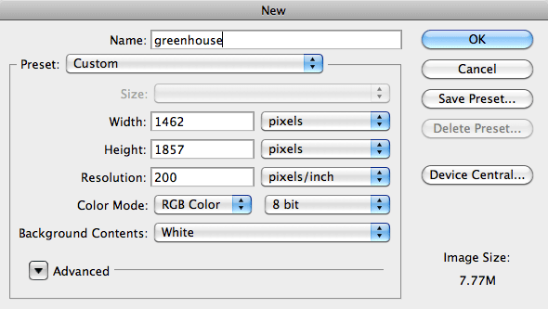

**Step 2**

Now that we have our document, let's begin setting up the background. We're going to use the grunge texture "Grunge 06" from the texture pack. Open this texture in Photoshop, and place it in the document. Use the Transform tool (Command/Ctrl + T) to scale it to size, and rotate it. Go to Image > Adjustments > Curves and apply a small curve. Name this layer "grunge", create a new group named "Background", and place this layer in the group.

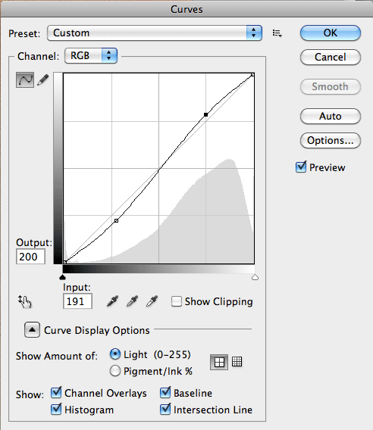

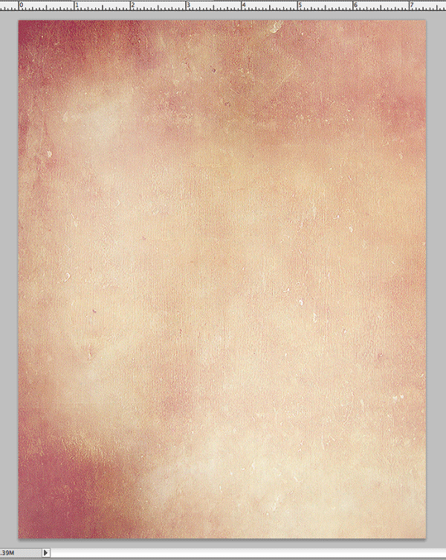

**Step 3**

Now, open up the image of our hand holding dirt. Since it has a white background, we can use the Magic Wand Selection tool (Command/Ctrl + W). Click anywhere in the white, then go to Select > Inverse to inverse our selection to select the hand.

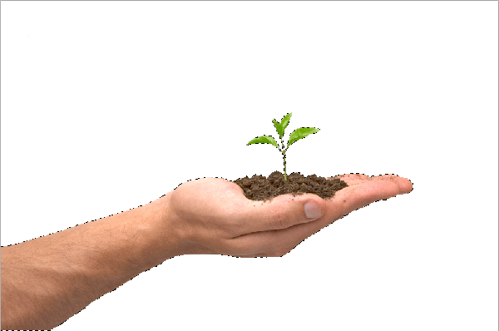

**Step 4**

Now use the Move tool (V) and move the hand into our composition. Group this layer into a group named "Hand". Once we've moved it, resize using the Transform tool (T) and position it so the hand is about the center of the composition. Duplicate this layer, and change the blending mode to "Overlay" Then go to Image > Adjustments > Brightness/Contrast. Apply a brightness of 95, and a contrast of 25. Merge the two layers together, and use the Eraser tool (E) and erase the plant. You should now have this.

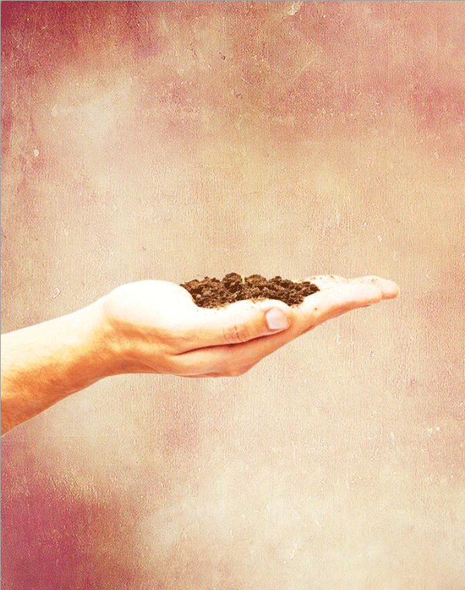

**Step 5**

Next we must place the tree to look as if it has sprouted out of the dirt in the hand. Let's open the tree image and place it in our composition. Use the Transform tool (T) to resize this accordingly.>

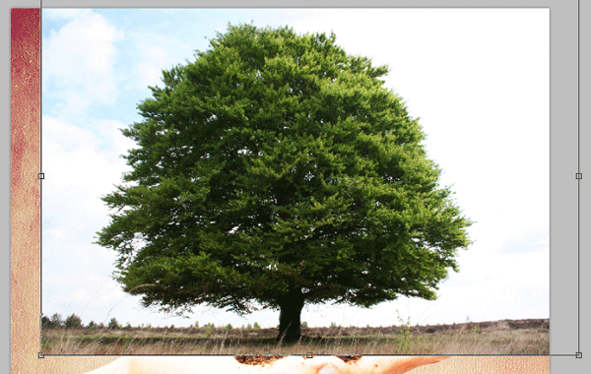

Group this layer, and name it "Tree". Make sure the groups blending mode is Pass Through and then set the Trees blending mode to Multiply. You should now have this.>

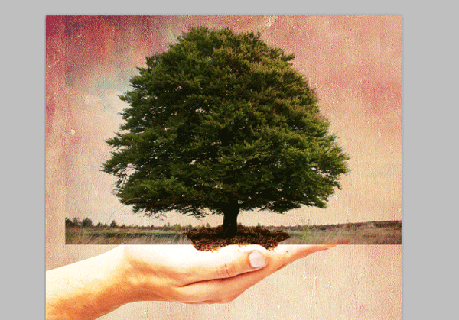

**Step 6**

Now we need to do a little erasing using the Eraser tool (E).

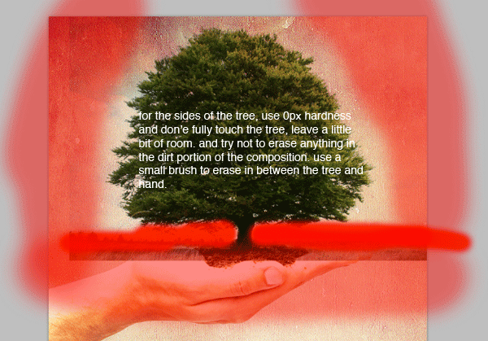

Duplicate the Tree layer and set the duplicates blending mode to Color Dodge. Notice the white glow around and behind the tree, this is why we didn't erase close to the tree the step before.

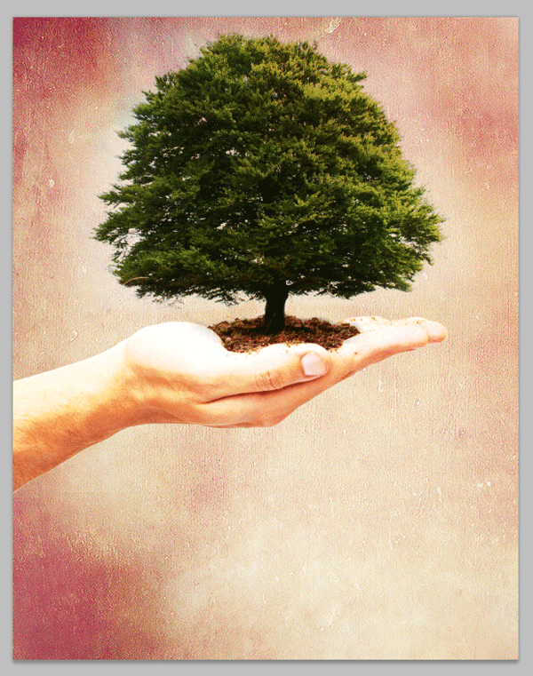

**Step 7**

Next, we'll add a little bit of lighting to our tree. Create a new group and name it "Lighting". Then create a new layer and call it "Tree Lighting". Using the brush, choose a fairly large brush size with 0px hardness. Make sure your color is white and paint two spots like so, or however many you desire.>

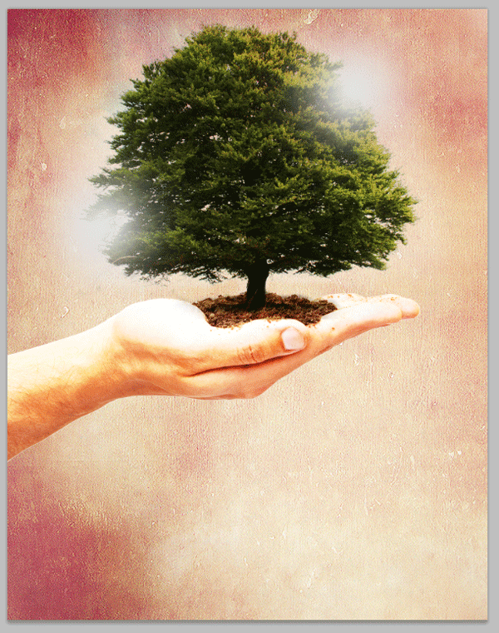

Set this layer’s blending mode to overlay.

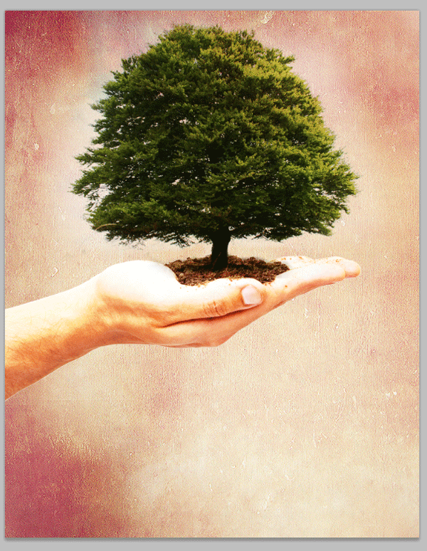

**Step 8**

Now, let's add some clouds to make a more interesting effect. Open the clouds image, and size it down. Make sure the bright spot where the sun is behind the clouds is above the top left of the tree.>

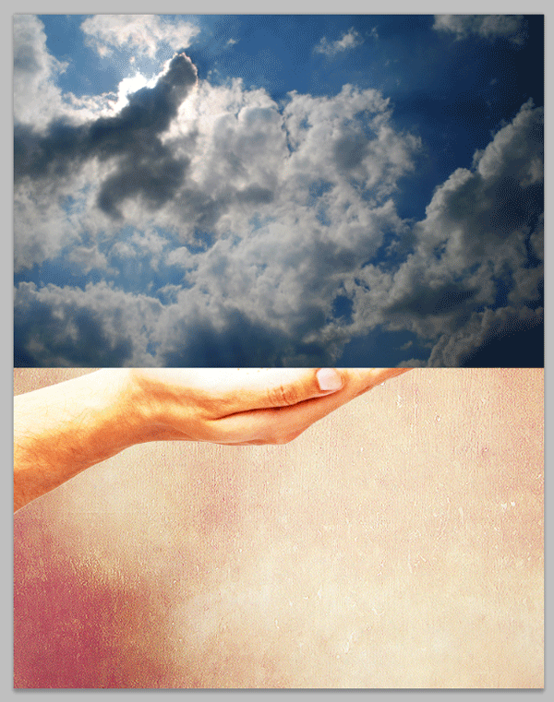

Set the layer’s blending mode to Screen. Be sure to group this cloud layer into a group called "Sky". It helps keep your layers organized and less cluttered.

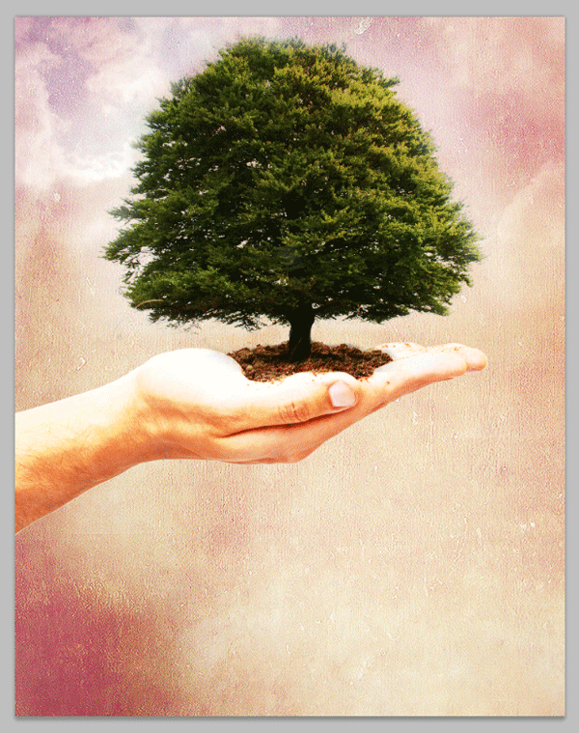

**Step 9**

Open up the owl image, but before we place it we are going to cut it out using quick mask.

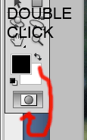

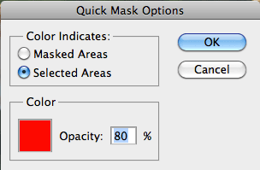

**Step 10**

Select the brush tool (B). Set the hardness to about 50% and outline the owl.

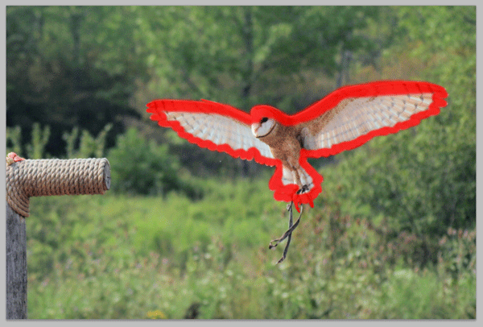

Once outlined, use either the Fill tool to fill in the inside. Or just use a bigger brush and paint it in.

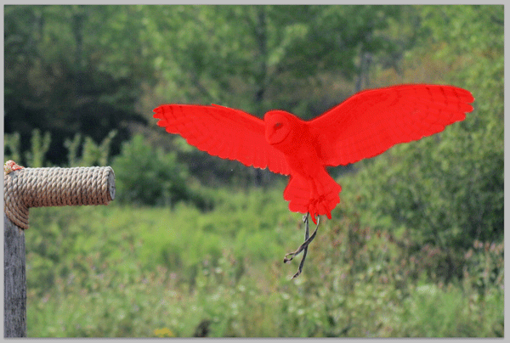

Use the magic wand tool and select the inside red. This will outline the owl.

Note: To hide the mask, on the Layers panel, click "Channels". The last channel will be your mask. Just click the eye and it will hide the mask.

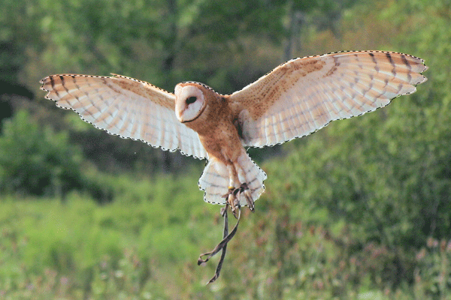

**Step 11**

Next, right click on the owl and go to Refine Edge, or go to Select > Refine Edge. Note that all settings are the same, depending on your mask. Play around a bit until you come up with the best possible outline.

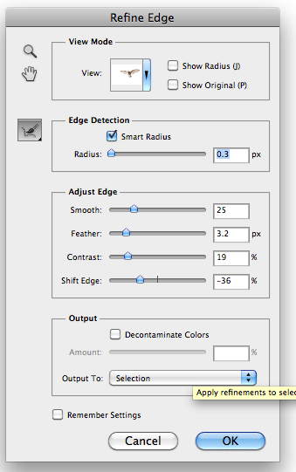

**Step 12**

Move the owl into our composition, and use the Transform tool (Cmd/Ctrl + T) to resize it. Place him it the top left, in the bright spot. Create a group called "Owls", and name the layer we moved "Owl 1" and place it inside the group.

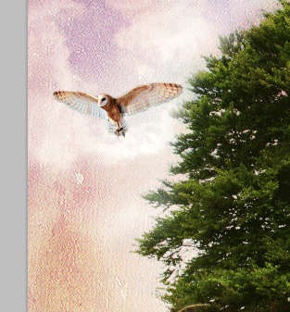

After placed, lets add some more to this owl by editing the levels. Go to Image > Adjustments > Levels. Apply these settings.

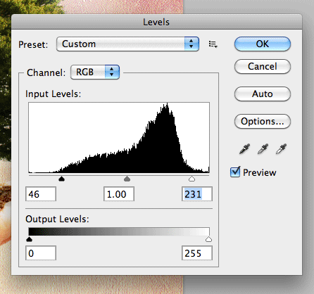

**Step 13**

Duplicate the Owl 1 layer and name it Owl 2. Flip this owl by going to Edit > Transform > Flip Horizontal to make him opposite to the first owl. Use the Transform tool (Cmd/Ctrl + T) To scale him down. Be sure to place the "Owl 2" layer under "Owl 1" in our layers pallette, and place the owl slightly behind the first owl.

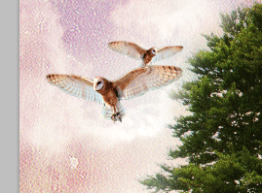

Next, lets add a filter to the second owl. Go to Image > Adjustments > Photo Filter.

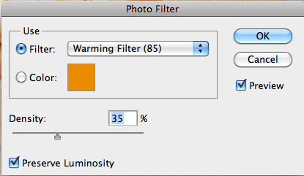

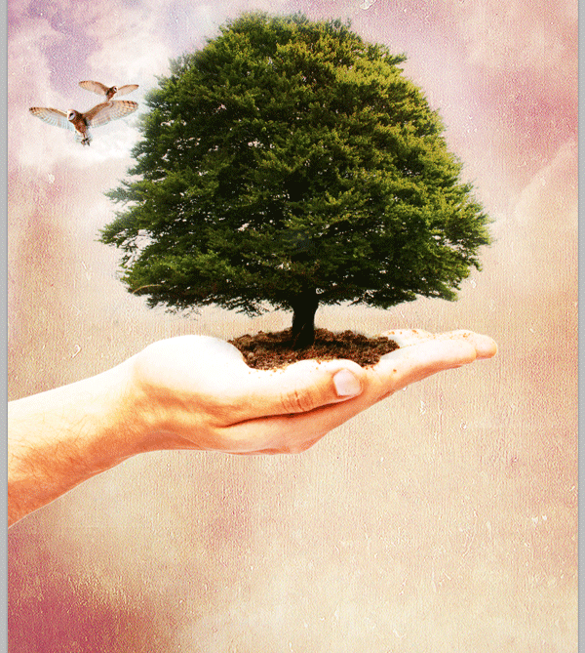

**Step 14**

Go into your Tree group and select the first layer. Use the Burn tool, and add a little more shadow in the dirt.

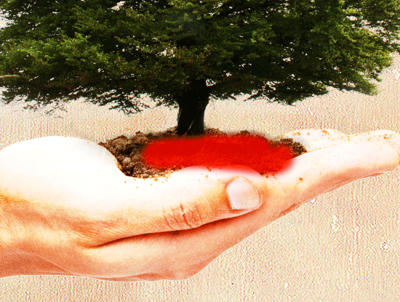

**Step 15**

Let's create some more lighting, except using colors. Create a new layer, and place it under your "Lighting" group. Select a fairly large brush with a hardness of 0px. For the colors, I used #9921b3 and #f8fb25. Paint like so, feel free to use variation of location and color!

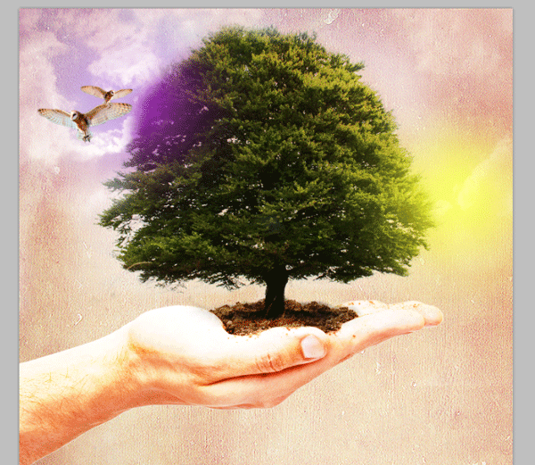

Now, set this layer’s blending mode to Linear Light.

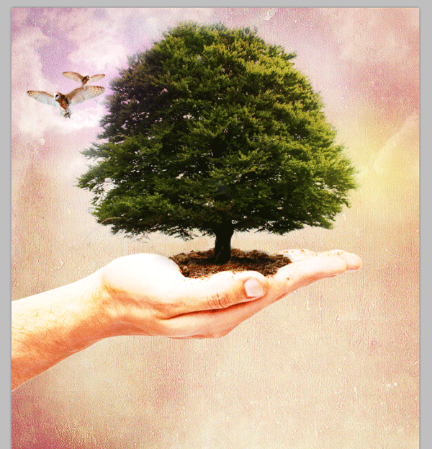

**Step 16**

Let's go back and do a little retouching on the hand, select your Color Dodge tool, and set the opacity at about 85%. And set the range to Shadows.

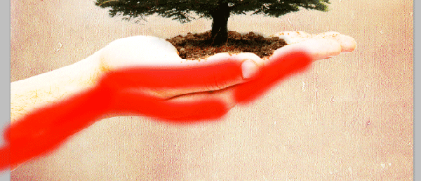

Once you've gone over the hand a few times, your hand should have a more white, lighter color.

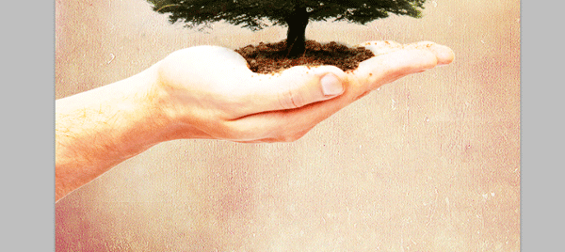

**Step 17**

Now let's do a little final touching to the clouds. Select the Cloud layer, and then select the Eraser tool (E) and using a relatively large brush with a 0px hardness, erase around the clouds.

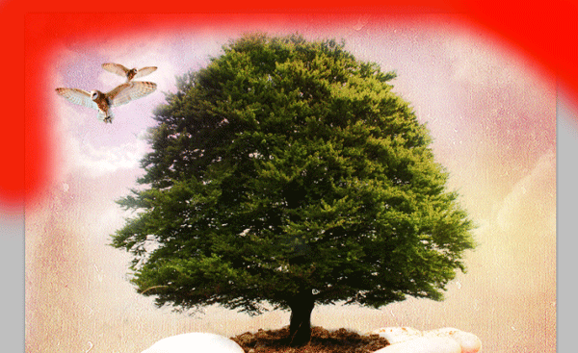

You should now have something like this.

Note: I also moved the two owl layers up a bit higher on the tree, by using the Transform tool.

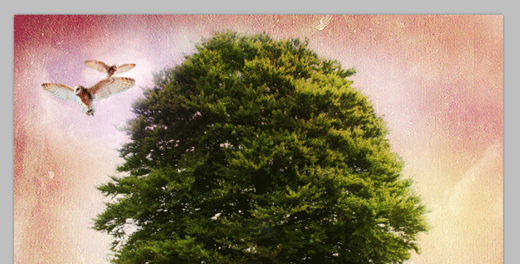

**Step 18**

Let's add some text now. The font used it Century Gothic, but feel free to experiment with your own font. Make sure you choose black for your color, and use your Text tool, with a size of 100px and write "the greenhouse effect". Set this layers blending mode to Soft Light.

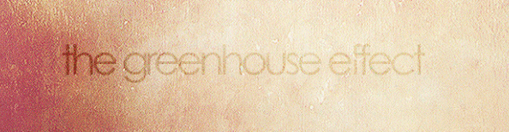

Advertisement

**Step 19**

Lastly, lets make a roof on top of the text. Using the rectangle tool, and create a rectangle, then duplicate this layer. Use the Transform tool and rotate each to just under a 45 degree angle. Then place them together. Merge these two rectangles. They should look like this

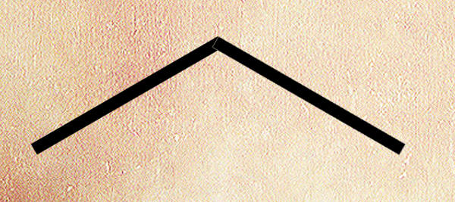

Lastly, move them and using the Transform tool again, size them to fit on top of text like below, and set the blending mode to Overlay and its opacity to 25%.>

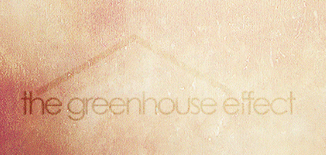

**Final Image**



[**How To Turn An Ordinary Photo To Extraordinary Photo**](http://blurbomat.com/2006/10/31/how-to-turn-an-ordinary-photo-into-an-extraordinary-photo/)

I’ve often been asked about my process for tweaking photos. I thought I’d use one of my favorite photos and show how I took it from initial capture to final public display. I had forgotten how far I had taken this image from its initial capture:

[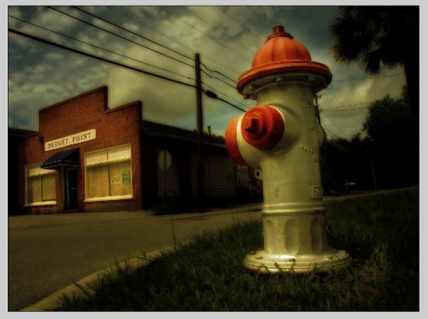](https://i2.wp.com/blurbomat.com/wordpress/wp-content/uploads/2006/10/13_blurb_finaltweaks.jpg)

click image to see larger version

As with all tools, there are many ways to accomplish the same thing. I found a set of techniques that work really well for taking a photo that doesn’t have the best light or isn’t shot at the perfect time of day and amping it up. You may have better or different techniques to accomplish similar things and I say to you things like, “Keep the hope alive.” And: “Awesome!”

I generally don’t like writing Photoshop tutorials, because my assumptions about everything are usually wrong. In this case, I wanted to write a fairly straightforward tutorial, but after showing a draft to Heather, decided to rework it substantially, with more screenshots and better explanations of the steps. This is not a beginner tutorial for Photoshop. This is an advanced tutorial. I hope it doesn’t frustrate you or confuse you.

**Some assumptions**  
—You have access to Photoshop and know your way around some of the palettes. In particular, the Layer Palette. There are several buttons at the bottom of the Layer Palette. There are two that I’ll be making reference to; 1) The New Layer/Duplicate Layer and; 2) the Adjustment Layer button.

[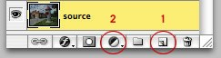](https://i0.wp.com/blurbomat.com/wordpress/wp-content/uploads/2006/10/blurb_layerspalette.jpg)

When I mention duplicating layers below, I mean you select the thumbnail/icon of the layer you want to duplicate and drag it to the New Layer button (#1 in the above illustration). This duplicates the layer and positions it above the layer you clicked and dragged.

—You have a photo that you’d like to tweak.

—You aren’t afraid to play around with sliders and settings.

**Taking the picture**  
I might muck about with some settings on the camera, but I want to capture the vision in my head as close as I can while I’m in the moment. I might think about post-processing, but that’s pretty rare. I usually make a mental note of the kind of thing I want, click the shot and move on. This isn’t always the best way to work, but it’s how the image I’m using in this tutorial evolved.

So here’s our starter image:

[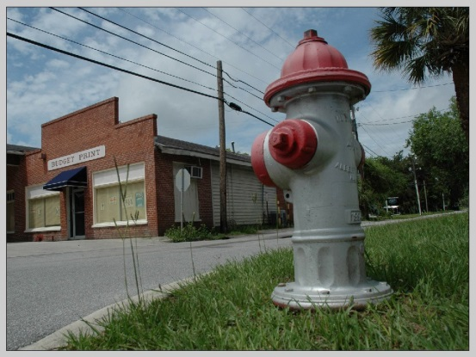](https://i1.wp.com/blurbomat.com/wordpress/wp-content/uploads/2006/10/1_blurb_baseshot.jpg)

Click image to see larger version

**Photoshop time**  
I always keep a layer in Photoshop of my original file, untouched and at the bottom of the stack in the Layer Palette. So the first thing I do is select the background layer and drag it to the New Layer button. This creates a layer of the same image that I can edit, calm in the assurance that if I do anything untoward, I can revert to my original without too much pain. After doing this, the Layers Palette looks like this:  
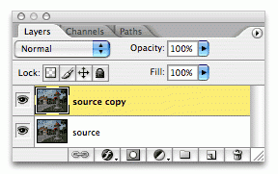

The photo has pretty flat light and not a lot of mood. I love the low angle and of the six shots I took of the building and hydrant, this image shows the most promise by far. That pesky tall grass really is distracting. In my first sharing of this photo, I left it in throughout the processing. Big mistake. It’s out. I’m going to use the stamp tool and get rid of a few strands of tall grass. Since this is optional on whatever you might be working on, I’ll skip all the technique and screenshots, as that would likely be enough information to be its own tutorial. After several hours of painstaking use of the stamp tool it’s time to perform an Unsharp Mask:

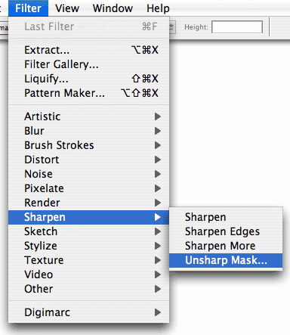

This is an entirely subjective thing. Use the three sliders to make your image sharper, without making it look like it came out of a digital camera circa 1997. Which would look like ass. Avoid looking like ass. I use the Amount and Radius settings to get what I want. There are times when the Threshold slider can help, but for speed, it’s all about a .4 to .9 pixel radius and a setting between 80% and 150% on the Amount slider. As with all the steps, the values you might use depend on your image resolution and degree of sharpness you want:

[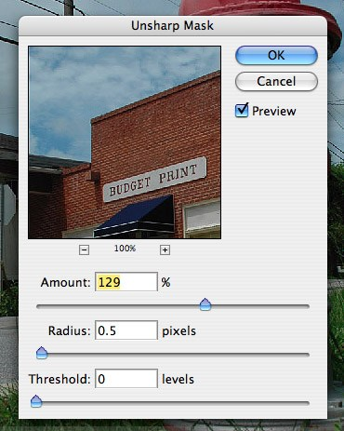](https://i0.wp.com/blurbomat.com/wordpress/wp-content/uploads/2006/10/unsharpmaskdialog.jpg)

With that, we are here:

[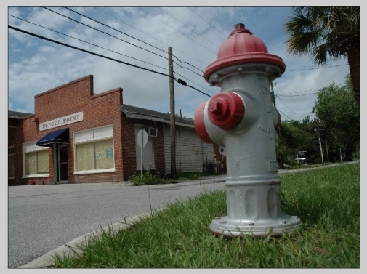](https://i1.wp.com/blurbomat.com/wordpress/wp-content/uploads/2006/10/2_blurb_baseshot-sharpened-.jpg)

Click image to see larger version

Note that because this is a screenshot of a large image, you might not see much difference between the previous image and this one; when you do it yourself, you’ll see a dramatic difference that will change how you look at photos.

**Time to Blur**  
The image is still very flat and there is very little contrast. Let’s take the layer we did the work on and duplicate it by selecting the layer and dragging it to the New Layer button. This will create the third layer in the image on top of the source/Background and the copy of the source we just finished working on. The Layers Palette looks like this:

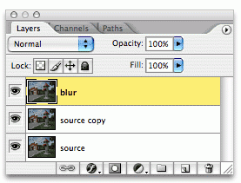

Apply a Gaussian Blur:

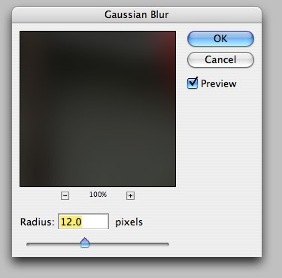

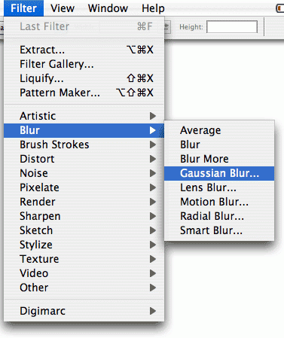



Click image to see a larger version

You’ll want to vary this based on how large your source image is. The larger the image, the higher you can set the blur. Our image now looks like this:

[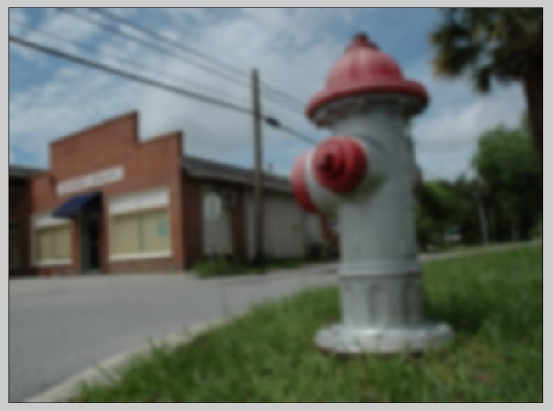](https://i0.wp.com/blurbomat.com/wordpress/wp-content/uploads/2006/10/3_blurb_copylayerandblur.jpg)

Click the image to see a larger version

Bear with me. You’ll take this layer and change it’s layer settings in the Layer Palette. We’ll set the transparency mode to Multiply by clicking on the drop down menu that says “Normal” and selecting Multiply:

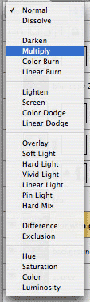

Click the image to see a larger version

Still a little dark:

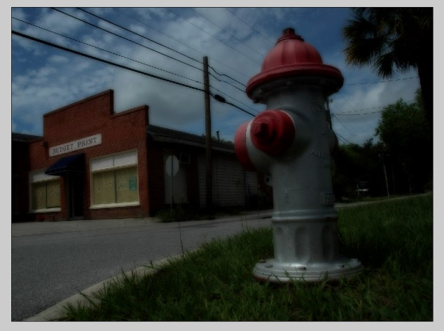

Click the image to see a larger version

Don’t panic yet. Set the Opacity of this blurred layer to 33%. This is in the top section of the Layer Palette next to the transparency drop down menu:  
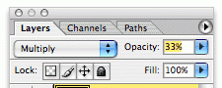

I know. Still a little dark, but we’re building a foundation. Of love:

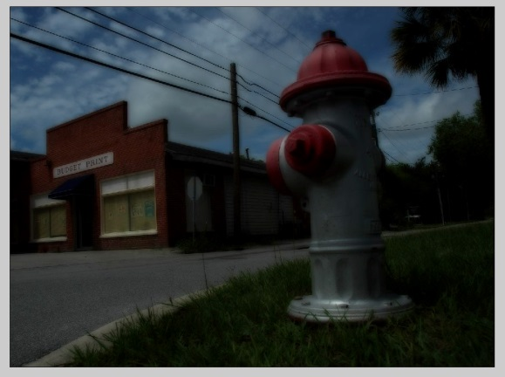

Click the image to see a larger version

**Mask It: It’s Like Cheese!**  
This is where the tutorial will take a turn for the fourth dimension. Masking images can be daunting and takes some time to get used to the concept and how layers can work for us. Think of the layers as a sandwich. The layer we will mask is the cheese layer of the sandwich. We’re going to take that cheese layer and turn it into Swiss cheese. We’ll use the mask to make holes in the image that will allow what is underneath to show through.

This step will rectify the darkness somewhat and is going to require some layer masking and painting on the masked portion of the layer. To do this, we’ll duplicate the blurred layer (the layer I’ve called “blur”) and add a Layer Mask to this new layer, selecting “Reveal All” in the submenu:

[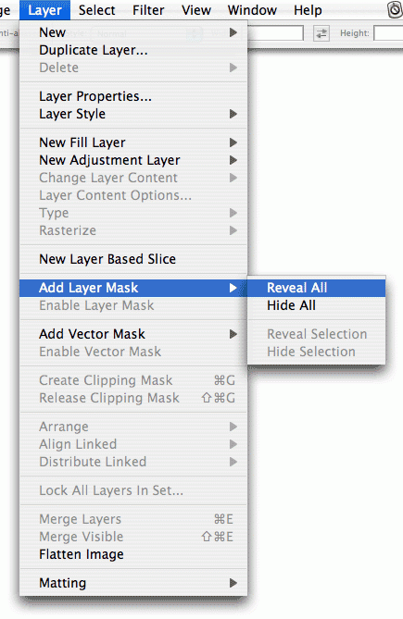](https://i1.wp.com/blurbomat.com/wordpress/wp-content/uploads/2006/10/blurb_layermaskset.gif)

Click the image to see a larger version

The effect we’re trying to get is to make the blacks darker and then mask out the parts of the image we want to keep light. This is where the drama and focal points come into play. In our case, the building and the hydrant are the two focal points we want to emphasize. This is what I saw in my head when I took the shot and what I want to achieve with the rest of the steps.

Your Layer Palette should have a mask icon next to the thumbnail of the image:  
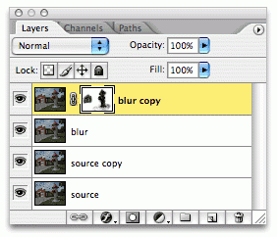

I took this shot after I did the work, to show what a Layer mask icon in the Layer Palette looks like. I used the brush tool and selected a basic brush with a blurred fall-off:  
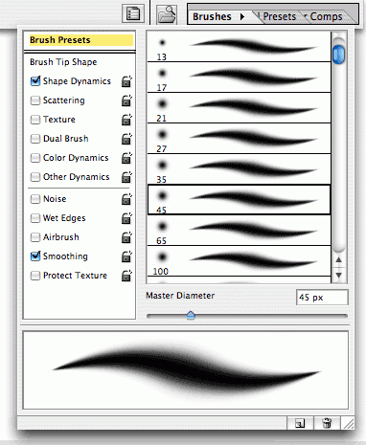

Make sure you select the mask icon in the Layer Palette before you start brushing, as you’ll destroy your masterpiece and want to throw things. Important: Masks are painted in grayscale, so I usually paint with black selected as the brush color and use varying flow rates and brush sizes to mask. In this case, I’ve painted black over the building and the hydrant. You’ll notice that it masks out the dark layer we just created and reveals the lighter layer underneath:

[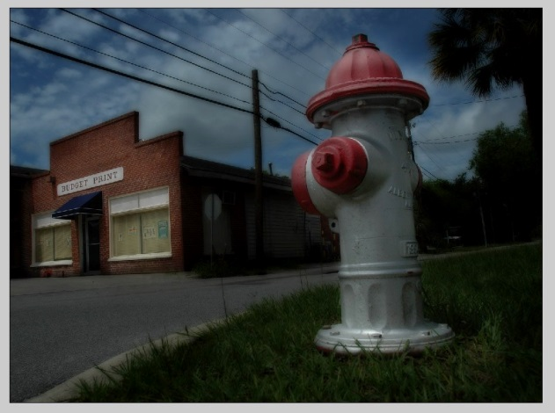](https://i1.wp.com/blurbomat.com/wordpress/wp-content/uploads/2006/10/9a_startthedrama.jpg)

Click the image to see a larger version

**Save the Drama**  
We’ve started to make the image more dramatic. Now we need to work with Colors, Curves and Levels. We’ll be using Adjustment Layers, which are your best friend when doing work like this. Adjustment layers are non-destructive layers that sit in the palette wherever you’d like and can make playing around a lot less time consuming (reducing the number of Undos). The Adjustment Layer button is at the bottom of the Layers Palette (it’s the half dark/half light one):  
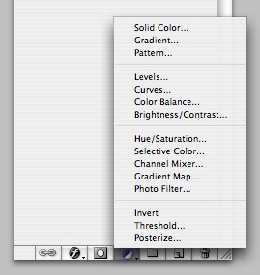

As you can see, there are a ton of options to play with. We’re going to start with Selective Color, as I want to bump up the yellows and reds:

[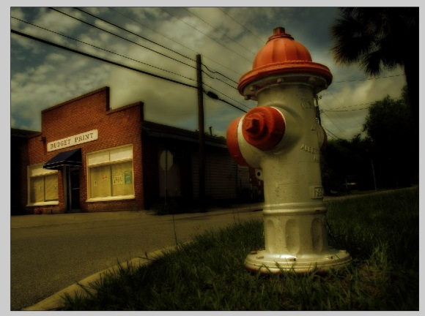](https://i1.wp.com/blurbomat.com/wordpress/wp-content/uploads/2006/10/10_blurb_nowwearetalking.jpg)

Click the image to see a larger version

Still not quite where it needs to be, but much closer. I’d share shots of the color selections I did, but it’s always different for every photo. So while you can see my settings, they wouldn’t necessarily apply to the image you might be working on. Remember, it’s non-destructive. So tweak away. After we’re done, the Layers Palette looks like this:

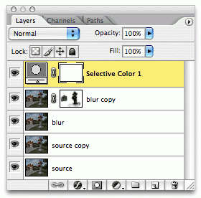

We need to add some contrast, and I like using Levels for this, because I can control the blacks, whites and midrange with more precision than just using Brightness/Contrast. We’ll add another Adjustment Layer by clicking on the button in the Layer Palette and selecting “Levels”. This looks just like the regular Photoshop “Levels” command under the image adjustments submenu. Except this is non-destructive and as an Adjustment Layer, holds your settings should you want to tweak them later. After we do the Level adjustments, our Layers Palette looks like this:

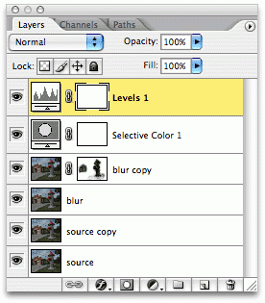

Which gives us:

[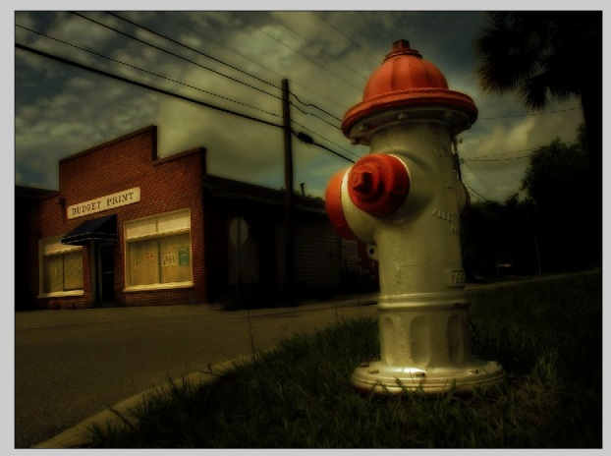](https://i2.wp.com/blurbomat.com/wordpress/wp-content/uploads/2006/10/12_blurb_almostdone.jpg)

Click the image to see a larger version

**Almost Done**  
The image is very close to being done. But I want just a tiny bit more light on the hydrant and a hint of a vignette. There are many ways to do this, but at the time I worked on this image, Photoshop didn’t have either Camera Raw or the Lens filters to add vignettes. So I did it using Lighting Effects.

We’ll take the blurred layer that isn’t masked and duplicate it. So we’ll be selecting the layer called “blur”, dragging it to the New Layer/Duplicate Layer button. Once the layer is created, we’ll drag it in the Layer Palette so that it is at the top of the palette, above the two adjustment layers we just made. Our Layers Palette looks like this:

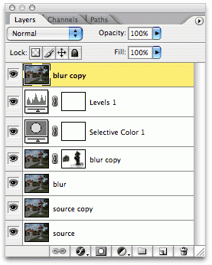

Then we’ll select this layer and do the Lighting Effects:

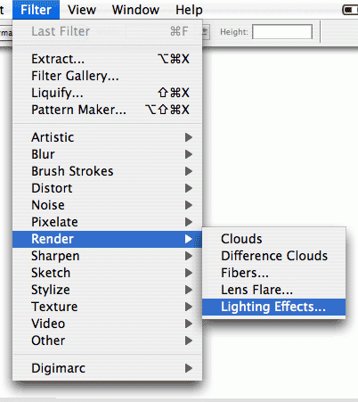

I used these settings in the Lighting Effects panel:  
[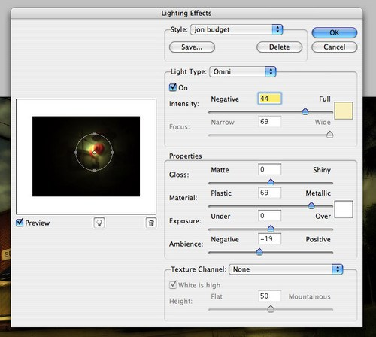](http://www.blurbomat.com/storyart/12b_blurb_lightingfx.php)

Set the transparency on this layer to Overlay and the Opacity to 33%:  
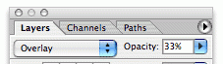

We are almost there. It still needs just a touch of lightening overall, and I like to use Curves to accomplish this. We’ll make a new Adjustment Layer by clicking the icon in the Layers Palette and selecting “Curves”. A simple adjustment lightens up the image enough to recapture some of our highlights. Our Layer Palette looks like this:

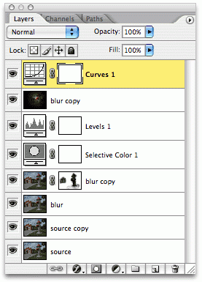

[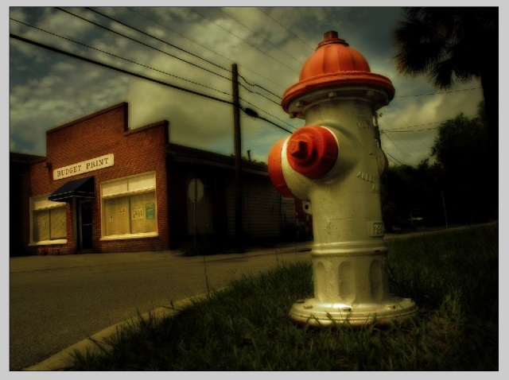](http://blurbomat.com/how-to-turn-an-ordinary-photo-into-an-extraordinary-photo/final-tweaks/)

click image to see larger version

And boom. We’re there. This concludes the Photoshop tutorial.

#### Step 1: Duplicate The Background Layer

With my image newly opened in Photoshop, if we look in my [Layers panel](http://www.photoshopessentials.com/basics/layers/layers-panel/), we see the image sitting on the [Background layer](http://www.photoshopessentials.com/basics/layers/background-layer/) which is currently the only layer in the document:

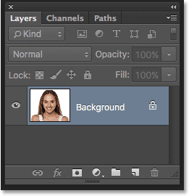

The Layers panel showing the original image on the Background layer.

As I mentioned, we'll start things off by removing any unwanted blemishes in the skin. We'll do the work on a separate layer, which means we'll need to make a copy of the Background layer. To do that, press and hold the **Alt** (Win) / **Option** (Mac) key on your keyboard as you click on the Background layer and drag it down onto the **New Layer** icon at the bottom of the Layers panel (second icon from the right):

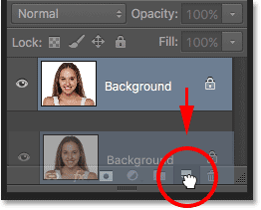

Dragging the Background layer onto the New Layer icon while holding Alt (Win) / Option (Mac).

Holding down the Alt (Win) / Option (Mac) key tells Photoshop to pop open the **Duplicate Layer** dialog box, allowing us to name the duplicate layer before it's added. Since we'll be using the Spot Healing Brush to remove any blemishes, let's name the layer "Spot Healing". Click OK when you're done to close out of the dialog box:

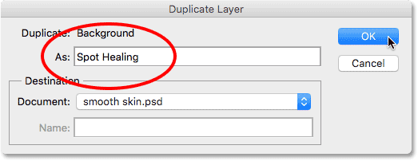

Naming the layer "Spot Healing".

If we look again in the Layers panel, we see the Spot Healing layer now sitting above the Background layer. The Spot Healing layer is highlighted in blue which tells us that it is now the active layer. Anything we do next will be done to this layer, while the original image remains safe and unharmed on the Background layer:

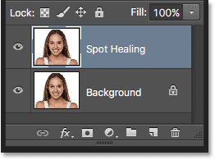

The Layers panel showing the new Spot Healing layer.

#### Step 2: Select The Spot Healing Brush Tool

Next, choose the **Spot Healing Brush Tool** from the Tools panel:

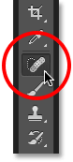

Selecting the Spot Healing Brush Tool.

#### Step 3: Set The Spot Healing Brush To "Content-Aware"

With the Spot Healing Brush selected, make sure the **Type** option in the Options Bar along the top of the screen is set to **Content-Aware**. This is a relatively new feature for the Spot Healing Brush (first added in CS5) that allows Photoshop to make better decisions about the replacement texture it chooses for the problem area you've clicked on:

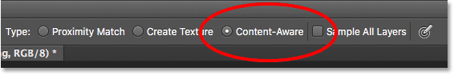

Make sure Content-Aware is selected (which it should be by default).

#### Step 4: Click On The Problem Spots To Heal Them

To remove any unwanted skin blemishes, all we need to do is click on them with the Spot Healing Brush. Photoshop will instantly replace the problem texture with good texture from the surrounding area.

For example, if we look at the young woman's forehead, we see a relatively large blemish just to the right of center. To remove it, I'll position the Spot Healing Brush over top of it. For best results, you'll want your brush to be slightly larger than the area you're trying to replace, and you can change the size of the brush directly from the keyboard. Press the **right bracket key** ( **]** ) repeatedly to make the brush **larger** or the **left bracket key** ( **[** ) to make it **smaller**. You'll find the bracket keys directly to the right of the letter P on most standard keyboards.

Here we see my brush cursor (the black circular outline) positioned over the blemish I want to remove:

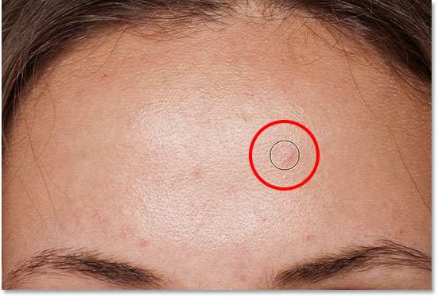

Positioning the Spot Healing Brush over a problem area.

I'll click on it with the Spot Healing Brush, and like magic, it's gone! Photoshop analyzed the area, found some good texture from the area surrounding it, and then blended the good texture in with the problem area's original tone and color to produce seamless results:

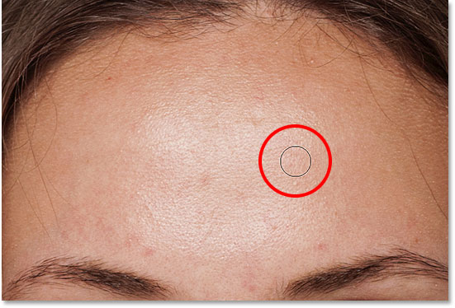

The result after clicking on the area to remove the blemish.

I'll do the same thing with another blemish on her forehead, keeping my brush just a bit larger than the problem area:

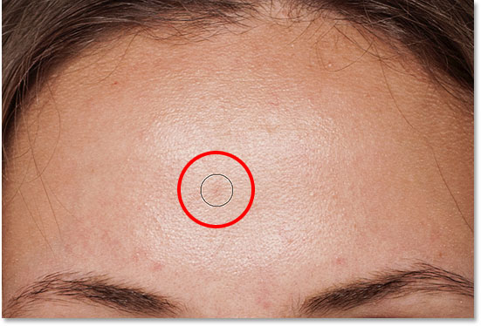

Positioning the Spot Healing Brush over a second blemish.

Once again, I'll click on the blemish with the Spot Healing Brush and Photoshop instantly removes it. If you find that Photoshop did not do as good of a job as you were hoping, press **Ctrl+Z** (Win) / **Command+Z** (Mac) on your keyboard to undo it. Resize your brush so it's a bit larger or smaller than last time, then click to try again:

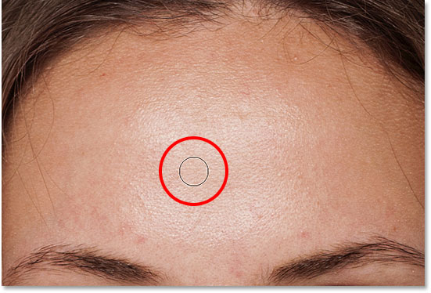

The second blemish is gone.

I'll click on the remaining blemishes on her forehead to remove them, and here's the result. Things are already looking much better:

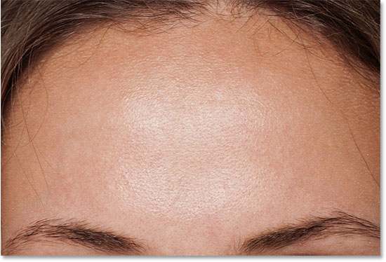

The blemishes have been removed from her forehead.

I'll continue working my way around her face to remove any other problem spots, including a few small pimples on her chin. Keep in mind as you're working that while it's okay to remove temporary problems like acne or other minor skin issues, it's usually not okay to remove permanent features like moles or even certain scars, as these things are part of what makes someone who they are. After all, the goal of image retouching should be to help people look their best, not make them look like somebody else.

Here's a side-by-side comparison of what she looked like originally (left) and after some quick retouching with the Spot Healing Brush (right). With most photos, the whole process should take no more than a couple of minutes. I covered the Spot Healing Brush fairly quick here, but to learn more about it, check out our [Removing Acne, Skin Blemishes With The Spot Healing Brush](http://www.photoshopessentials.com/photo-editing/spot-healing-brush/) tutorial where I cover it in much more detail:

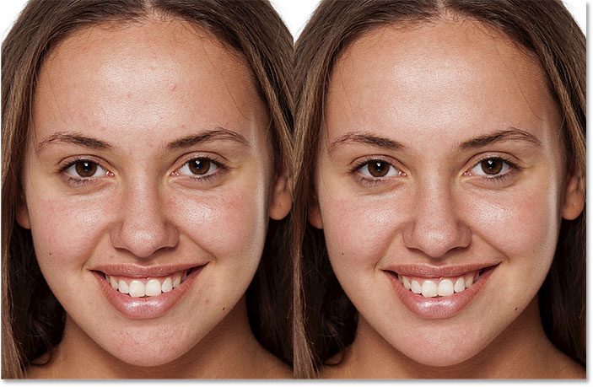

Before (left) and after (right).

#### Step 5: Duplicate The Spot Healing Layer

Now that we've removed any blemishes, we're ready to smooth and soften the skin. Just like we did with the Spot Healing Brush, we'll do the work on its own separate layer. Press and hold the **Alt** (Win) / **Option** (Mac) key on your keyboard as you click on the **Spot Healing** layer and drag it down onto the **New Layer** icon at the bottom of the Layers panel:

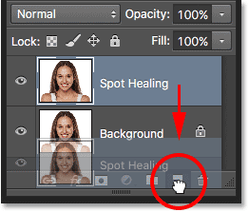

Dragging the Spot Healing layer onto the New Layer icon while holding Alt (Win) / Option (Mac).

When the Duplicate Layer dialog box opens, name the layer "Soften Skin", then click OK:

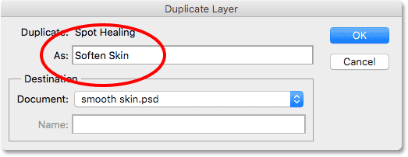

Naming the duplicate layer "Soften Skin".

The new Soften Skin layer appears above the Spot Healing layer in the Layers panel:

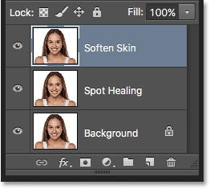

The Layers panel showing the new Soften Skin layer.

#### Step 6: Apply The High Pass Filter

To soften the skin, we'll use Photoshop's High Pass filter. Go up to the **Filter** menu in the Menu Bar along the top of the screen, choose **Other** down near the bottom of the list, and then choose **High Pass**:

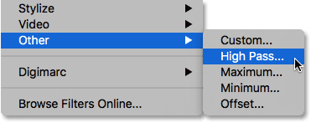

Going to Filter > Other > High Pass.

If you're familiar with the High Pass filter, it's most likely because you've used it before as an advanced way of sharpening images. In this case, we're softening the skin, not sharpening it, but many of the steps are the same. The High Pass filter works by looking for edges in the image (areas where there's a big, sudden change in brightness or color between neighboring pixels). In the case of a portrait photo, the edges would be along the hair, around the eyes, the mouth, and so on. Skin, on the other hand, has relatively low amounts of detail with much smoother transitions, so it would be largely ignored.

If we were sharpening the image, the High Pass filter would allow us to sharpen the edges without affecting the skin. What we're going to use it for, though, is the exact opposite. We're going to let the High Pass filter detect the edges not so we can sharpen them, but so we can soften everything except the edges.

The **Radius** value at the bottom of the High Pass filter's dialog box controls the "thickness" of the edges. In other words, once Photoshop has detected an edge, the Radius value tells it how many additional pixels on either side of it to include as part of the edge. Low Radius values will detect only the finest details, but to make sure we don't end up softening these areas, we want more of the edge to be included. For a typical portrait shot, a Radius value of **24 pixels** works well, so that's what I'll use:

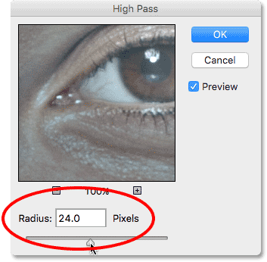

Setting the Radius value to 24 pixels.

If your subject is further back in the photo, or you're working on a fairly low resolution image, a smaller Radius value might work better. In that case, you might want to try **18 pixels** or even **12 pixels** depending on the size of the image. The reason I'm mentioning these values specifically is because it's important for the next step that you choose a value that's easily divisible by 3. For example, 24 divided by 3 is 8, 18 divided by 3 is 6, and 12 divided by 3 is 4. Nice, easy numbers. Again, we'll see why in the next step.

Click OK to close out of the High Pass filter's dialog box. Your image will turn mostly gray, with the gray being the areas with little to no detail detected. The edges are shown with higher contrast:

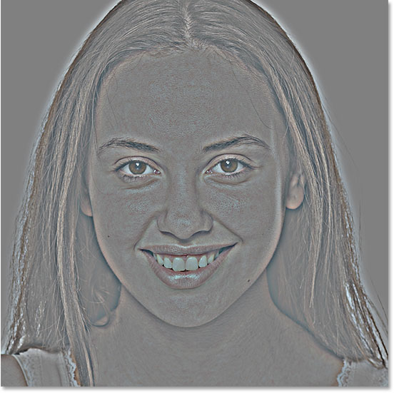

The result after applying the High Pass filter.

#### Step 7: Apply The Gaussian Blur Filter

Next, we'll add some blurring to our High Pass filter effect using Photoshop's Gaussian Blur filter. It may seem counterintuitive, but the blurring will actually help to bring out more good texture in the skin.

Go up to the **Filter** menu at the top of the screen, choose **Blur**, and then choose **Gaussian Blur**:

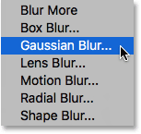

Going to Filter > Blur > Gaussian Blur.

Just like with the High Pass filter, we control the blur amount using the **Radius** value along the bottom of the Gaussian Blur dialog box. Enter an amount that's exactly **one third** of the value you entered for the High Pass filter. In my case, I went with a radius of 24 pixels for High Pass, so for the Gaussian Blur filter, I'll enter one third of that which is **8 pixels**:

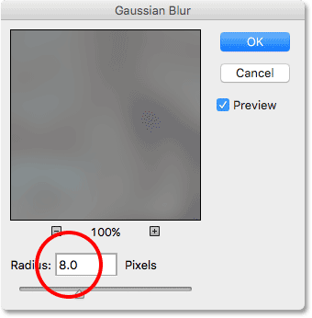

Setting the Gaussian Blur's radius to one third of the High Pass radius.

Click OK to close out of the dialog box. The High Pass effect now looks softer and less detailed:

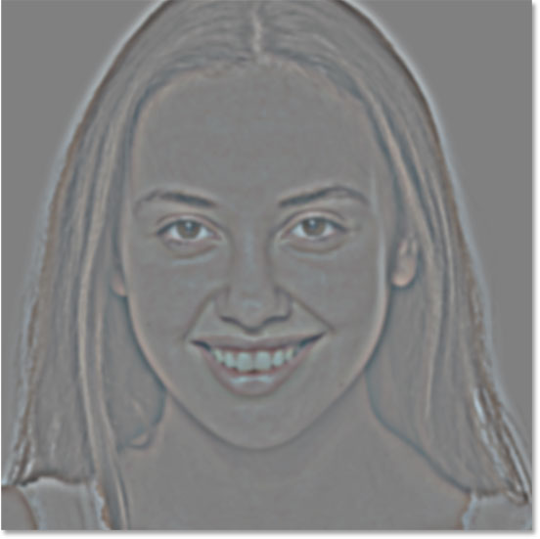

The result after applying the Gaussian Blur filter.

#### Step 8: Change The Layer Blend Mode To Linear Light

To blend the High Pass filter effect in with the image, change the **blend mode** for the Soften Skin layer from Normal (the default mode) to **Linear Light**. You'll find the Blend Mode option in the upper left corner of the Layers panel:

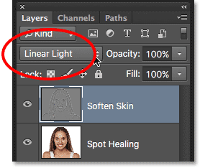

Changing the blend mode of the Soften Skin layer to Linear Light.

This creates a very high contrast, over-sharpened effect. Don't worry if you think this looks terrible; it will look even worse in a moment:

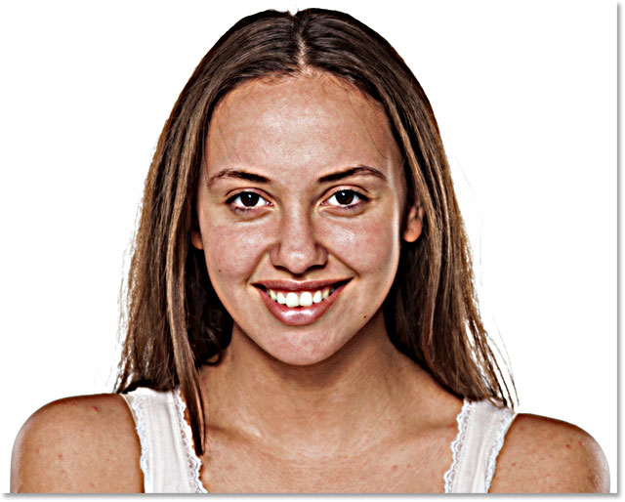

The result after changing the Soften Skin layer's blend mode to Linear Light.

**Learn More:** [Photoshop's Five Essential Blend Modes For Photo Editing](http://www.photoshopessentials.com/photo-editing/layer-blend-modes/intro/)

#### Step 9: Invert The Layer

If our goal was to over-sharpen the heck out the image, we'd be done. But of course, we're trying to smooth and soften the skin. To use our High Pass effect not for sharpening but for softening, we need to invert the Soften Skin layer. To do that, go up to the **Image** menu at the top of the screen, choose **Adjustments**, and then choose **Invert**. Or, just press **Ctrl+I** (Win) / **Command+I** (Mac) on your keyboard:

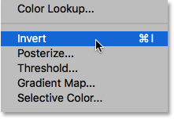

Going to Image > Adjustments > Invert.

With the layer inverted, the image goes from being over-sharpened to looking like a weird, blurry mess with big ugly halos around everything:

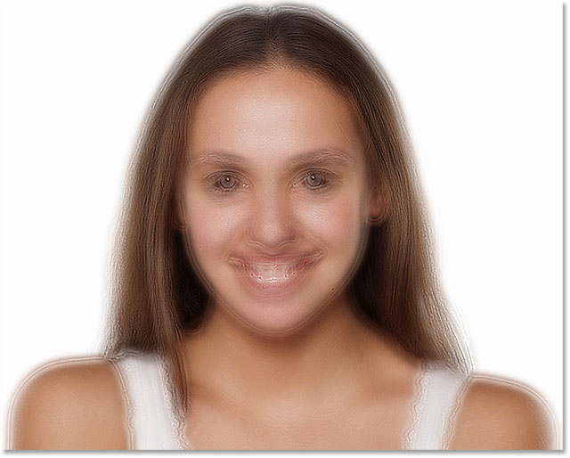

The result after inverting the Soften Skin layer.

#### Step 10: Open The Blending Options

To reduce the halo effect, click on the small **menu icon** in the upper right corner of the Layers panel:

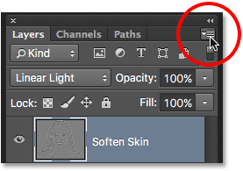

Clicking the Layers panel menu icon.

Choose **Blending Options** from the menu that appears:

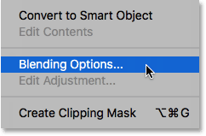

Choosing "Blending Options" from the Layers panel menu.

This opens the **Layer Style** dialog box set to the Blending Options in the middle column. If you look down at the bottom, you'll see two sets of sliders; one labeled "This Layer" and another below it labeled "Underlying Layer". These are Photoshop's **Blend If** sliders and they allow us to control how our currently-selected layer (the Soften Skin layer) blends with the layer below it. To reduce the intensity of the halos, we need the first set of sliders (the one on top labeled "This Layer"). You can ignore the other one:

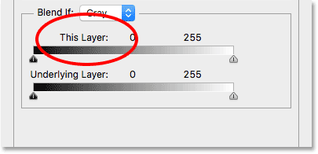

The Blend If sliders. The one on top is the one we need.

You'll find the actual sliders below either end of the horizontal gradient bar. There's one for controlling the darker areas of the image on the left and one for the lighter areas on the right:

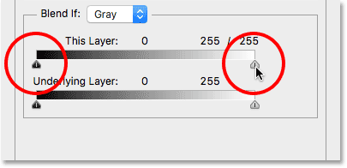

The dark (left) and light (right) sliders.

It looks like the sliders are solid, but we can actually split them in half and then spread the two halves of each slider apart. If we were to simply click on one of the sliders and drag it around, we'd create very harsh and noticeable transitions between the layers. But by splitting the sliders apart, the space between the two halves creates a much smoother and more subtle blend.

We'll start by reducing the lighter halos. To do that, press and hold the **Alt** (Win) / **Option** (Mac) key on your keyboard as you click on the slider on the **right** and begin dragging it towards the left. The Alt (Win) / Option (Mac) key tells Photoshop to split the slider in half so that as you're dragging, only the left side of the slider actually moves while the right side stays in place.

Keep an eye on the image as you're dragging the slider and you'll see the lighter halos fading away. You'll need to drag almost all the way to the left to reduce them as much as possible:

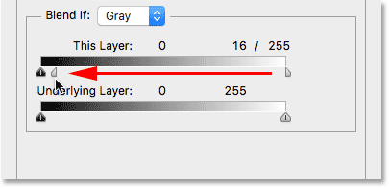

Dragging the left half of the slider on the right.

Here's the result after dragging the first slider. Most of the lighter halos are now gone, or at least, much less noticeable. Only the darker ones remain:

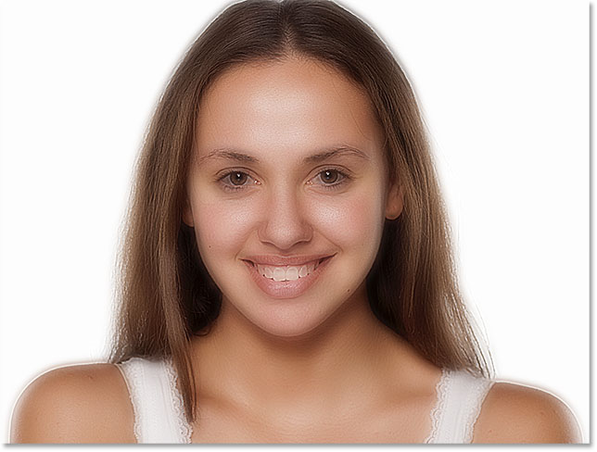

The result after dragging the first slider.

To reduce the darker halos, press and hold your **Alt** (Win) / **Option** (Mac) key as you click on the slider on the **left** and drag the right half of it towards the right. Again, you'll need to drag almost all the way to the right for most of the dark halos to disappear:

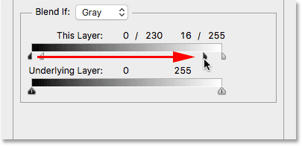

Dragging the right half of the slider on the left.

When you're done, click OK to close out of the Layer Style dialog box, and here's the result. Notice how smooth the skin looks:

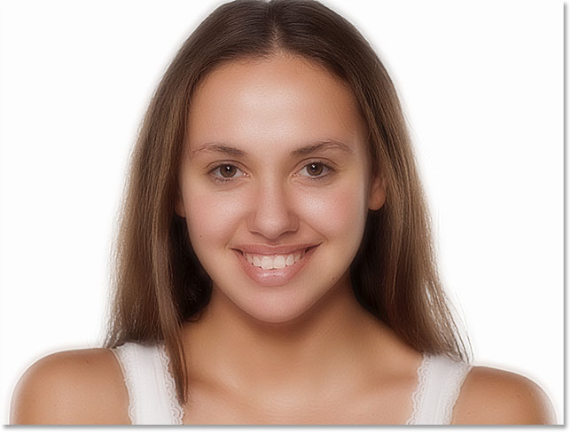

The image after dragging the second slider.

#### Step 11: Add A Layer Mask

At this point, we've softened the skin, but we've also softened the eyes, mouth, hair, and everything else in the image. We need a way to hide the effect everywhere except the skin, and we can do that using a [layer mask](http://www.photoshopessentials.com/basics/layers/layer-masks/). Press and hold the **Alt** (Win) / **Option** (Mac) key on your keyboard and click the **Add Layer Mask** icon at the bottom of the Layers panel:

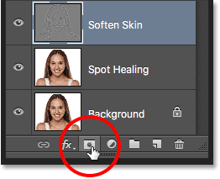

Adding a layer mask while holding Alt (Win) / Option (Mac).

This adds a layer mask to the Soften Skin layer. Normally, Photoshop fills a layer mask with white, which allows the entire layer to remain visible until we paint over certain areas with black to hide them. But by pressing and holding Alt (Win) / Option (Mac) as we clicked the Add Layer Mask icon, we told Photoshop to fill the mask with **black**, as we can see by looking at the **layer mask thumbnail**. This temporarily hides the entire softening effect from view:

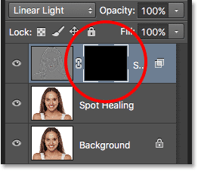

A black-filled layer mask has been added to the Soften Skin layer.

**Learn More:** [Understanding Layer Masks in Photoshop](http://www.photoshopessentials.com/basics/layers/layer-masks/)

#### Step 12: Select The Brush Tool

We're going to paint back the softening effect, but only over the skin. To do that, select Photoshop's **Brush Tool** from the Tools panel:

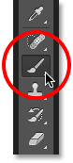

Selecting the Brush Tool.

#### Step 13: Set Your Foreground Color To White

We'll need to paint on the mask with white. Photoshop uses the current **Foreground color** as the color of the brush, so make sure your Foreground color is set to **white**. You can see your current Foreground and Background colors in the **color swatches** near the bottom of the Tools panel. The swatch in the upper left is the Foreground color. If it's not showing white, press the letter **D** on your keyboard to quickly reset the colors to their defaults:

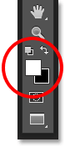

The Foreground (upper left) and Background (lower right) color swatches.

#### Step 14: Paint Over The Skin

With the Brush Tool in hand and white as your Foreground color, simply paint over the skin to reveal the softening effect. A soft-edge brush will work best. We already know that we can adjust the size of the brush using the left and right bracket keys, but if you press and hold your **Shift** key while pressing the **left bracket key**, you'll make the brush **softer**. Holding **Shift** while pressing the **right bracket key** will make the brush **harder**.

Before you begin painting, it's also a good idea to look up in the Options Bar and check to make sure that the **Mode** option (short for Blend Mode) for the Brush Tool is set to **Normal**, **Opacity** is set to **100%** and **Flow** is also set to **100%**. If you made changes to any of these settings in the past and forgot to set them back, you could end up with unexpected results:

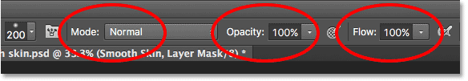

Making sure the Mode, Opacity and Fill options are all set to their defaults.

I'll start by painting over her forehead. Since we're painting on the layer mask, not on the layer itself, we don't see our brush strokes. Instead, we reveal the softening effect in the areas where we've painted:

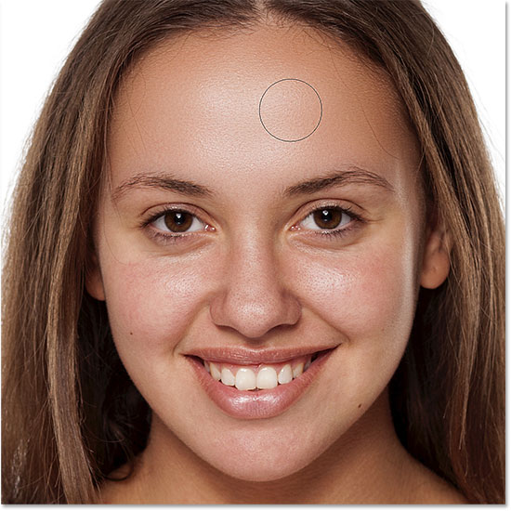

Painting with white on the layer mask to reveal the softening effect on her forehead.

I'll do the same thing over her nose, her cheeks, and around her eyes, adjusting my brush size as needed so I don't accidentally paint over her eyes or any other areas that should remain sharp. If you do slip and paint over the wrong area, simply press the letter **X** on your keyboard to swap your Foreground and Background colors. This will set your **Foreground color** to **black**. Paint with black over the area to hide it, then press **X** once again to set your Foreground color back to **white** and continue painting:

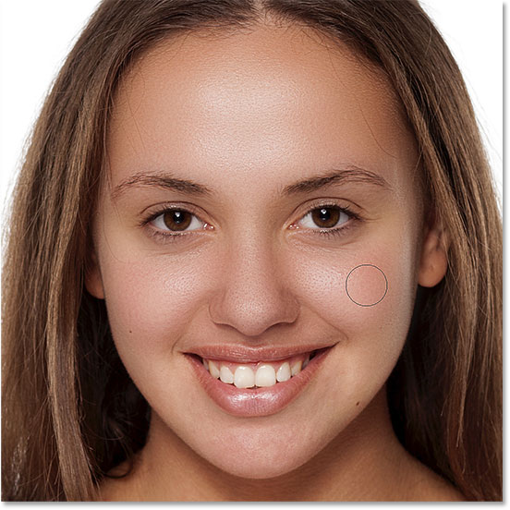

Revealing more of the softening effect, but just over the skin.

To finish things off, I'll paint around her mouth and over her chin, being careful to avoid her lips:

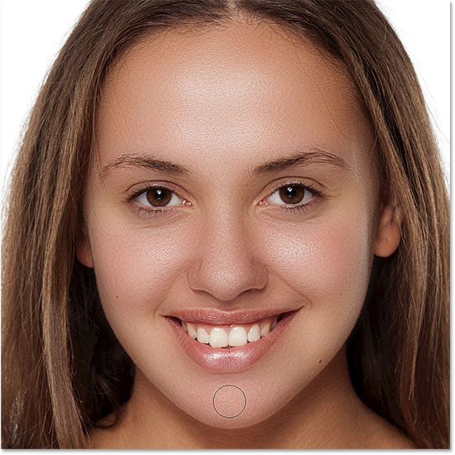

Revealing the skin softening effect over the lower portion of her face.

#### Viewing The Layer Mask

If you want to see exactly where you've painted, you can view the layer mask itself in the document by pressing and holding your **Alt** (Win) / **Option** (Mac) key and clicking on the **mask thumbnail** in the Layers panel:

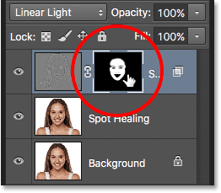

Holding Alt (Win) / Option (Mac) and clicking the layer mask thumbnail.

Your image will temporarily be replaced by the mask. The white areas are where you've painted. It looks a little creepy, but this can be a handy way of checking to make sure you haven't missed any spots. You can even paint directly on the mask if you need to. To switch back to your image, just press and hold Alt (Win) / Option (Mac) and click again on the mask thumbnail in the Layers panel:

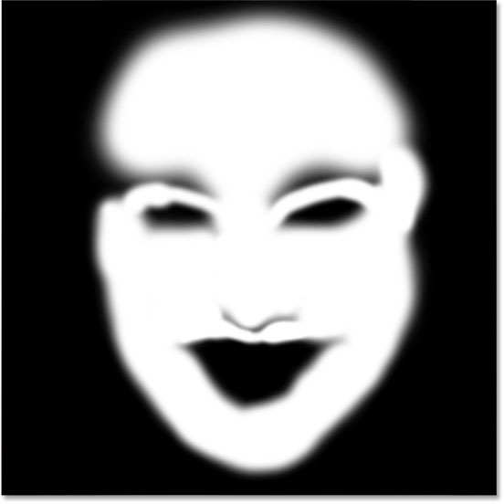

Use the mask view to look for any areas you missed.

#### Step 15: Lower The Layer Opacity

Finally, the skin softening effect is usually too intense at this point. To reduce it, simply lower the opacity of the Soften Skin layer. You'll find the **Opacity** option directly across from the Blend Mode option at the top of the Layers panel. In general, an opacity value of between 40% and 60% works best, but it will depend on your image. For my image, I'll set the opacity to **50%**:

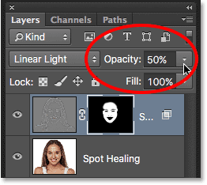

Lowering the opacity of the skin softening effect to 50%.

And with that, we're done! Here, after lowering the opacity, is my final skin softening result:

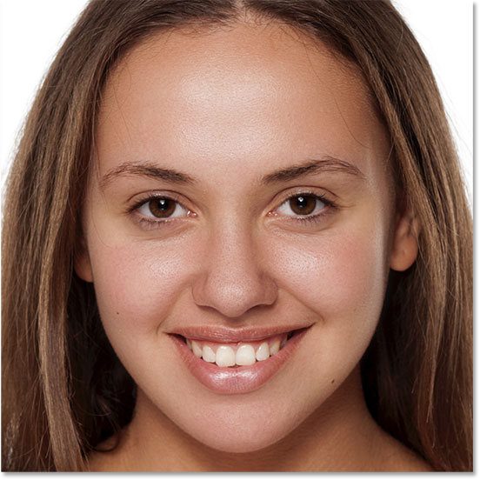

The final result.

And there we have it! That's how to remove unwanted blemishes, and then how to smooth and soften skin, in Photoshop! Looking for more portrait retouching tutorials? Learn more about the [Spot Healing Brush](http://www.photoshopessentials.com/photo-editing/spot-healing-brush/), or how to [reduce wrinkles](http://www.photoshopessentials.com/photo-editing/healing-brush/) with the Healing Brush. Or check out our [Photo Retouching](http://www.photoshopessentials.com/photo-editing/) section for more retouching tutorials!

In this tutorial, we'll learn how to use the Spot Healing Brush in Photoshop to quickly and easily remove acne and other minor skin blemishes from an image.

The Spot Healing Brush is basically a texture replacement tool. It takes damaged or unwanted texture from one area and replaces it with good texture from another area. It then blends the good texture in with the problem area's original tone and color to produce seamless results.

It works a lot like the regular Healing Brush in Photoshop, but what makes the Spot Healing Brush such an amazing and time-saving tool is that it does what it does with almost no effort from us!

If you're familiar with the [Healing Brush](http://www.photoshopessentials.com/photo-editing/healing-brush/), you know that for it to work, we need to tell the Healing Brush which area of good texture to use to replace the bad texture. But the Spot Healing Brush makes the decision all on its own. In most cases, all we need to do is click on a problem area with the Spot Healing Brush and Photoshop repairs it instantly, almost like magic!

It works by choosing good texture from the area surrounding the spot we clicked on, and it usually does a great job as long as we remember that the name of the tool is the Spot Healing Brush, not the Huge Problem Area Healing Brush or the Click And Drag Me All Over The Image And Expect Miracles Healing Brush. The Spot Healing Brush works best on, well, little spots. In this tutorial, we'll learn how to use it to quickly and effortlessly remove pimples and other minor skin blemishes, but the Spot Healing Brush also works great at removing things like dust, dirt and mold, and repairing small scratches. Let's see how it works.

This tutorial is for **Photoshop CS6** (the version I'm using here) and is also fully compatible with **Photoshop CC**. If you're using Photoshop CS5, you can still follow along, or you may wish to check out the [original version](http://www.photoshopessentials.com/photo-editing/removing-skin-blemishes-spot-healing-brush/) of this tutorial. Photoshop CS4 and earlier users will also want to check out the original version.

#### Making The Spot Healing Brush Even Faster With Keyboard Shortcuts

The Spot Healing Brush works fast, but learning a few simple keyboard shortcuts before we begin will speed things up even more. To zoom in on the image, press and hold **Ctrl+spacebar** (Win) / **Command+spacebar** (Mac) to temporarily access the **Zoom Tool**, then click on the spot where you need to zoom in. To zoom out, hold down **Alt+spacebar** (Win) / **Option+spacebar** (Mac) and click. To pan around inside the image while you're zoomed in, hold down the **spacebar** by itself to temporarily switch to Photoshop's **Hand Tool**, then click and drag to move the image around.

**Learn More:** [Image Navigation Essentials – Zooming And Panning In Photoshop](http://www.photoshopessentials.com/basics/image-navigation-essentials-zooming-panning-photoshop/)

For best results with the Spot Healing Brush, you'll want your brush to be slightly larger than the area you're trying to fix. This means you'll usually need to change your brush size quite often as you make your way from one problem spot to the next. The fastest way to change your brush size is with the left and right bracket keys on your keyboard. Press the **left bracket key** ( **[** ) repeatedly to make the brush smaller or the **right bracket key** ( **]** ) to make it larger. Also, since the Spot Healing Brush chooses the replacement texture on its own, sometimes it makes a mistake. When it does, simply undo your last step by pressing **Ctrl+Z** (Win) / **Command+Z** (Mac) on your keyboard, then try again.

For this tutorial, I'll be using the Spot Healing Brush to quickly remove some distracting pimples from the girl's face in the photo below, but the method is the same no matter what it is you're trying to remove or repair as long as the area is small enough for the Spot Healing Brush to be effective. Here's the photo I'll be working with ([acne on face photo](http://www.shutterstock.com/pic-82534531/stock-photo-image-of-acne-on-face.html) from Shutterstock):

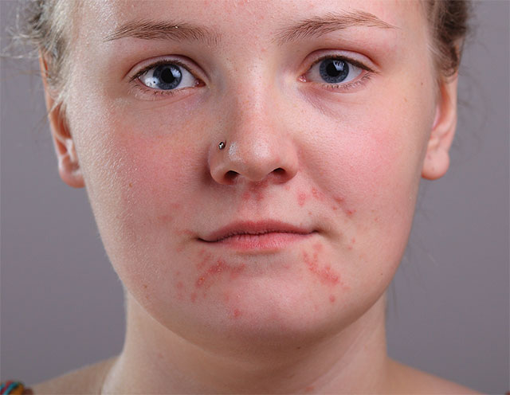

A teenager with typical teenage skin problems.

And here's what she'll look like when we're done:

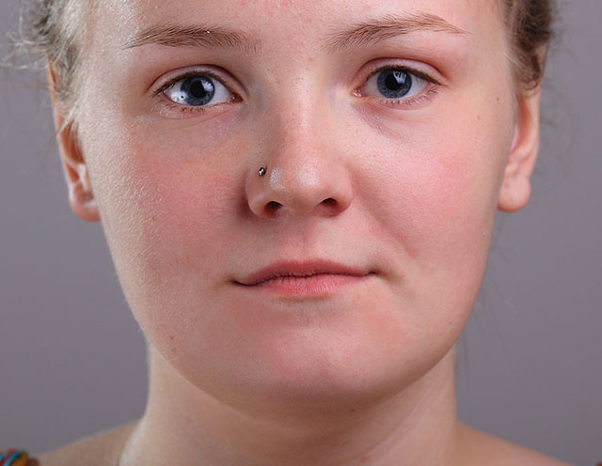

The final result.

Let's get started!

[Download our tutorials as print-ready PDFs!](http://www.photoshopessentials.com/print-ready-pdfs/)

#### Step 1: Add A New Blank Layer

With the photo newly opened in Photoshop, we can see in the [Layers panel](http://www.photoshopessentials.com/basics/layers/layers-panel/) that we currently have one layer, the [Background layer](http://www.photoshopessentials.com/basics/layers/background-layer/), which holds our image:

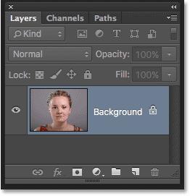

The Layers panel showing the original image on the Background layer.

Even though our goal is to make the photo look better, we still want to protect the original, so let's add a new blank layer above the Background layer. We'll do all of our spot healing work on this separate layer. Press and hold the **Alt** (Win) / **Option** (Mac) key on your keyboard and click the **New Layer** icon at the bottom of the Layers panel:

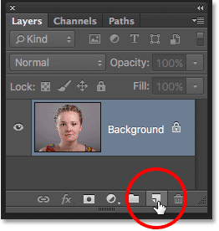

Clicking the New Layer icon while holding Alt (Win) / Option (Mac).

Pressing and holding the Alt (Win) / Option (Mac) key while clicking the New Layer icon tells Photoshop to first open the **New Layer** dialog box where we can name the new layer before it's added. Let's name the layer "Spot Healing". Click OK when you're done to close out of the dialog box:

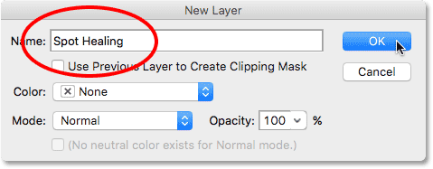

Naming the layer in the New Layer dialog box.

If we look again in the Layers panel, we see the new Spot Healing layer sitting above the image:

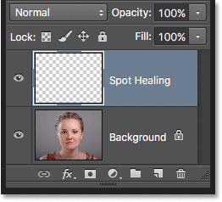

The Layers panel showing the Spot Healing layer.

#### Step 2: Select The Spot Healing Brush

Select the **Spot Healing Brush** from the Tools panel. You'll find it grouped in with Photoshop's other healing tools. If one of the other tools is showing in place of the Spot Healing Brush, simply **right-click** (Win) / **Control-click** (Mac) on the tool and then choose the Spot Healing Brush from the fly-out menu:

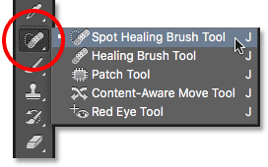

The Spot Healing Brush is grouped in with the other healing tools.

#### Step 3: Select The "Sample All Layers" Option

By default, the Spot Healing Brush works only with the layer that's currently selected in the Layers panel. Since our currently-selected layer (the Spot Healing layer) is blank, that would cause us some problems. All we'd be able to do is replace nothing with different nothing. We need to tell Photoshop to look at the image on the Background layer as well. To do that, select the **Sample All Layers** option in the Options Bar along the top of the screen:

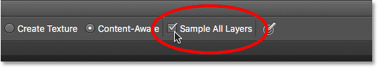

Selecting the "Sample All Layers" option in the Options Bar.

#### Step 4: Select "Content-Aware"

Next, we want to make sure that the **Type** option is set to **Content-Aware** which it should be by default. The Content-Aware feature, which was first added to the Spot Healing Brush in CS5, allows Photoshop to make more intelligent decisions when choosing good replacement texture for the problem area you've clicked on:

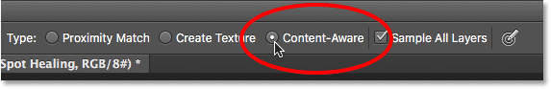

The Content-Aware option for the Spot Healing Brush.

#### Step 5: Click On The Problem Spots To Heal Them

With the Spot Healing Brush in hand, and "Sample All Layers" and "Content-Aware" selected, all we need to do now is click on problem areas in the image to fix them. I'll zoom in on an area of the girl's face so I can see the problem spots more clearly. Then, I'll move my brush cursor over one of the pimples and adjust my brush size using the left and right bracket keys so that the cursor (the black circular outline) is just slightly larger than the pimple itself:

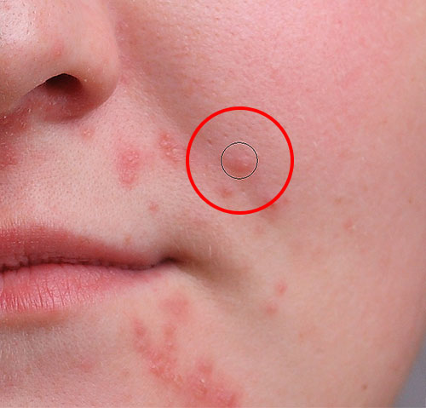

Use the keyboard shortcut to make the brush cursor a bit larger than the problem spot.

I'll click on the pimple with the Spot Healing Brush, and just like that, it's gone, replaced with good texture from the surrounding area:

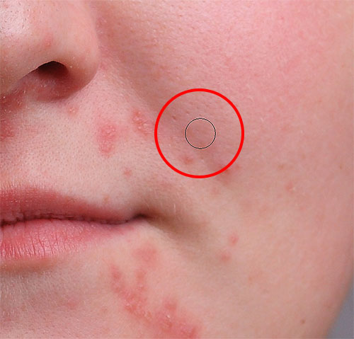

One click is all it took to remove the pimple.

As I mentioned earlier, sometimes the Spot Healing Brush can make a mistake, so if that happens, just press **Ctrl+Z** (Win) / **Command+Z** (Mac) to undo it and try again. Each time you try again, you'll get a different result. I'll continue clearing up other pimples in the area by moving my brush over them, adjusting its size with the left and right bracket keys, and clicking:

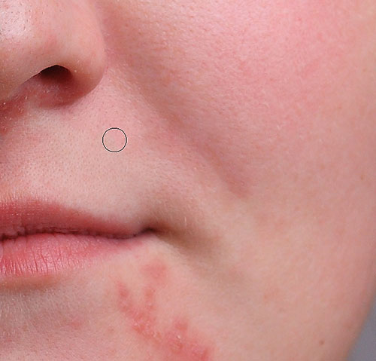

More pimples have been cleared up with just a few simple clicks of the mouse.

Let's move down to her chin where we see some larger problem areas:

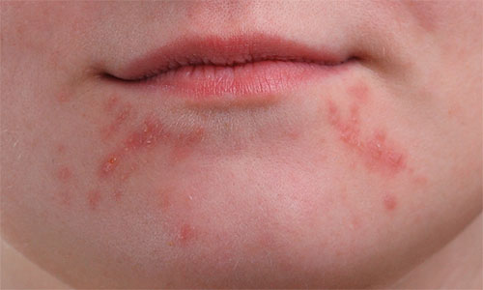

Larger clusters of pimples can be a bit more of a challenge.

To retouch these areas, I'll start by clicking on the smaller, isolated pimples to heal them first and get them out of the way:

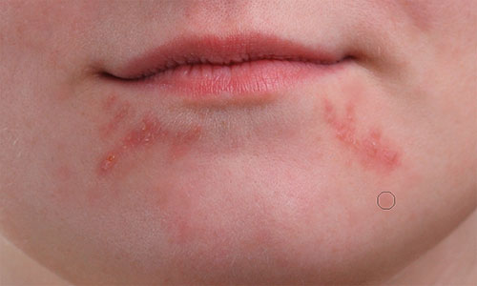

Removing the isolated pimples before moving on to the larger areas.

Then, rather than trying to fix a large area with a super wide brush and a single click, I'll approach and retouch it in smaller sections, beginning from the outside and making my way inward. Along with clicking the Spot Healing Brush, you can also click and drag in short strokes. As you drag, your brush stroke will appear black:

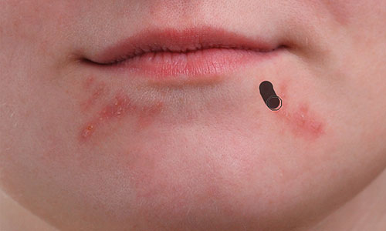

Dragging a short brush stroke across the area.

Release your mouse button and Photoshop heals the area with surrounding texture:

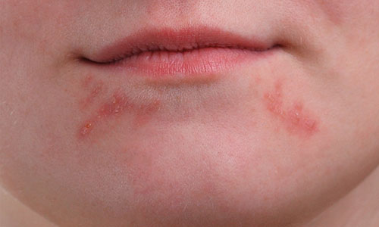

Releasing the brush to let the Spot Healing Brush do its thing.

I'll continue clicking and dragging over the area one small section at a time, going back over any problem spots as needed with additional clicks, and after just a couple of minutes worth of effort, Photoshop was able to do a pretty good job:

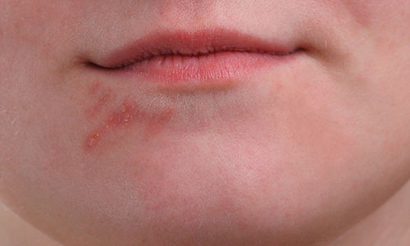

The area on the right is now looking a lot better.

I'll do the same thing for the area on the other side, using a small brush and a series of clicks and short brush strokes to tackle the area a little at a time. Here's the result, again after just a couple of minutes worth of effort:

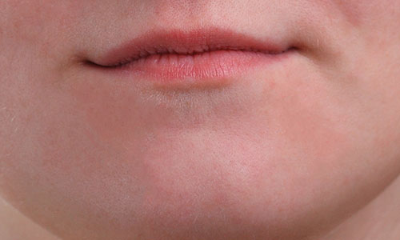

Her chin is now pimple-free thanks to the Spot Healing Brush.

There's one larger problem area remaining, and it's directly under her nose:

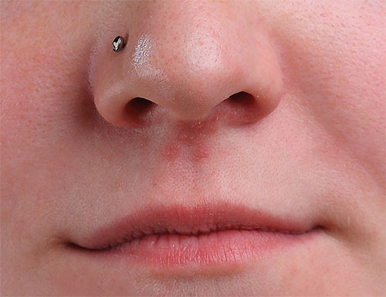

A few more pimples left to retouch.

Once again, I'll start by clicking on the individual, isolated pimples to heal them, keeping my brush just slightly larger than the pimple itself:

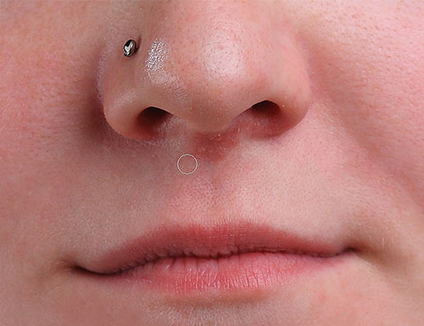

Healing the smaller areas first.

Then I'll use a combination of clicking and dragging with a small brush to heal the remaining area:

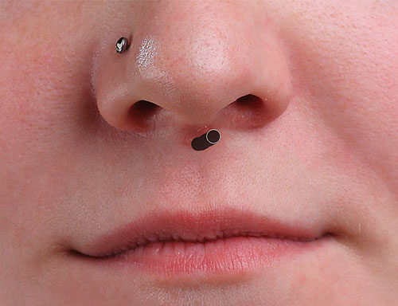

Clearing up the last of the pimples.

The area is now pimple-free, with healthy skin texture in its place:

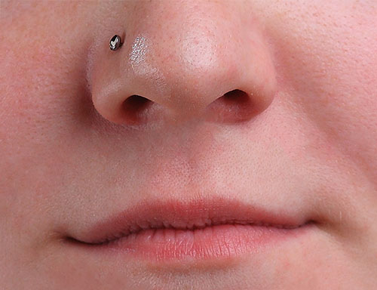

Another great job by the Spot Healing Brush.

#### The Lighten Brush Mode

If you’re using the Spot Healing Brush to remove acne or other skin problems as I am here, you’ll often get even better results by changing the **Brush Mode** in the Options Bar from Normal (the default setting) to **Lighten**:

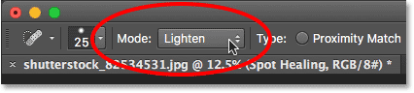

Try the Lighten brush mode when fixing skin problems.

With the brush mode set to Lighten, Photoshop will only replace pixels that are darker than the good texture data. Since pimples and other skin blemishes are usually darker than normal skin tone, only the pimple or blemish itself gets replaced, leaving more of the original image surrounding it intact. If a blemish happens to be lighter than the normal skin tone, try the **Darken** mode instead. You can quickly switch between all of the brush modes for the Spot Healing Brush from your keyboard by holding down the Shift key and pressing the + or - keys.

For comparison, here once again is what the photo looked like originally:



The original, untouched image.

And here's our final result:



The final result.

And there we have it! That's how to clear up acne and remove minor skin blemishes, leaving healthy looking skin in their place, using the Spot Healing Brush in Photoshop! Now that you know how the Spot Healing Brush works, take your skills to the next level by learning [how to smooth and soften skin](http://www.photoshopessentials.com/photo-editing/smooth-skin/) in a portrait, or how to [reduce the appearance of wrinkles](http://www.photoshopessentials.com/photo-editing/healing-brush/)! Or, check out our [Photo Retouching](http://www.photoshopessentials.com/photo-editing/) section for more image editing tutorials!

#### Step 1: Duplicate The Background Layer

With my image newly opened in Photoshop, if we look in my [Layers panel](http://www.photoshopessentials.com/basics/layers/layers-panel/), we see the photo sitting on the [Background layer](http://www.photoshopessentials.com/basics/layers/background-layer/), currently the only layer in my document:

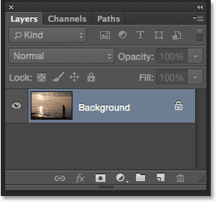

The Layers panel showing the photo on the Background layer.

The first thing we need to do for our soft glow effect is make a copy of the Background layer, and the easiest way to do that is to click on the Background layer and drag it down onto the **New Layer** icon at the bottom of the Layers panel (it's the second icon from the right):

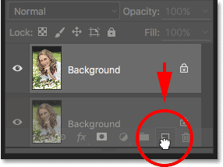

Dragging the Background layer onto the New Layer icon.

Release your mouse button when your hand cursor is directly over the New Layer icon. Photoshop will make a copy of the Background layer, name the new layer "Background copy" and place it above the original:

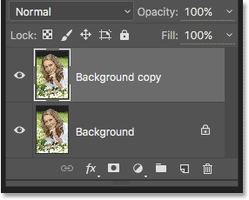

The "Background copy" layer appears above the original Background layer.

#### Step 2: Rename The New Layer

It's always a good idea to rename layers in your Layers panel so you have a better sense of what's on each layer and what it's being used for. Let's give the "Background copy" layer a more descriptive name. To rename a layer, simply double-click directly on its name in the Layers panel. This will highlight the current name:

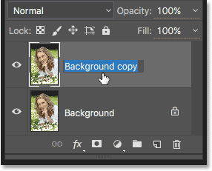

Double-clicking on the name "Background copy" to highlight it.

Since we'll be using this layer to create our soft glow effect, let's name it "Soft Glow". Press **Enter** (Win) / **Return** (Mac) on your keyboard when you're done to accept the name change:

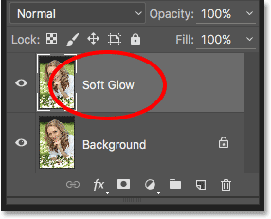

The "Background copy" layer is now the "Soft Glow" layer.

#### Step 3: Apply The Gaussian Blur Filter

To create the actual soft glow effect, we'll first apply some blurring to the "Soft Glow" layer. Then we'll change the way the blurred layer mixes with the original image below it by changing its blend mode.

To blur the layer, we'll use Photoshop's Gaussian Blur filter. Go up to the **Filter** menu in the Menu Bar along the top of the screen, choose **Blur**, and then choose **Gaussian Blur**:

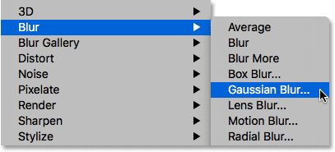

Going to Filter > Blur > Gaussian Blur.

This opens the Gaussian Blur dialog box, which lets us control the amount of blur being applied to the layer using the **Radius** slider along the bottom. The further you drag the slider to the right, the stronger the blur effect will appear. Photoshop gives us a live preview of the effect in the document, so keep an eye on your image as you drag the slider to judge the results.

We don't want to blur the image so much that our subject becomes unrecognizable. We're just trying to soften things up a bit, so lower radius values tend to work best. Keep in mind, though, that the blur amount that works best for your specific image may be different from mine and will depend a lot on its size, with larger photos needing more blurring than smaller ones. Generally, for a subtle glow effect, a radius value of somewhere around **10 pixels** should work well:

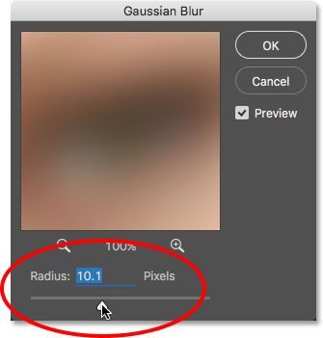

For a subtle glow, use smaller radius values.

Here's what my blur effect looks like with a radius value of 10 pixels. Notice that while the photo looks softer than it did before, we can still make out plenty of detail. We'll see even more detail once we change the layer's blend mode in the next step:

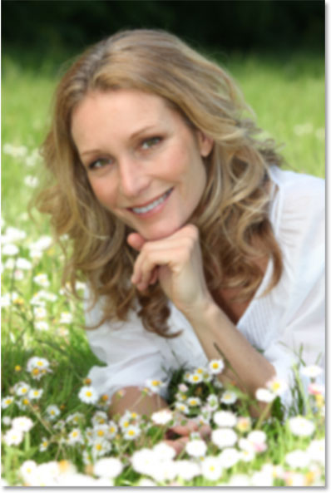

The blurring effect with a radius of 10 pixels.

For an even softer, more dream-like glow effect, try a larger radius value of around **20 pixels**:

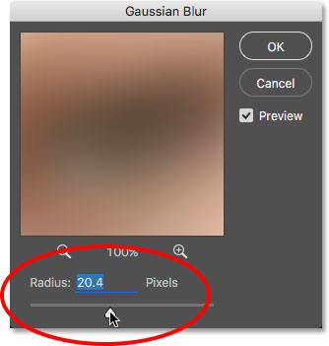

For a more dream-like glow, use a larger radius value.

Here's my blurring effect using a 20 pixel radius. We can still make out detail in the photo, but the blurring is definitely stronger this time. Choosing the right amount of blur is really a personal choice and will depend on the image. In my case, I think this is too much so I'll go with the smaller 10 pixel radius. When you're happy with the results, click **OK** to close out of the Gaussian Blur dialog box:

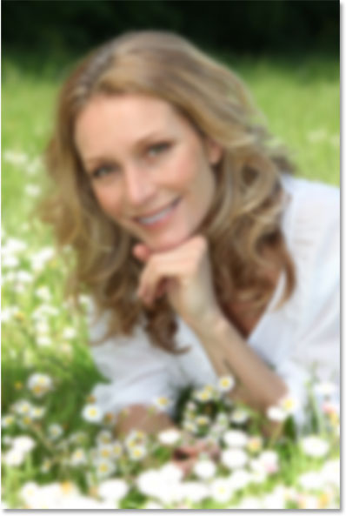

The blurring effect with a radius of 20 pixels.

#### Step 4: Change The Blend Mode To Soft Light

Now that we've blurred the "Soft Glow" layer, let's change the way it interacts with the original image on the Background layer below it. We do that by changing its **blend mode**. You'll find the Blend Mode option in the upper left of the Layers panel. By default, it's set to Normal. Click on the word "Normal" to bring up a menu of other blend modes and choose **Soft Light** from the list:

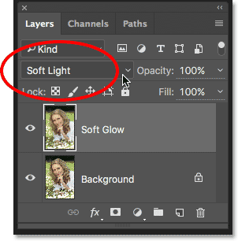

Changing the layer blend mode from Normal to Soft Light.

The Soft Light blend mode in Photoshop does two things; it boosts the overall contrast in the image, and it enhances the colors, making them appear more vibrant. Here's my image with the blend mode set to Soft Light, giving everything a warm, subtle glow:

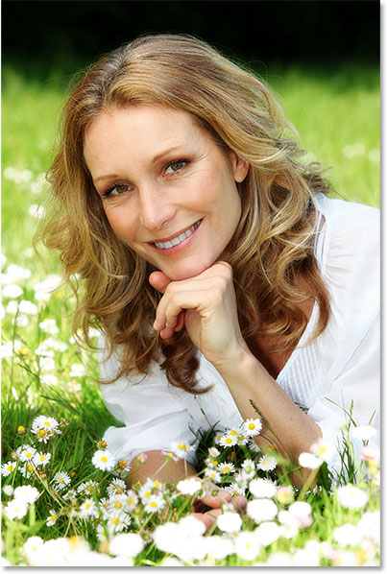

The effect using the Soft Light blend mode.

For a stronger effect, try the **Overlay** blend mode instead. The Overlay blend mode is very similar to Soft Light, boosting contrast and color, but where Soft Light is more subtle, Overlay is more intense:

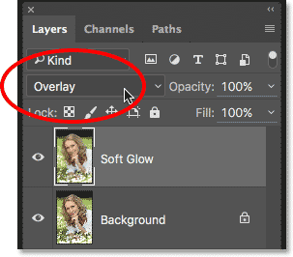

Changing the blend mode from Soft Light to Overlay.

Here's my result with the Overlay blend mode. Overlay may work better with a different image, but in this case, it's too strong so I'll go with Soft Light instead:

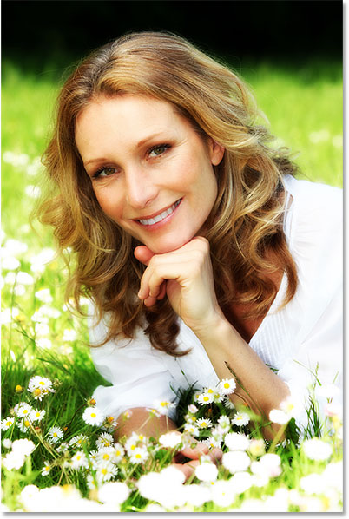

The result using the Overlay blend mode.

#### Step 5: Lower The Layer Opacity

To fine-tune the effect, simply lower the layer's **opacity**. You'll find the Opacity option in the upper right of the Layers panel, directly across from the Blend Mode option. The default opacity value is 100%. The more you lower it, the more the original photo below the "Soft Glow" layer will show through. In other words, we’ll see more of the original image and less of the blurred image.

To change the opacity value, click on the small arrow to the right of the current value, then drag the slider. I'll lower mine to around **75%**, but again, you'll want to keep an eye on your image as you drag the slider to judge the results:

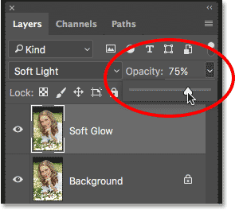

Lowering the opacity of the "Soft Glow" layer.

Here, after lowering the opacity, is my final soft glow effect:

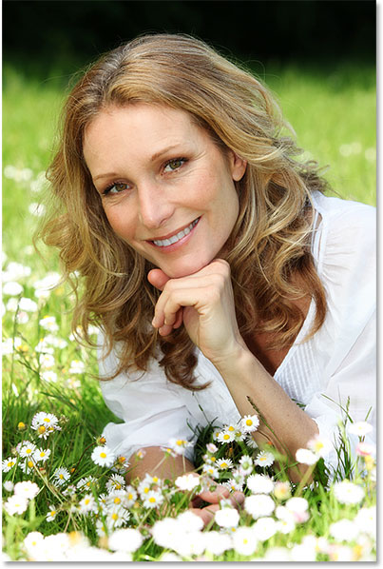

The final result.

And there we have it! That's the quick and easy way to add a soft glow effect to an image with Photoshop!

But, now that I'm done, well, what if I don't really like the result? I went with a subtle glow, but what if a stronger, more "dreamy" glow would have worked better? How can I go back and change it? I mean, I can easily change the blend mode from Soft Light to Overlay (and vice versa), and I can try changing the layer's Opacity value, but that's not really what I want to do. I want to go back and adjust the amount of blurring I applied with the Gaussian Blur filter way back in Step 3. How do I do that?

The short answer is, I can't, and that's where the problem with this way of creating the soft glow effect comes in. As soon as we clicked OK to close out of the Gaussian Blur filter, we committed the blur effect to the layer. In other words, we made a permanent change, or at least, one that can't easily be undone. A better way to work would be to keep the entire effect, including the Gaussian Blur filter, fully editable from start to finish. That way, even after the effect is completed, we could still go back and try different blur amounts to make sure we're getting the best result possible.

So how do we do that? We do it by taking advantage of Photoshop's powerful **Smart Objects** and **Smart Filters**. They may sound intimidating, but they're actually very simple to use. In fact, they're every bit as easy to use as normal layers and filters in Photoshop, but they give us much more flexibility.

In the next tutorial, we'll learn how to create this exact same soft glow effect while keeping every step completely editable. So if you're ready to take your Photoshop skills to the next level, head on over to the [Editable Soft Glow With Smart Filters](http://www.photoshopessentials.com/photo-editing/soft-glow-with-smart-filters-in-photoshop/) tutorial. See you there!

# How To Use Blend Modes With Color Channels In Photoshop

**[](http://www.facebook.com/sharer.php?u=http://www.photoshopessentials.com/photo-editing/apply-image-cs6/&t=How%20To%20Use%20Blend%20Modes%20With%20Color%20Channels%20In%20Photoshop&s=100&p%5burl%5d=http://www.photoshopessentials.com/photo-editing/apply-image-cs6/&p%5bimages%5d%5b0%5d=http://www.photoshopessentials.com/newsite/wp-content/uploads/2012/10/apply-image-80j.jpg&p%5btitle%5d=How%20To%20Use%20Blend%20Modes%20With%20Color%20Channels%20In%20Photoshop)[](https://twitter.com/intent/tweet?url=http://www.photoshopessentials.com/photo-editing/apply-image-cs6/&text=Hey%20check%20this%20out)[](https://plus.google.com/share?url=http://www.photoshopessentials.com/photo-editing/apply-image-cs6/)[](http://pinterest.com/pin/create/button/?url=http://www.photoshopessentials.com/photo-editing/apply-image-cs6/&media=http://www.photoshopessentials.com/newsite/wp-content/uploads/2012/10/apply-image-80j.jpg&description=How%20To%20Use%20Blend%20Modes%20With%20Color%20Channels%20In%20Photoshop)[](http://www.facebook.com/sharer.php?u=http://www.photoshopessentials.com/photo-editing/apply-image-cs6/&t=How%20To%20Use%20Blend%20Modes%20With%20Color%20Channels%20In%20Photoshop&s=100&p%5burl%5d=http://www.photoshopessentials.com/photo-editing/apply-image-cs6/&p%5bimages%5d%5b0%5d=http://www.photoshopessentials.com/newsite/wp-content/uploads/2012/10/apply-image-80j.jpg&p%5btitle%5d=How%20To%20Use%20Blend%20Modes%20With%20Color%20Channels%20In%20Photoshop)[](https://twitter.com/intent/tweet?url=http://www.photoshopessentials.com/photo-editing/apply-image-cs6/&text=Hey%20check%20this%20out)[](https://plus.google.com/share?url=http://www.photoshopessentials.com/photo-editing/apply-image-cs6/)[](http://pinterest.com/pin/create/button/?url=http://www.photoshopessentials.com/photo-editing/apply-image-cs6/&media=http://www.photoshopessentials.com/newsite/wp-content/uploads/2012/10/apply-image-80j.jpg&description=How%20To%20Use%20Blend%20Modes%20With%20Color%20Channels%20In%20Photoshop)**

Written by Steve Patterson. In this tutorial, we'll look at how to enhance the contrast and color of an image in unique and creative ways by learning how to apply **blend modes** to a photo's individual **color channels**. If you've been using Photoshop for a while, you know that we usually select blend modes from the Layers panel because they're most often used to change how a layer interacts, or blends, with the layer(s) below it. Here, we'll learn how we can take things even further by applying those same blend modes not to an entire layer but to the individual **RGB** (**Red**, **Green** and **Blue**) color channels that Photoshop uses to create our full color image. How do we apply blend modes to color channels? As we'll see, it's actually very simple and easy thanks to Photoshop's **Apply Image** command.

Working with color channels in Photoshop is a bit of an advanced topic. I'll briefly cover them here as we go along, but I highly recommend reading through our [RGB and Color Channels Explained](http://www.photoshopessentials.com/essentials/rgb/) tutorial first if they're brand new to you. You'll find it in our [Digital Photo Essentials](http://www.photoshopessentials.com/essentials/) section of the website. That way, you'll have a better sense of what's going on as we work inside the Apply Image dialog box. To learn more about blend modes, be sure to read through our popular [Five Essential Blend Modes For Photo Editing](http://www.photoshopessentials.com/photo-editing/layer-blend-modes/) tutorial where you'll find a detailed explanation of how the most commonly used blend modes in Photoshop work.

[Download our tutorials as print-ready PDFs!](http://www.photoshopessentials.com/print-ready-pdfs/)

I'll be using Photoshop CS6 for this tutorial but any recent version of Photoshop will do. Here's a [photo](http://www.fotolia.com/partner/202479569) I currently have open on my screen:

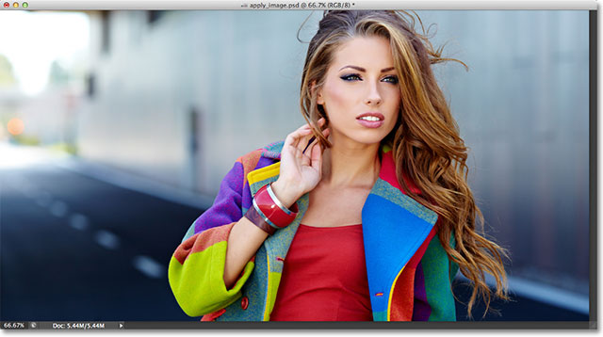

The original photo.

The first thing we need to do before we go any further is make a copy of our image. If we look in my [Layers panel](http://www.photoshopessentials.com/basics/layers/layers-panel/), we see my original photo sitting all by itself on the [Background](http://www.photoshopessentials.com/basics/layers/background-layer/) layer:

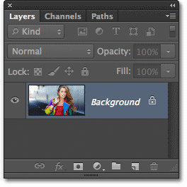

The Layers panel showing the image on the Background layer.

Let's quickly duplicate the Background layer using a handy shortcut. Press **Ctrl+Alt+J** (Win) / **Command+Option+J** (Mac) on your keyboard. This tells Photoshop not only to create a copy of the layer but to first pop open the **New Layer** dialog box so we can name the new layer before it's added. Name the layer "Apply Image", then click OK to close out of the dialog box:

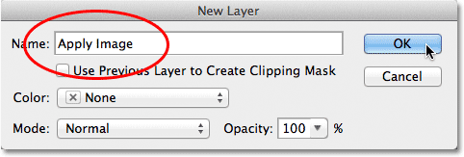

The New Layer dialog box.

If we look again in my Layers panel, we see a copy of the image sitting on the new "Apply Image" layer directly above the Background layer. It's always best to give layers descriptive names like this, otherwise we're stuck with the generic names Photoshop gives them, like "Layer 1", which tells us nothing about what the layer is being used for:

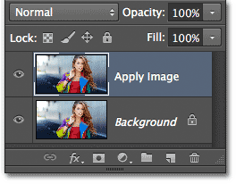

A copy of the image appears on the Apply Image layer.

As I mentioned at the beginning of the tutorial, we usually select blend modes from the Layers panel because we normally apply them to an entire layer. The Blend Mode option is found in the upper left corner of the Layers panel. As a quick example, I'll change the blend mode of my Apply Image layer from Normal (the default) to **Soft Light**:

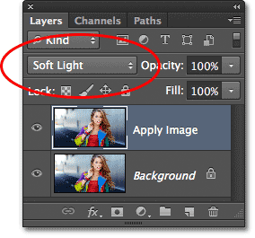

Changing the layer blend mode to Soft Light.

This changes how the Apply Image layer interacts with the Background layer below it. Soft Light is part of the [Contrast group of blend modes](http://www.photoshopessentials.com/photo-editing/layer-blend-modes/) because it increases the overall contrast of the image, as we can see with my photo. Color saturation has also been given a slight boost:

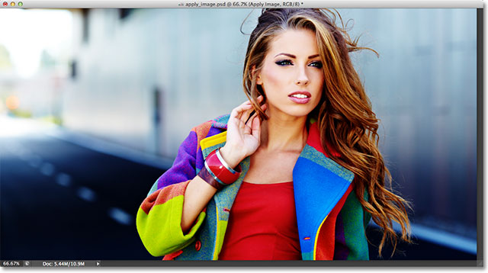

The photo after changing the layer blend mode to Soft Light.

I'll change my blend mode to **Normal** to switch it back to the default setting:

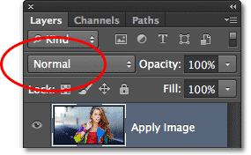

Changing the blend mode back to Normal.

So if changing the blend mode in the Layers panel is great for blending layers together, where are these individual color channels, and how do we use blend modes with them? Well, to answer the first part of the question, if you look more closely at the top of your Layers panel, you'll see that it's actually grouped in with two other panels - Channels and Paths - with each panel having its own **name tab** along the top. Click on the **Channels** name tab:

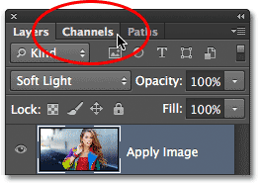

Clicking on the Channels name tab.

This switches us to the Channels panel where we can see the individual **Red**, **Green** and **Blue** color channels that make up our image. The **RGB** channel at the top isn't really a channel. It's the result of the Red, Green and Blue channels being merged together, or in other words, it's what we see as the full color version of our image (every color in the image is made from some combination of red, green and blue):

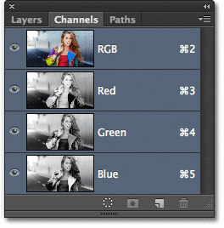

We can find the individual color channels in the Channels panel.

We can select an individual color channel simply by clicking on it. I'll click on the Red channel to select it:

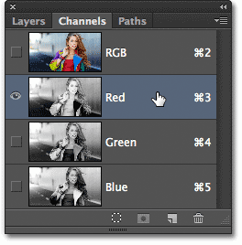

Selecting the Red channel.

Selecting the Red channel temporarily turns off the Green and Blue channels and lets us see the Red channel on its own in the document window. Photoshop displays color channels as **grayscale images**, and each channel gives us a different looking grayscale image. Here's what my Red channel looks like in the document window. If you compare this grayscale version with the original full color version, you'll notice that areas that contained lots of red in the full color version appear lighter in this grayscale version, while areas that contained little or no red appear darker:

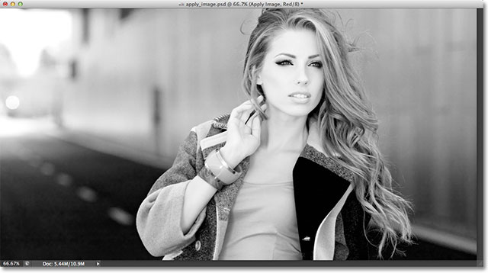

The Red channel's grayscale image.

Next, I'll click on the Green channel in the Channels panel to select it, which temporarily turns off the Red and Blue channels:

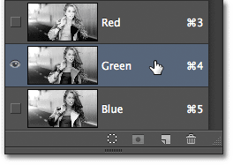

Selecting the Green channel.

The Green channel is now displayed as a grayscale image in the document window. Notice that it looks considerably different from the Red channel. Again, if you were to compare it with the original full color version, you'd notice that areas that contained lots of green appear lighter in this grayscale version, while areas with little or no green appear darker:

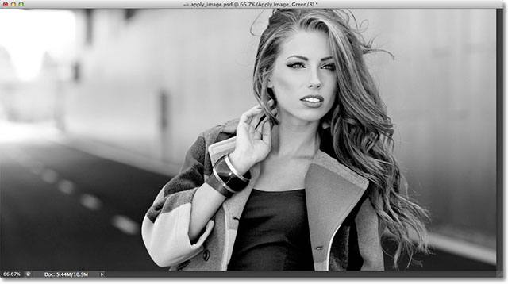

The Green channel's grayscale image.

Finally, I'll click on the Blue channel in the Channels panel to select it, which turns off the Red and Green channels:

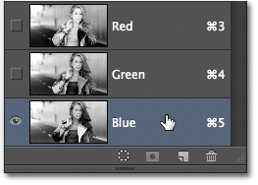

Selecting the Blue channel.

And now we see the Blue channel in the document window, which again gives us a different looking grayscale version from the Red and Green channels. This time, the more blue an area contained in the full color version, the lighter it appears in the grayscale version, while areas with little or no blue appear darker. When we choose an individual color channel in the Apply Image dialog box, as we'll do in a moment, keep in mind that it's actually these different grayscale versions of the image, with their different brightness values, that we're selecting:

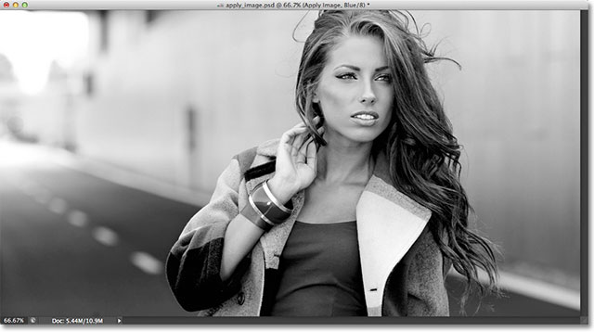

The Blue channel's grayscale image.

To switch back to the full color version of the image, click on the **RGB** channel at the top of the Channels panel. This turns all three color channels back on:

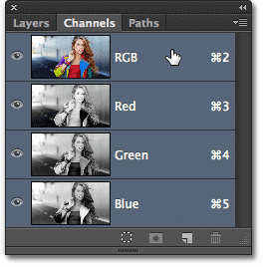

Selecting the composite RGB channel.

And we're back to seeing the full color version of the image once again:



The full color version of the photo re-appears in the document window.

#### The Apply Image Command

Now that we know where to find the color channels and what each one looks like as a grayscale image, let's answer the second part of the question - how do we apply blend modes to them? You may have noticed that there is no Blend Mode option at the top of the Channels panel like there is with the Layers panel. In fact, we don't actually need the Channels panel open at all, so let's switch back over to the Layers panel by clicking on its name tab:

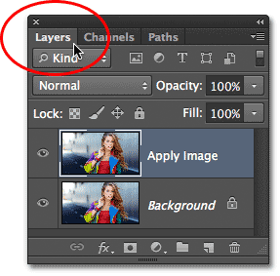

Switching back to the Layers panel.

To apply blend modes to individual color channels, we use Photoshop's Apply Image command. To get to it, go up to the **Image** menu in the Menu Bar along the top of the screen and choose **Apply Image**:

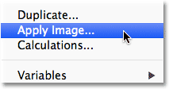

Go to Image > Apply Image.

This opens the Apply Image dialog box. It can look a bit intimidating if you've never used it before, but for what we're doing here, it's actually quite simple. In fact, there's really only two options we'll be using - **Channel** and **Blending**:

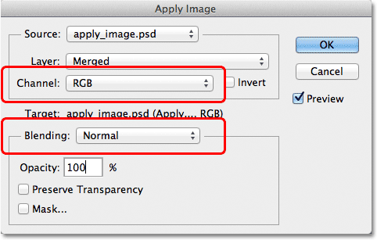

The Channel and Blending options in the Apply Image dialog box.

The Channel option is where we select the color channel we want to use. By default, it's set to **RGB** which, if you remember, was that RGB composite channel we saw at the top of the Channels panel (the one that blends the Red, Green and Blue channels together to create our full color image). The Blending option below it is where we select the blend mode we want to use. If we leave the Channel option set to RGB and simply choose a blend mode from the Blending option, we'll get the exact same result as if we had selected a blend mode from the Layers panel. For example, I'll select the **Soft Light** blend mode for the Blending option (with Channel set to RGB):

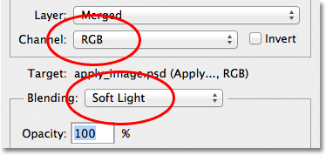

Leaving Channel set to RGB while changing Blending to Soft Light.

And here we see that my image looks no different than when I selected the Soft Light blend mode from the Layers panel earlier. We get the exact same boost in contrast and color saturation:

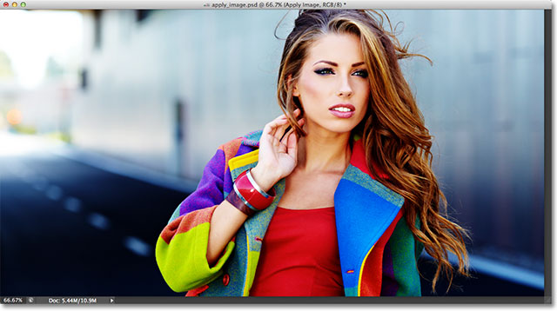

The Blending option works the same as the Blend Mode option in the Layers panel when Channel is set to RGB.

But here's where things get interesting. Instead of leaving the Channel option set to RGB, we can choose any of the three individual color channels. I'll leave my Blending option set to Soft Light but I'll change the Channel option from RGB to **Red** so I'm blending just the red color channel:

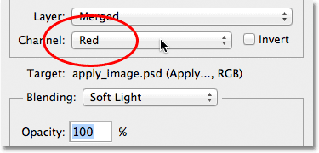

Selecting the Red color channel.

This time, we get something different. We're still seeing an overall boost in contrast with the Soft Light blend mode, but by blending only that grayscale image for the Red channel that we saw earlier, we get a different effect. The woman's skin looks much lighter than before. So does her hair, along with her red top and the areas of red, orange and yellow in her jacket. Basically, anything that contains lots of red now looks lighter. Likewise, areas that contain little or no red, like the blue and green areas of her jacket, appear darker than before:

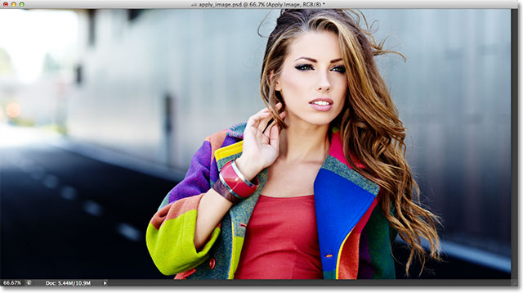

The effect of blending the Red color channel with the Soft Light blend mode.

Let's see what happens if I select the **Green** channel in the Channel option (with Blending still set to Soft Light):

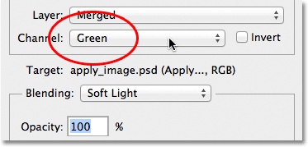

Switching from the Red channel to the Green channel.

With the Green channel selected, we get another variation on the effect. This time, areas with lots of green appear lighter, while areas with more red or blue in them look darker. The most immediately obvious difference is with the woman's skin which appears darker and with more detail than we saw with the Red channel:

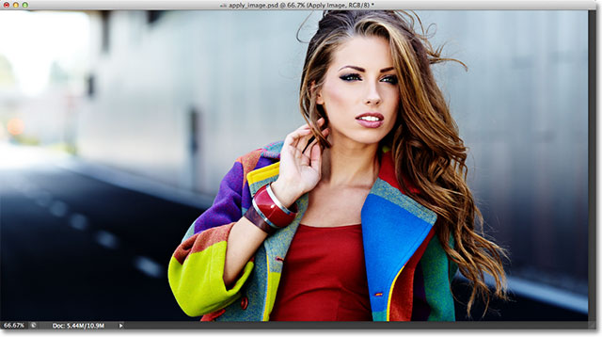

Blending the Green channel with Soft Light.

Next, I'll set the Channel option to **Blue**:

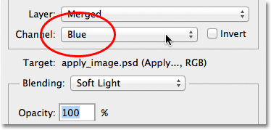

Selecting the Blue channel.

And here, we get a third variation, with areas of blue appearing lighter while areas with mostly red or green appearing darker. These variations of the effect wouldn't be possible (at least not without more time and effort) if we didn't have the access to the individual color channels that Photoshop's Apply Image command gives us:

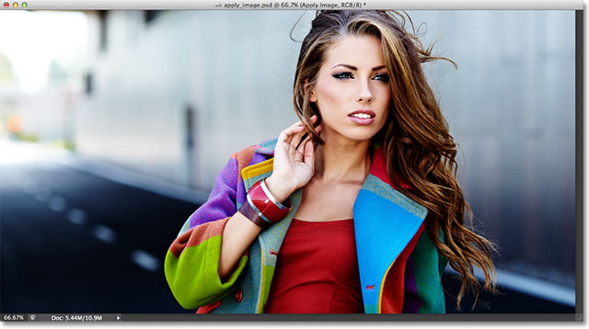

Each color channel gives us a unique variation of the effect.

Of course, we're not limited to using just the Soft Light blend mode with our color channels. We can use any of the blend modes we'd normally select from the Layers panel. I'll leave my Channel option set to Blue but I'll change my Blending option from Soft Light to **Overlay**:

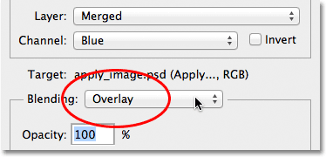

Selecting the Overlay blend mode for the Blue channel.

Like Soft Light, Overlay is a contrast-boosting blend mode but with a stronger, more intense result:

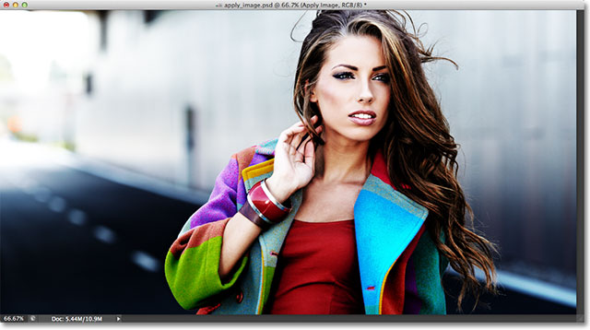

Blending the Blue channel with the Overlay blend mode.

Here's what the same Overlay blend mode gives us if we change the Channel option from Blue to **Green**:

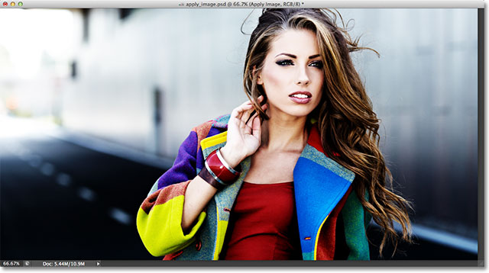

Blending the Green channel with Overlay.

And here's what the **Red** channel looks like with Overlay:

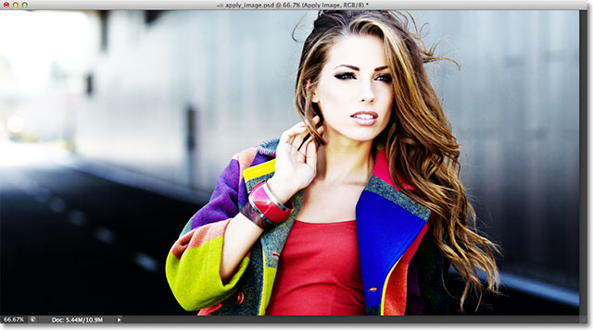

Blending the Red channel with Overlay.

The Red channel is looking too intense with the Overlay blend mode, but we can easily tone things down if needed simply by lowering the opacity of the blending. You'll find the **Opacity** option directly below the Blending option and it works the same way here as it does in the Layers panel. By default, it's set to 100%. I'll lower mine down to 60%:

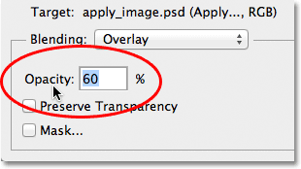

Lower the Opacity value to reduce the intensity of the blending effect.

With the opacity lowered, we've brought back some of the detail in the highlights and shadows:

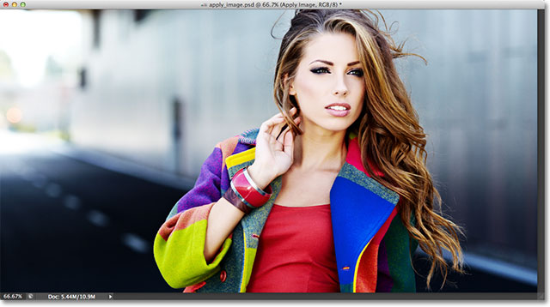

The image after lowering the opacity of the Overlay blend mode.

If, at any time, you want to compare what you're doing with the original version of the image, simply uncheck the **Preview** option over on the right side of the dialog box. This will hide the effect and let you see the original photo in the document window. Select the Preview option again to turn the effect preview back on:

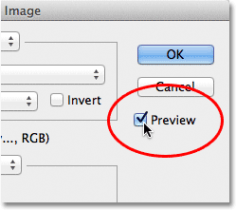

Turn the Preview option on and off to compare the current result with the original photo.

You'll most often find, especially when working with photos of people, that the Soft Light and Overlay blend modes will give you the best results, but a couple of other useful blend modes you'll want to try are **Screen** and **Multiply**. Screen will lighten everything in the image, while Multiply will darken everything. Try them out with each of the three color channels to see what you get, then fine-tune the effect by raising or lowering the opacity value. For example, here I've set my Channel to Green, the Blending option to Multiply, and I've lowered the Opacity value down to 40%:

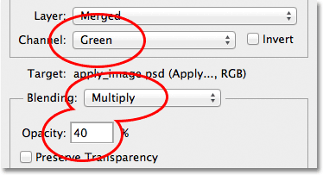

Channel = Green, Blending = Multiply, Opacity = 40%.

The result is darker, more detailed version of the image:

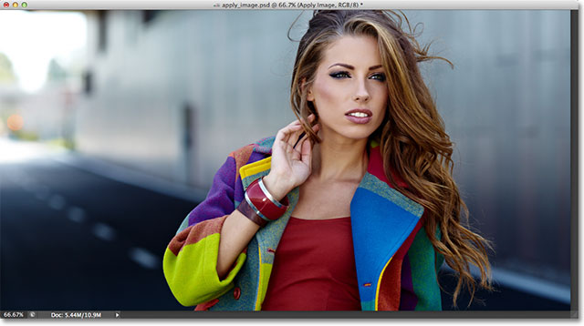

The Multiply blend mode is great for darkening the image. Try the Screen blend mode to lighten it.

When you're happy with the results, click OK to close out of the Apply Image dialog box. You can then compare the effect again with the original image in the document window by clicking on the **layer visibility icon** (the eyeball) on the far left of the Apply Image layer in the Layers panel. Click it once to turn the Apply Image layer off and view the original photo. Click it again to turn the Apply Image layer back on:

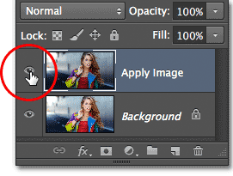

Toggle the layer visibility on and off to compare the final result with the original version.

And there we have it! That's how to apply blend modes to individual color channels using the Apply Image command in Photoshop! Check out our [Photo Retouching](http://www.photoshopessentials.com/photo-editing/) section for more Photoshop image editing tutorials!

# New And Improved Curves In Photoshop CS3

**[](http://www.facebook.com/sharer.php?u=http://www.photoshopessentials.com/photo-editing/photoshop-cs3-curves/&t=New%20And%20Improved%20Curves%20In%20Photoshop%20CS3&s=100&p%5burl%5d=http://www.photoshopessentials.com/photo-editing/photoshop-cs3-curves/&p%5bimages%5d%5b0%5d=http://www.photoshopessentials.com/newsite/wp-content/uploads/2012/10/curves-cs3-80j.jpg&p%5btitle%5d=New%20And%20Improved%20Curves%20In%20Photoshop%20CS3)[](https://twitter.com/intent/tweet?url=http://www.photoshopessentials.com/photo-editing/photoshop-cs3-curves/&text=Hey%20check%20this%20out)[](https://plus.google.com/share?url=http://www.photoshopessentials.com/photo-editing/photoshop-cs3-curves/)[](http://pinterest.com/pin/create/button/?url=http://www.photoshopessentials.com/photo-editing/photoshop-cs3-curves/&media=http://www.photoshopessentials.com/newsite/wp-content/uploads/2012/10/curves-cs3-80j.jpg&description=New%20And%20Improved%20Curves%20In%20Photoshop%20CS3)[](http://www.facebook.com/sharer.php?u=http://www.photoshopessentials.com/photo-editing/photoshop-cs3-curves/&t=New%20And%20Improved%20Curves%20In%20Photoshop%20CS3&s=100&p%5burl%5d=http://www.photoshopessentials.com/photo-editing/photoshop-cs3-curves/&p%5bimages%5d%5b0%5d=http://www.photoshopessentials.com/newsite/wp-content/uploads/2012/10/curves-cs3-80j.jpg&p%5btitle%5d=New%20And%20Improved%20Curves%20In%20Photoshop%20CS3)[](https://twitter.com/intent/tweet?url=http://www.photoshopessentials.com/photo-editing/photoshop-cs3-curves/&text=Hey%20check%20this%20out)[](https://plus.google.com/share?url=http://www.photoshopessentials.com/photo-editing/photoshop-cs3-curves/)[](http://pinterest.com/pin/create/button/?url=http://www.photoshopessentials.com/photo-editing/photoshop-cs3-curves/&media=http://www.photoshopessentials.com/newsite/wp-content/uploads/2012/10/curves-cs3-80j.jpg&description=New%20And%20Improved%20Curves%20In%20Photoshop%20CS3)**

Written by Steve Patterson. In this Photoshop tutorial, we'll look at what's new and improved in the **Curves** dialog box in **Photoshop CS3**. The Curves image adjustment has been around in Photoshop since the very beginning and is widely considered to be the most powerful and versatile photo editing tool in the entire program.

In a previous tutorial, we looked at the [basics of Curves](http://www.photoshopessentials.com/photo-editing/levels-curves/) and how it compares with another of Photoshop's most popular image adjustments, the [Levels](http://www.photoshopessentials.com/photo-editing/levels/) command. While the fundamentals of how Curves works haven't changed in Photoshop CS3, the Curves dialog box itself certainly has. Adobe made major changes to Photoshop's user interface in CS3, and the Curves dialog box received quite a few improvements and additions, including the ability to view the [histogram](http://www.photoshopessentials.com/photo-editing/histogram/) directly inside the Curves grid. In fact, with Photoshop CS3, Curves has become such a complete image editing solution that you may never go back to using Levels again!

Be sure to check out our [Comparing the Levels and Curves Image Adjustments](http://www.photoshopessentials.com/photo-editing/levels-curves/) tutorial if you're completely new to Curves, since in this tutorial, we'll simply be covering what's new with Curves in Photoshop CS3. Let's get started!

[Download our tutorials as print-ready PDFs!](http://www.photoshopessentials.com/print-ready-pdfs/)

#### The New Curves Dialog Box

In previous versions of Photoshop, we had the option of viewing the Curves dialog box in two different sizes, the default smaller version or a larger full-size version which featured a larger grid area to work with. In Photoshop CS3, the smaller version is gone and the larger version is all we get. This is actually a good thing, since the grid area in the smaller version of the dialog box was too small to include all 256 brightness levels. Even though the larger version takes up more space on your screen, having access to all 256 brightness levels in the grid makes it much more useful:

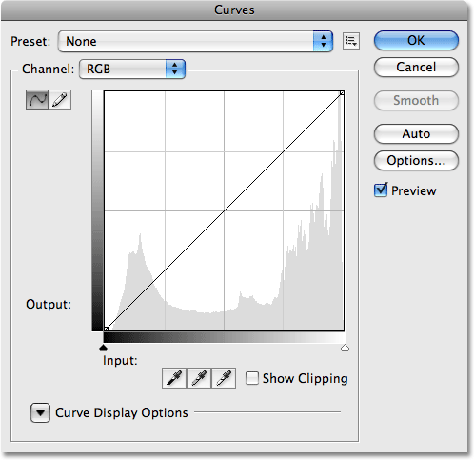

Only the larger, full size version of the Curves dialog box is available in Photoshop CS3.

#### The Histogram

In Photoshop CS3, we can finally see the [**histogram**](http://www.photoshopessentials.com/photo-editing/histogram/) directly within the Curves grid! Previously, the histogram was only available in the Levels dialog box or by viewing it in the Histogram palette. The only downside to the histogram in Curves is that like Levels, it shows us only what the image looked like before making any adjustments. To view an updated histogram as you work, you'll still want to keep the Histogram palette open. However, having the histogram displayed in the Curves grid makes it much easier to judge which tonal values need to be adjusted, and makes it almost as easy to set new black and white points for an image as it is in Levels. And when I say almost as easy, wait till you see the next new feature!

If the histogram appears different to you in Curves than it does in Levels or in the Histogram palette, it's only due to the shape of the Curves grid. Both the Levels dialog box and the Histogram palette display the histogram in a rectangular window. In Curves, the histogram has been stretched upward to take better advantage of the square grid area. Other than that, the histograms are the same:

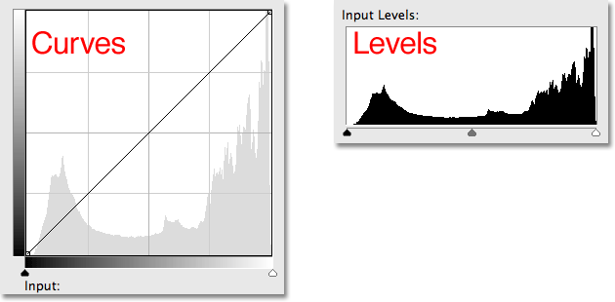

Both Curves (left) and Levels (right) now display the same image histogram, although it appears taller in Curves due to the square shape of the grid.

#### The Black Point And White Point Sliders

Most people over the years have found it easier to make basic tonal adjustments to an image with Levels thanks to its histogram and sliders, but in Photoshop CS3, Levels may have just become obsolete. Not only does the Curves dialog box now display a histogram, it also now features the same **Black Point** and **White Point sliders** found in Levels, and they work exactly the same way. Simply drag the sliders, which you'll find below the bottom gradient bar, to the left and right edges of the histogram to set new black and white points, making the darkest pixels in the image pure black and the lightest pixels pure white, improving overall image tone. As you drag the sliders, you'll see the points on either end of the diagonal line moving with you:

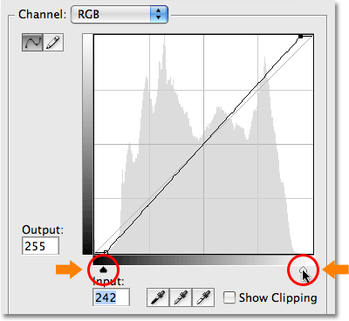

The Black Point and White Point sliders from Levels have been brought over to Curves in Photoshop CS3.

#### Show Clipping

If you want to make sure you're not clipping any shadow areas to pure black or any highlights to pure white as you're dragging the Black Point and White Point sliders, select the new **Show Clipping** option:

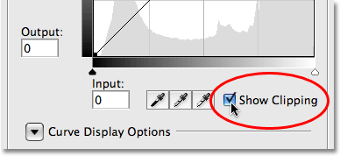

Select the new Show Clipping option to view any areas being clipped to pure black or white.

As you drag the Black Point slider towards the right with the Show Clipping option enabled, areas where you're losing some detail will appear in different colors (representing the [color channels](http://www.photoshopessentials.com/essentials/rgb/) that are being clipped), while areas that have lost all detail will appear black:

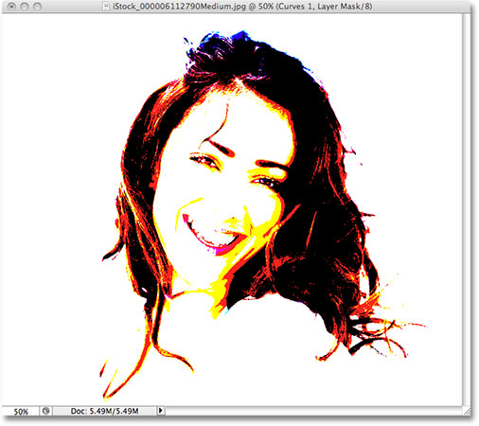

Areas appearing in black or in different colors indicate a loss of image detail when dragging the Black Point slider.

The same thing happens with the White Point slider. As you drag the slider towards the left, areas that are losing some detail will appear in color, and areas where all detail has been lost will appear white:

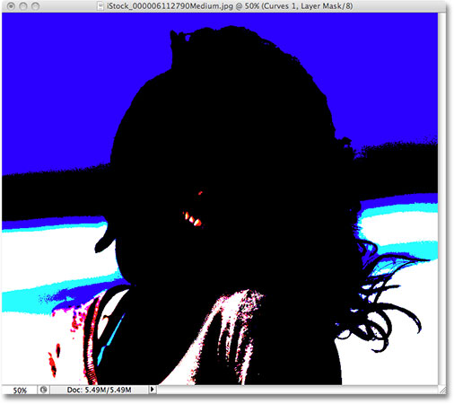

Areas appearing in white or in different colors indicate a loss of image detail when dragging the White Point slider.

You can switch between viewing the black and white clipping displays by clicking on the **Black and White eyedroppers** to the left of the Show Clipping option (with Show Clipping enabled):

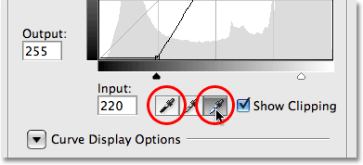

Switch between the black and white clipping displays with the Black and White eyedroppers.

You can also turn on the clipping display temporarily by simply holding down your **Alt** (Win) / **Option** (Mac) key while dragging the Black and White Point sliders.

#### Switching Between Light And Ink

By default, Photoshop displays the Input levels and Output levels gradients in the Curves dialog box from black to white, which makes sense when working with brightness values. Black represents areas of no light, a brightness value of 0, and as we increase the brightness values, we add more and more light until finally reaching white, the maximum amount of light possible, at level 255. For most people, this is the preferred way of working in Curves. If you come from a printing background, though, and you're more comfortable thinking in terms of ink percentages rather than light values, where white represents 0% ink and black is 100% ink, you may prefer to switch the gradients around so that they go from white-to-black rather than black-to-white.

In previous versions of Photoshop, the Input levels gradient along the bottom of the grid contained a small toggle icon in the middle. Clicking on it would switch the gradients between light values and ink percentages. In Photoshop CS3, Adobe has removed the toggle icon and replaced it with a more descriptive set of options. You'll find these options, along with the rest of the options we're about to look at, in the **Curve Display Options** section at the bottom of the dialog box. You'll need to click on the small triangle icon to twirl the options open, since they're hidden by default. If you want to keep working with brightness values, leave the **Light (0-255)** option selected. To switch to ink percentages, select the **Pigment/Ink %** option:

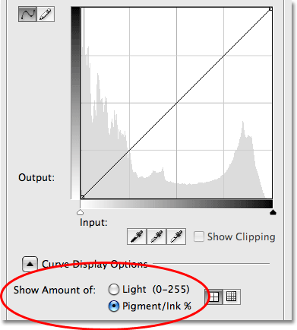

The Light / Ink options switch the gradients between black-to-white and white-to-black.

#### Changing Grid Sizes

Previous versions of Photoshop have allowed us to switch from the default 4x4 grid size to a more precise 10x10 grid by holding down **Alt** (Win) / **Option** (Mac) and clicking anywhere inside the grid area, but it's always felt like more of a hidden trick than a feature. In Photoshop CS3, Adobe has finally given us an actual option for switching between the two grid sizes. You'll find two icons directly to the right of the Light / Ink % options. Click on the left icon to select the standard 4x4 grid, or click on the right icon to select the 10x10 grid:

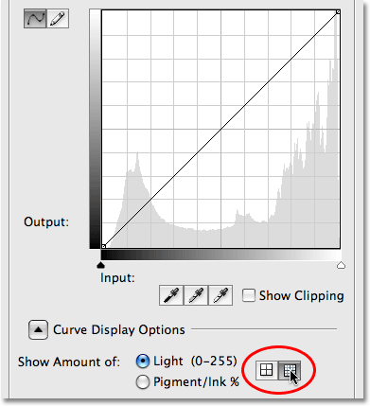

Photoshop CS3 now gives us easy icons for switching between the 4x4 and 10x10 grid sizes in Curves.

#### Channel Overlays

At the very bottom of the Curves dialog box in Photoshop CS3 are four new options that control what's displayed inside the grid area. The first one is **Channel Overlays**. Curves isn't used only for adjusting brightness levels in an image. It's also great at correcting color problems by allowing us to adjust the curve for each individual color channel. We've always been able to select individual color channels from the **Channel** option above the grid area, but we could only view the curve for a color channel when we had that channel selected. In Photoshop CS3, we can now view the curves for all color channels at once as an overlay when viewing the composite channel. Simply select the Channel Overlays option at the bottom of the dialog box (it's already selected by default) to view the overlay:

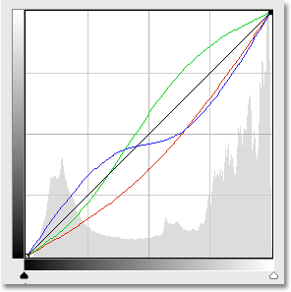

It's now possible to view the individual color channel curves while the composite channel is selected.

Unfortunately, we can't select any of the individual color channels in the overlay. We still need to select a color channel from the Channel option to make any changes to it.

#### To View Or Not To View The Histogram

If you find that the histogram makes the Curves grid area in Photoshop CS3 look too cluttered, you can hide it by unchecking the **Histogram** option at the bottom of the dialog box. Select the option again to turn the histogram back on:

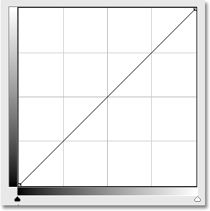

The histogram can be turned on or off in the Curves grid with the Histogram option at the bottom of the dialog box.

#### Baseline

As you drag points around and reshape the curve in Photoshop CS3, you'll see a light gray diagonal line appear from the bottom left corner to the top right corner of the grid. This is known as the **Baseline** and it represents the starting point of the curve before any adjustments were made. The Baseline gives us a quick way to see what's happening with our adjustments. When working with brightness values, any areas of the curve that appear above the baseline will be brighter than they were originally, and any areas of the curve below the baseline will be darker. If you're working with ink percentages, the opposite is true. By default, the Baseline is visible, but if you'd prefer to hide it, simply uncheck the Baseline option at the bottom of the dialog box:

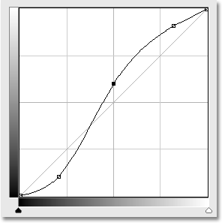

The Baseline is the light gray diagonal line showing the initial starting point before any adjustments were made to the curve.

#### Intersection Lines

As you move a point from one spot to another, a horizontal and vertical line will appear that intersects at the point, helping to see exactly which brightness values you're selecting in the bottom gradient bar and where you're moving them to in the left gradient bar. If you'd rather not see the intersecting lines, uncheck the **Intersection Lines** option at the bottom of the dialog box:

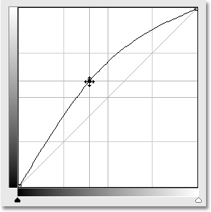

Intersecting horizontal and vertical lines appear at the point when moving it to help judge the "before and after" brightness values.

#### Ready-Made Curves

Photoshop CS3 comes with a collection of ready-made curves that you can choose from to quickly lighten or darken an image, adjust contrast or create simple photo effects. You can access the list of preset curves from the **Preset** drop-down list at the top of the Curves dialog box. Click on the name of the one you want in the list to select it:

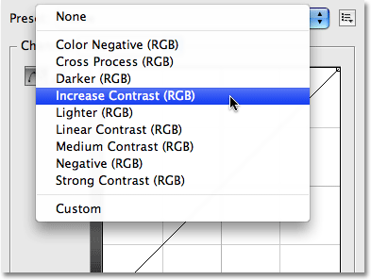

Choose from any of the preset curves available from the Preset drop-down list at the top of the dialog box.

#### Saving Your Own Custom Curve Presets

If you've created a curve and you know you'll want to use the same curve with other images, there's no need to recreate it each time. Simply click on the icon directly to the right of the **Preset** option at the top of the dialog box and choose **Save Preset** from the list:

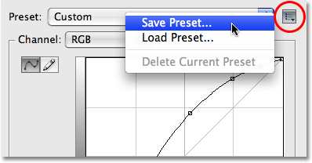

Curves can now easily be saved as custom presets when you need to apply them to several images.

Give your custom curve a descriptive name (I named mine "Steve's Curve" but you may want to come up with something better), then click **Save**. As long as you saved your curve in the default location, your curve will now be available any time you need it along with the rest of the preset curves in the Preset drop-down list:

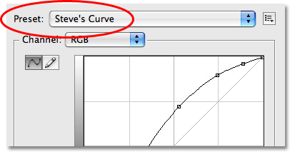

Custom curves will appear with the other preset curves in the Preset list.

If you chose to save your curve somewhere else, you'll need to click back on the icon to the right of the list of presets and choose **Load Preset**, then navigate to the where you saved the curve to access it.

And there we have it! That's our look at what's new and improved inside the Curves dialog box in Photoshop CS3! Check out our [Photo Retouching](http://www.photoshopessentials.com/photo-editing/) section for more Photoshop image editing tutorials!

# Cropping Photos Without Changing The Aspect Ratio

**[](http://www.facebook.com/sharer.php?u=http://www.photoshopessentials.com/photo-editing/crop-photo/&t=Cropping%20Photos%20Without%20Changing%20The%20Aspect%20Ratio&s=100&p%5burl%5d=http://www.photoshopessentials.com/photo-editing/crop-photo/&p%5bimages%5d%5b0%5d=http://www.photoshopessentials.com/newsite/wp-content/uploads/2012/10/cropphoto80j.jpg&p%5btitle%5d=Cropping%20Photos%20Without%20Changing%20The%20Aspect%20Ratio)[](https://twitter.com/intent/tweet?url=http://www.photoshopessentials.com/photo-editing/crop-photo/&text=Hey%20check%20this%20out)[](https://plus.google.com/share?url=http://www.photoshopessentials.com/photo-editing/crop-photo/)[](http://pinterest.com/pin/create/button/?url=http://www.photoshopessentials.com/photo-editing/crop-photo/&media=http://www.photoshopessentials.com/newsite/wp-content/uploads/2012/10/cropphoto80j.jpg&description=Cropping%20Photos%20Without%20Changing%20The%20Aspect%20Ratio)[](http://www.facebook.com/sharer.php?u=http://www.photoshopessentials.com/photo-editing/crop-photo/&t=Cropping%20Photos%20Without%20Changing%20The%20Aspect%20Ratio&s=100&p%5burl%5d=http://www.photoshopessentials.com/photo-editing/crop-photo/&p%5bimages%5d%5b0%5d=http://www.photoshopessentials.com/newsite/wp-content/uploads/2012/10/cropphoto80j.jpg&p%5btitle%5d=Cropping%20Photos%20Without%20Changing%20The%20Aspect%20Ratio)[](https://twitter.com/intent/tweet?url=http://www.photoshopessentials.com/photo-editing/crop-photo/&text=Hey%20check%20this%20out)[](https://plus.google.com/share?url=http://www.photoshopessentials.com/photo-editing/crop-photo/)[](http://pinterest.com/pin/create/button/?url=http://www.photoshopessentials.com/photo-editing/crop-photo/&media=http://www.photoshopessentials.com/newsite/wp-content/uploads/2012/10/cropphoto80j.jpg&description=Cropping%20Photos%20Without%20Changing%20The%20Aspect%20Ratio)**

Written by Steve Patterson. Cropping images is by far one of the most common, every day uses for Photoshop. It's so common that Photoshop comes with a tool designed specifically for cropping photos, conveniently named the Crop Tool. One of the great things about the Crop Tool is that you can easily crop your photos to common photo sizes like 4x6, 5x7 or 8x10 simply by entering the width and height values into the Options Bar before dragging out your cropping border, or by selecting a preset crop size from the Preset picker.

That may be great, but what if you don't want to change the aspect ratio of the photo? What if you want to crop the image while keeping the width-to-height ratio the same as the original? And what if you're not sure what the original aspect ratio actually is? You could open the Image Size dialog box to find out the width and height of the image and then do the math, but there's an even easier way thanks to a rarely used but very useful command in Photoshop called **Transform Selection**, which is what we're going to be looking at in this tutorial.

Here's the photo I'll be working with. I want to crop the image more closely around the woman's face and the flowers she's holding, but I want the final result to maintain the same aspect ratio as the original:

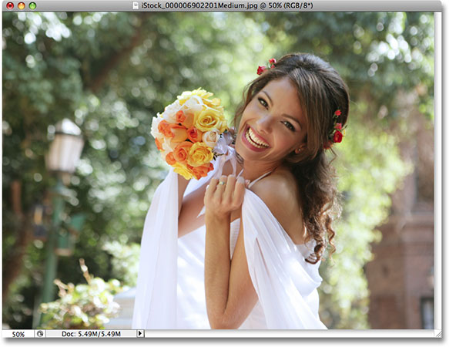

The original photo.

Let's get started!

[Download our tutorials as print-ready PDFs!](http://www.photoshopessentials.com/print-ready-pdfs/)

#### Step 1: Select The Entire Photo

The first thing we need to do is select our entire photo. Go up to the **Select** menu at the top of the screen and choose **All** at the very top of the list, or use the keyboard shortcut **Ctrl+A** (Win) / **Command+A** (Mac). Either way selects the entire photo, and you'll see a selection outline appear around the edges of the image in the document window:

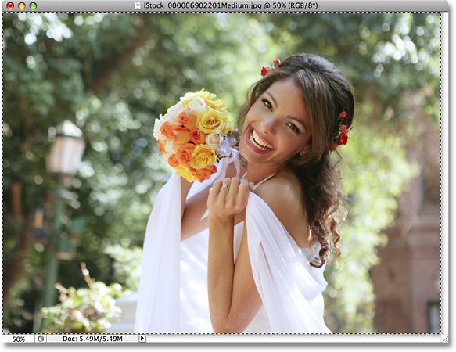

A selection outline appears around the entire photo in the document window.

#### Step 2: Choose "Transform Selection" From The Select Menu

With a selection outline now around the entire photo, go back up to the **Select** menu once again and this time choose **Transform Selection** near the bottom of the list:

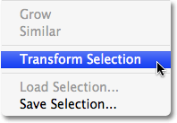

Go to Select > Transform Selection.

#### Step 3: Resize The Selection

As its name implies, Photoshop's Transform Selection command allows us to make changes to the selection outline itself without affecting anything inside of the selection. In this case, we want to resize the selection outline and make it smaller until it surrounds only the part of the photo that we want to keep, allowing us to crop away everything else. To resize the selection, hold down your **Shift** key, then click on any of the handles (the little squares) in the corners of the selection and drag the corner inward. Holding the Shift key down forces the width-to-height aspect ratio of the selection to remain the same as you drag, which is what allows us to maintain the same aspect ratio as the original photo.

You can move the selection outline as well by clicking anywhere inside of the selection and dragging it to a new location. Just don't click on that little target symbol in the center of the selection, otherwise you'll move the target symbol, not the selection. Continue moving and resizing the selection as needed until it's surrounding only the area you want to keep:

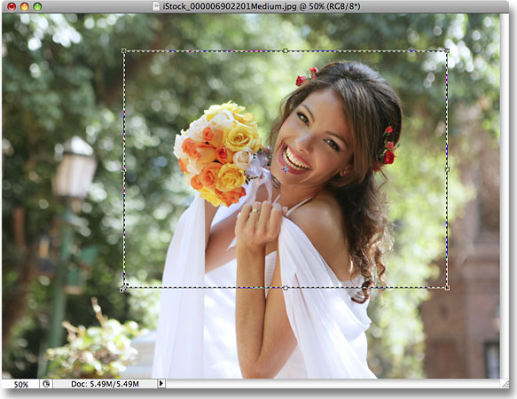

Hold Shift and drag any of the corner handles inward to resize the selection outline while keeping the aspect ratio the same.

When you're done, press **Enter** (Win) / **Return** (Mac) to accept the transformation.

#### Step 4: Crop The Image

At this point, all that's left to do is crop away the area outside of our selection! For that, we can use Photoshop's **Crop** command. Go up to the **Image** menu at the top of the screen and choose **Crop**:

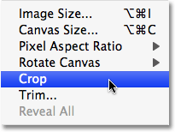

Go to Image > Crop.

As soon as you select Crop, Photoshop goes ahead and crops away everything that falls outside of the selection, leaving us with a cropped version of the photo that maintains the exact same aspect ratio as the original:

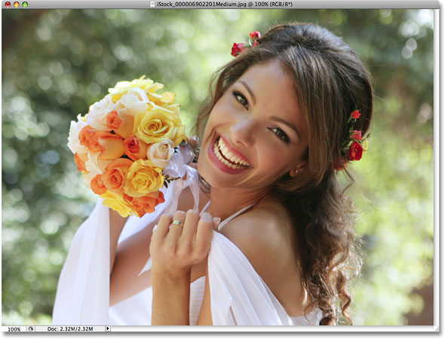

The aspect ratio of the cropped image remains the same as the original photo.

To remove the selection outline, either go back up to the **Select** menu and choose **Deselect** or use the keyboard shortcut **Ctrl+D** (Win) / **Command+D** (Mac).

And there we have it! That's how to crop photos without changing the original aspect ratio in Photoshop! Check out our [Photo Retouching](http://www.photoshopessentials.com/photo-editing/) section for more Photoshop image editing tutorials!

# Non-Destructive Dodge and Burn in Photoshop

**[](http://www.facebook.com/sharer.php?u=http://www.photoshopessentials.com/photo-editing/dodge-burn/&t=Non-Destructive%20Dodge%20and%20Burn%20in%20Photoshop&s=100&p%5burl%5d=http://www.photoshopessentials.com/photo-editing/dodge-burn/&p%5bimages%5d%5b0%5d=http://www.photoshopessentials.com/newsite/wp-content/uploads/2012/10/dodgeburn80j.jpg&p%5btitle%5d=Non-Destructive%20Dodge%20and%20Burn%20in%20Photoshop)[](https://twitter.com/intent/tweet?url=http://www.photoshopessentials.com/photo-editing/dodge-burn/&text=Hey%20check%20this%20out)[](https://plus.google.com/share?url=http://www.photoshopessentials.com/photo-editing/dodge-burn/)[](http://pinterest.com/pin/create/button/?url=http://www.photoshopessentials.com/photo-editing/dodge-burn/&media=http://www.photoshopessentials.com/newsite/wp-content/uploads/2012/10/dodgeburn80j.jpg&description=Non-Destructive%20Dodge%20and%20Burn%20in%20Photoshop)[](http://www.facebook.com/sharer.php?u=http://www.photoshopessentials.com/photo-editing/dodge-burn/&t=Non-Destructive%20Dodge%20and%20Burn%20in%20Photoshop&s=100&p%5burl%5d=http://www.photoshopessentials.com/photo-editing/dodge-burn/&p%5bimages%5d%5b0%5d=http://www.photoshopessentials.com/newsite/wp-content/uploads/2012/10/dodgeburn80j.jpg&p%5btitle%5d=Non-Destructive%20Dodge%20and%20Burn%20in%20Photoshop)[](https://twitter.com/intent/tweet?url=http://www.photoshopessentials.com/photo-editing/dodge-burn/&text=Hey%20check%20this%20out)[](https://plus.google.com/share?url=http://www.photoshopessentials.com/photo-editing/dodge-burn/)[](http://pinterest.com/pin/create/button/?url=http://www.photoshopessentials.com/photo-editing/dodge-burn/&media=http://www.photoshopessentials.com/newsite/wp-content/uploads/2012/10/dodgeburn80j.jpg&description=Non-Destructive%20Dodge%20and%20Burn%20in%20Photoshop)**

Written by Steve Patterson. It may be hard to believe these days, but there was a time not so long ago when cameras were not digital, and photo developing was done in a lab, not on your computer. Digital cameras and Photoshop may have brought the world of photo editing out of the darkroom and into your living room (or wherever your computer happens to be), but many of Photoshop's tools and features have their roots in traditional film development.

Two great examples of this are Photoshop's Dodge and Burn tools, both of which are found in the Tools palette. The terms "dodge" and "burn" refer to techniques that were used to either lighten (dodge) or darken (burn) specific areas of a photo by increasing or limiting the exposure in those areas. The Dodge and Burn tools in Photoshop are the digital versions of these techniques and are often used to either lighten underexposed areas of a photo or darken overexposed areas.

As useful as the Dodge and Burn tools are, however, they both suffer from a serious problem. Both of them cause permanent damage to your image, and this is never a good thing. The best way to work in Photoshop is to keep your original pixel information intact so you always have the original photo to fall back on. This is often referred to as working "non-destructively" in Photoshop, and it's the way you should be working whenever and wherever possible. Fortunately, Adobe has given us numerous ways to work non-destructively on our images, and in this photo editing tutorial, we're going to look at one of them. We'll look at a great technique for selectively controlling the exposure in a photo by lightening and darkening specific areas, giving us results very similar to what we could achieve with the Dodge and Burn tools but without harming a single pixel in the image.

Here we have a photo suffering from a very common problem. The wedding couple should be the main focal point of the image, but thanks to the direction of sunlight and an apparent lack of fill flash, the couple appears too dark in the photo while the background appears too bright:

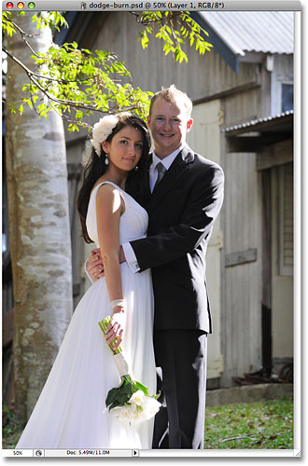

The original photo.

Using nothing more than Photoshop's Brush Tool and a layer blend mode, as we'll see in a moment, we can easily fix things by lightening the couple and darkening the background:

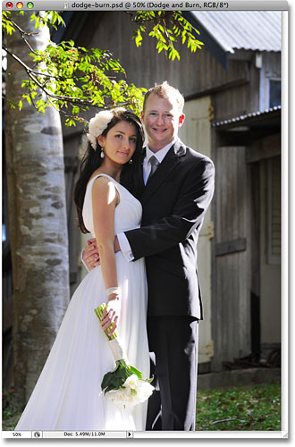

The photo after lightening and darkening specific areas.

Let's get started!

[Download our tutorials as print-ready PDFs!](http://www.photoshopessentials.com/print-ready-pdfs/)

#### Step 1: Add A New Layer

Open the image you need to work on in Photoshop, then hold down your Alt (Win) / Option (Mac) key and click on the New Layer icon at the bottom of the Layers palette:

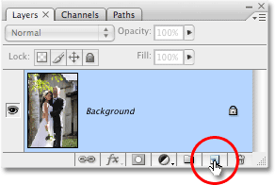

Hold down "Alt" (Win) / "Option" (Mac) and click on the New Layer icon.

Normally, this adds a new blank layer above the currently selected layer, but by holding down the Alt/Option key as we click on the New Layer icon, we tell Photoshop to pop open the New Layer dialog box for us before the layer is added. This gives us a chance to name the layer, and it also allows us to change a couple of important options. First, since I'll be using this layer to dodge and burn different areas of the photo, I'm going to name the layer "Dodge and Burn". You don't have to name the layer if you don't want to, but naming layers is a very good habit to get into:

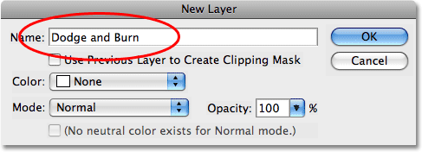

Name the new layer "Dodge and Burn" (optional).

The real reason why we brought up the New Layer dialog box is for the option at the very bottom, Mode. "Mode" is short for Layer Blend Mode, and by default, it's set to Normal. Change the blend mode to Overlay:

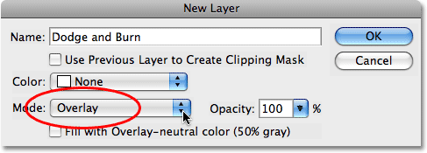

Set the blend mode of the new layer to Overlay.

I cover the Overlay blend mode in much more detail in our [**Five Essential Blend Modes For Photo Editing**](http://www.photoshopessentials.com/photo-editing/layer-blend-modes/) tutorial, but briefly, the Overlay blend mode is part of the Contrast group of blend modes and is often used to quickly boost the overall contrast in an image. Any areas on the layer that are lighter than 50% gray (meaning the shade of gray directly between black and white) are used to lighten the image, while areas darker than 50% gray darken the image. Any areas that are exactly 50% gray are completely ignored by Photoshop, and when I say "ignored", I mean they actually become transparent. In fact, we're about to see this is action.

With the blend mode now set to Overlay in the dialog box, you'll see a new option directly below it, Fill with Overlay-neutral color (50% gray). Click inside the checkbox to select this option:

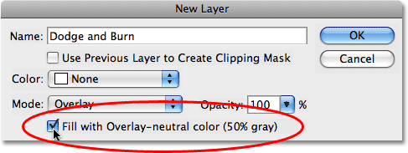

Click inside the checkbox to select the "Fill with Overlay-neutral color (50% gray) option.

This option tells Photoshop to fill our new layer with 50% gray. Click OK when you're done to exit out of the dialog box. If we look in our Layers palette now, we can see that we have a new layer named "Dodge and Burn" sitting above the photo on the Background layer. The layer is set to the Overlay blend mode for us, and if we look in the layer's preview thumbnail to the left of the layer's name, we can see that it has in fact been filled with gray:

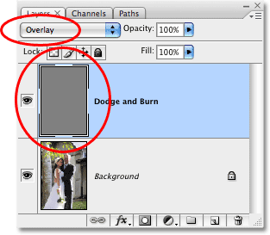

The new "Dodge and Burn" layer appears in the Layers palette.

I said a moment ago that when a layer is set to the Overlay blend mode, any areas of the layer that are 50% gray become transparent, and if we look at our image in the document window, even though the "Dodge and Burn" layer is filled with solid gray, which would normally mean that our document window is filled with gray, all we see is our original photo. The gray on the "Dodge and Burn" layer is completely transparent:



The solid gray on the "Dodge and Burn" layer appears transparent in the document window.

#### Step 2: Select The Brush Tool

We're going to lighten and darken different areas of the image simply by painting over them with either black or white. Areas we paint over with white will be lightened, while areas we paint over with black will be darkened. Again, this is because we'll be painting on a layer that's set to the Overlay blend mode. Before we can paint over anything, though, we need to grab the Brush Tool, so either select the Brush Tool from the Tools palette or press the letter B on your keyboard to access it with the shortcut:

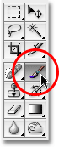

Select the Brush Tool.

#### Step 3: Set Your Foreground Color To White

I'm going to begin by lightening the couple, which means I'll need to paint over them with white, which means I need to set my Foreground color to white, since the Brush Tool paints with whatever color the Foreground color is currently set to. If you're following along with your image, press the letter D on your keyboard which resets the Foreground and Background colors to their defaults. This makes black the Foreground color and white the Background color. To swap them so white becomes the Foreground color, press the letter X on your keyboard. If we look at the Foreground and Background color swatches near the bottom of the Tools palette, we can see that white is now the Foreground color (the left swatch):

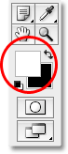

The Foreground color swatch in the Tools palette.

#### Step 4: Lower The Opacity Of The Brush To Between 10 - 20%

The best way to work with this technique is to gradually build up the amount of lightening and darkening that's being applied, since even a subtle amount can sometimes be enough. To do that, we'll need to work with a low opacity brush. Make sure you have the Brush Tool selected, then go up to the Options Bar at the top of the screen and lower the Opacity option down to somewhere between 10-20%. I'm going to set mine to 10%. This way, each time I paint over the same area, I'll increase the amount of lightening or darkening in 10% increments, giving me lots of room to work with:



Lower the brush opacity in the Options Bar.

#### Step 5: Paint Over Areas That Need To Be Lightened

With your Brush Tool selected, white as your Foreground color and the opacity of your brush lowered, simply paint over any areas in your photo that need to be lightened. The effect will be subtle at first due to the low brush opacity, but if you need more lightening in certain areas, just paint over them a few times to build up the effect, making sure to release your mouse button in between paint strokes. You can change the size of your brush by pressing the left bracket key to make the brush smaller or the right bracket key to make it larger. You'll want to use a soft edge brush, and you can make the brush edges softer by holding down the Shift key and pressing the left bracket key a few times. Holding Shift and pressing the right bracket key will make the edges harder.

I want to brighten the couple in my photo, so I'm going to paint over them with a medium size, soft edge brush. Each time I paint over them, I'll increase the brightness by 10%. Painting over them 3 or 4 times should do it. The man's face is especially dark in the photo, so that area may need an extra click or two with the brush:

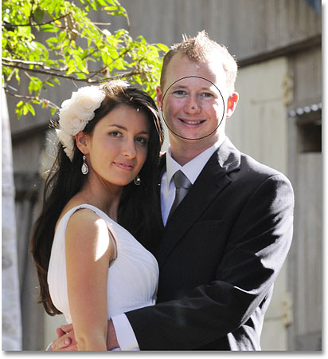

Paint with white over any areas in the photo that need to be brighter.

#### Step 6: Set Your Foreground Color To Black

When you're done with the areas that needed to be lightened, press the letter X on your keyboard to swap your Foreground and Background colors so black becomes your Foreground color:

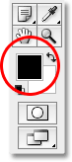

The color swatches in the Tools palette showing black as the Foreground color.

#### Step 7: Paint Over Areas That Need To Be Darkened

With your Foreground color now set to black, paint over any areas in the photo that need to be darkened. Again, each time you paint over the same area, you'll increase the amount of darkening that's applied. In my case, I want to make everything behind the couple darker, so I'm going to use a larger brush and paint around the couple a few times to darken the background:

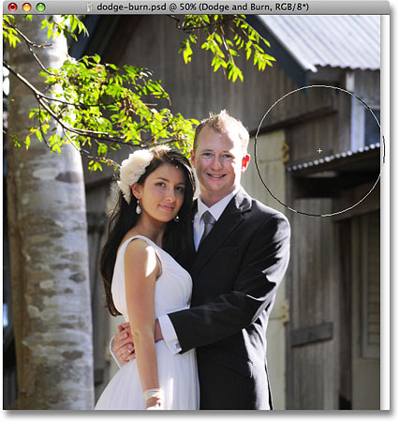

Painting with black over the background to darken it.

If we look at the preview thumbnail for the "Dodge and Burn" layer in the Layers palette, we can see all the areas where we painted with white or black:

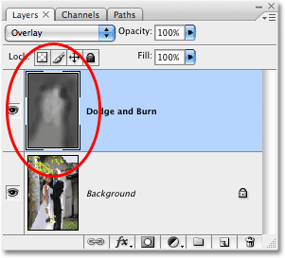

The preview thumbnail shows where we painted on the layer.

If you accidentally paint over areas you didn't mean to and want to set those areas back to 50% gray, simply click on the Foreground color swatch in the Tools palette, which will bring up Photoshop's Color Picker. Enter a value of 128 for the R, G and B options in the Color Picker, which gives you the 50% gray color:

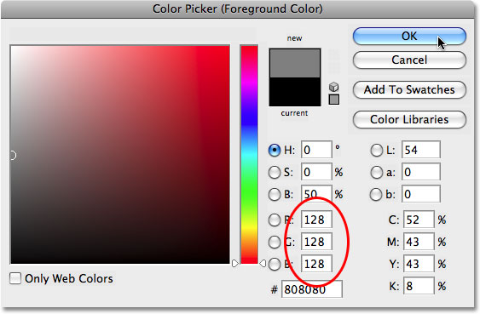

Enter a value of 128 for the R, G and B values in the Color Picker to select the 50% gray color.

Click OK to exit out of the Color Picker, then simply paint over those areas in the image to set them back to the original 50% gray.

And with that, we're done! We've successfully adjusted the exposure levels in different areas of the photo by manually painting over them with black or white, giving us results very similar to what we could have achieved with Photoshop's Dodge and Burn tools, without touching a single pixel in our original image! To see the difference, here is my original photo on the left and the corrected image on the right:

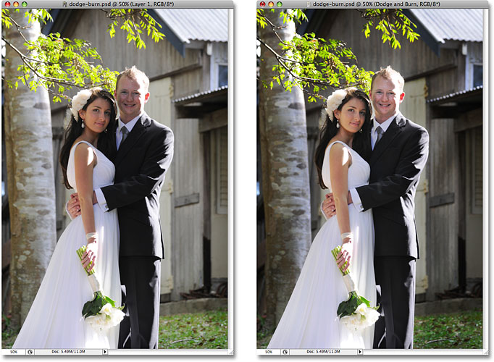

The original photo (left) and the corrected version (right).

And there we have it! That's how to dodge and burn images non-destructively using the Overlay blend mode in Photoshop! Check out our [Photo Retouching](http://www.photoshopessentials.com/photo-editing/) section for more Photoshop image editing tutorials!

# Smooth And Soften Skin In Photoshop

**[](http://www.facebook.com/sharer.php?u=http://www.photoshopessentials.com/photo-editing/smooth-soften-skin-photoshop/&t=Smooth%20And%20Soften%20Skin%20In%20Photoshop&s=100&p%5burl%5d=http://www.photoshopessentials.com/photo-editing/smooth-soften-skin-photoshop/&p%5bimages%5d%5b0%5d=http://www.photoshopessentials.com/newsite/wp-content/uploads/2012/10/smooth-skin80j.jpg&p%5btitle%5d=Smooth%20And%20Soften%20Skin%20In%20Photoshop)[](https://twitter.com/intent/tweet?url=http://www.photoshopessentials.com/photo-editing/smooth-soften-skin-photoshop/&text=Hey%20check%20this%20out)[](https://plus.google.com/share?url=http://www.photoshopessentials.com/photo-editing/smooth-soften-skin-photoshop/)[](http://pinterest.com/pin/create/button/?url=http://www.photoshopessentials.com/photo-editing/smooth-soften-skin-photoshop/&media=http://www.photoshopessentials.com/newsite/wp-content/uploads/2012/10/smooth-skin80j.jpg&description=Smooth%20And%20Soften%20Skin%20In%20Photoshop)[](http://www.facebook.com/sharer.php?u=http://www.photoshopessentials.com/photo-editing/smooth-soften-skin-photoshop/&t=Smooth%20And%20Soften%20Skin%20In%20Photoshop&s=100&p%5burl%5d=http://www.photoshopessentials.com/photo-editing/smooth-soften-skin-photoshop/&p%5bimages%5d%5b0%5d=http://www.photoshopessentials.com/newsite/wp-content/uploads/2012/10/smooth-skin80j.jpg&p%5btitle%5d=Smooth%20And%20Soften%20Skin%20In%20Photoshop)[](https://twitter.com/intent/tweet?url=http://www.photoshopessentials.com/photo-editing/smooth-soften-skin-photoshop/&text=Hey%20check%20this%20out)[](https://plus.google.com/share?url=http://www.photoshopessentials.com/photo-editing/smooth-soften-skin-photoshop/)[](http://pinterest.com/pin/create/button/?url=http://www.photoshopessentials.com/photo-editing/smooth-soften-skin-photoshop/&media=http://www.photoshopessentials.com/newsite/wp-content/uploads/2012/10/smooth-skin80j.jpg&description=Smooth%20And%20Soften%20Skin%20In%20Photoshop)**

Written by Steve Patterson. In this Photoshop tutorial, we'll learn an easy way to soften and smooth someone's skin in a photo without blurring out important image details, such as the person's eyes and mouth. The technique we'll be looking at is actually a slight variation on a method normally used for advanced image sharpening, which serves as a great example of why it's much more important to understand what you're doing rather than simply memorizing a bunch of steps or "recipes". The more you understand what you're doing in Photoshop and why, the more your mind will open to new ideas and new possibilities.

This version of the tutorial is for Photoshop CS5 or earlier. Using **Photoshop CS6** or **CC**? You'll want to check out our [fully updated version](http://www.photoshopessentials.com/photo-editing/smooth-skin/).

Here's the image I'll be working with in this tutorial. Since this is a tutorial on skin softening and smoothing, I've cropped away most of the image so we can focus on the young woman's face:

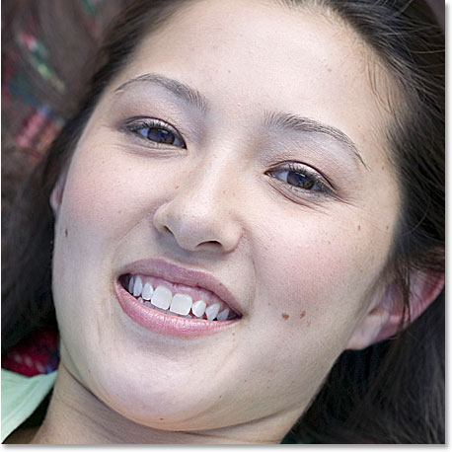

The original image.

It's a nice photo on its own, but it would probably look even better if we softened her skin a little. Here's what she'll look like when we're done:

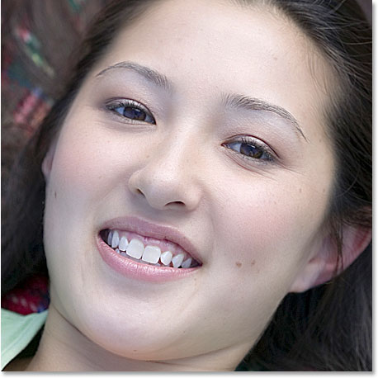

The final result showing the woman's skin now smoother and softer looking.

Let's get started!

[Download our tutorials as print-ready PDFs!](http://www.photoshopessentials.com/print-ready-pdfs/)

#### Step 1: Duplicate The Background Layer

With my image newly opened in Photoshop, I can see in my Layers palette that I currently have one layer, the Background layer, which contains my original image:

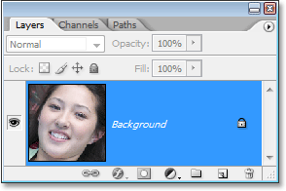

The Layers palette in Photoshop showing the original image on the Background layer.

I know I say this in every tutorial, but it can't be stressed enough how important it is to leave the original image information untouched. If we lose it and we make a mistake, we have nothing to fall back on. That's why the first thing we should always do before doing anything else is make a copy of the Background layer. To do that, either go up to the Layer menu at the top of the screen, choose New, and then choose Layer via Copy, or simply use the keyboard shortcut Ctrl+J (Win) / Command+J (Mac). Either way tells Photoshop to make a copy of the Background layer, and if I look again in my Layers palette, I can see that I now have the copy, which Photoshop has automatically named "Layer 1", above the original Background layer:

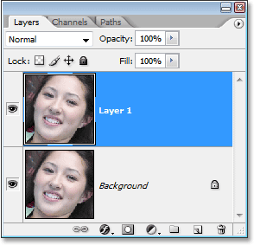

The Layers palette in Photoshop now showing a copy of the Background layer, named "Layer 1", above the original.

#### Step 2: Change The Blend Mode Of "Layer 1" to "Overlay"

With "Layer 1" selected in the Layers palette (the currently selected layer is highlighted in blue), go up to the layer blend mode option in the top left corner of the Layers palette. It's the drop-down box that's currently set to "Normal". Click on the small down-pointing arrow to the right of the word "Normal", which brings up a list of all the different layer blend modes we have to choose from, and select Overlay from the list:

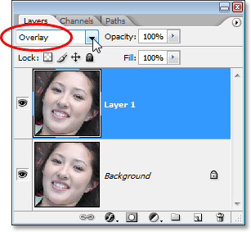

Change the blend mode of "Layer 1" from "Normal" to "Overlay".

As soon as you change the blend mode to Overlay, you'll see a big increase in contrast and color saturation in your image:

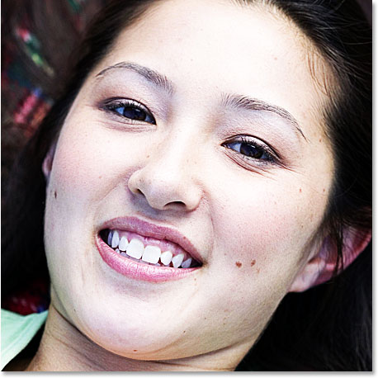

The image now appears with increased contrast and color saturation after changing the blend mode of "Layer 1" to "Overlay".

This increased contrast and color saturation can make for an interesting effect on its own, depending on the image you're using, but it's not the effect we're going for here. The only reason we've changed the blend mode to Overlay is so we can see what we're doing in the next step.

#### Step 3: Apply The "High Pass" Filter To "Layer 1"

To smooth and soften the woman's skin, we're going to use Photoshop's High Pass filter. If you're familiar with the High Pass filter, it's most likely because you've used it before as an advanced way of sharpening images. I say "advanced" not because it's somehow difficult or complicated to use but because it usually gives you better sharpening results than you'd get by using Photoshop's classic Unsharp Mask filter. Check out our [Sharpen Images With The High Pass Filter](http://www.photoshopessentials.com/photo-editing/sharpen-high-pass) tutorial for more information.

One of the reasons why learning Photoshop can seem nearly impossible sometimes is because we tend to get stuck on the names of things rather than focusing on what they do. For example, if you had never used the High Pass filter before and someone asked you what it does, what would you tell them? "Well, it's a filter that passes high over the image." That may sound technically impressive (sort of, I think), but what does it mean? I sure wouldn't know.

So rather than worry about the name Adobe has given to something, let's look at what it does, which is all that really matters. Before we do that though, let's bring the filter up on the screen. To access the High Pass filter, make sure you still have "Layer 1" selected, then go up to the Filter menu at the top of the screen, choose Other down near the bottom of the list, and then select High Pass:

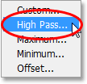

Go to Filter > Other > High Pass.

This brings up the High Pass filter's dialog box, which is made up of a large preview area and a single option, Radius, down at the bottom. The High Pass filter looks for details in an image, such as the edges around people, objects, and so on. The reason why it's so effective at image sharpening is because it allows us to sharpen only the edges in an image while leaving everything else untouched. If my goal was to sharpen the image I'm using in this tutorial, the High Pass filter would do a great job of sharpening the woman's eyes, mouth, hair, etc., without sharpening her skin. What I want, though, is sort of the opposite of what I just described. I want to use the filter to find the edges not so I can sharpen them, but so I can smooth and soften everything except the edges.

To do that, begin dragging the slider at the bottom of the dialog box to the right until you have your Radius value set to somewhere around 6 pixels. If you're using a high resolution image, try a higher setting somewhere around 9-10 pixels. As you drag the slider towards the right, if you keep an eye on the preview area in the dialog box, you'll see more and more areas of the image become affected by the filter, starting with only the finest details and then gradually expanding to include more and more of the photo. If we were sharpening the image, we would want to stick to a very low Radius value to target only the edges themselves, but for our softening effect, we need to go a bit higher:

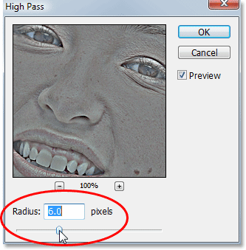

Increase the Radius value of the High Pass filter to around 6 pixels, or try 9-10 pixels for a high resolution image.

Click OK when you're done to exit out of the dialog box. If I look at my image now in the document window, it looks like I've gone way too far with my image sharpening:

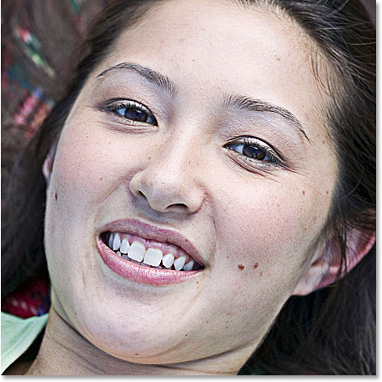

The image now appears overly sharpened in the document window.

You may be wondering why the image in the preview window of the High Pass filter's dialog box looked gray while the image in the document window didn't (and still doesn't). The reason is because in Step 2, we changed the blend mode of "Layer 1" to Overlay, and in Overlay mode, any part of the layer that is 50% gray (meaning the shade of gray you get half-way between pure black and pure white) is hidden from view. Areas that are either lighter or darker than 50% gray are blended in with the layer(s) below the layer we're working on, affecting the contrast and color saturation of the image. That may sound complicated, but don't worry if you don't fully understand how the Overlay blend mode works. We have an entire tutorial coming up on blend modes in Photoshop, so for now, all we need to know is that we changed the blend mode to Overlay in Step 2 so that we could see what we were doing with the High Pass filter in Step 3.

Our image isn't looking all that great after applying the High Pass filter, but we're going to fix that in the next couple of steps.

#### Step 4: Invert "Layer 1"

So far, we've used the High Pass filter to sharpen all the edge details in the image, but what we really want to do is smooth and soften everything that is not an edge detail, like the woman's skin. In other words, we want the opposite of what we currently have. We want to soften all the non-detail areas while leaving the edges alone. To do that, all we need to do is invert the layer!

With "Layer 1" still selected, go up to the Image menu at the top of the screen, choose Adjustments, and then choose Invert, or for a faster way, use the keyboard shortcut Ctrl+I (Win) / Command+I (Mac):

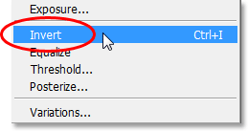

Go to Image > Adjustments > Invert, or press "Ctrl+I" (Win) / "Command+I" (Mac) to invert the layer.

Once you've inverted "Layer 1", take a look at your image in the document window. A moment ago, the image was suffering from an extreme amount of sharpening, but now everything appears soft and blurred-out. That is, everything except the important details in the image. The woman's eyes and mouth are slightly blurred out, but nowhere near the extent of her skin:

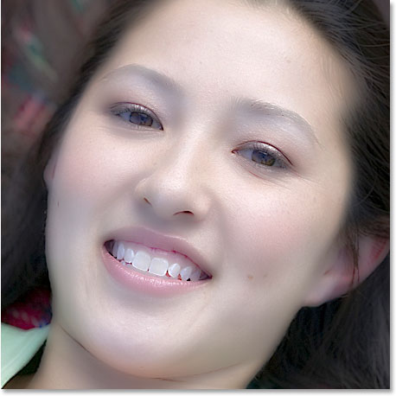

All the non-detail areas in the image now appear blurry while the important details have barely been affected.

#### Step 5: Lower The Opacity Of "Layer 1" To Fine-Tune The Amount Of Skin Softening

We've definitely succeeded in smoothing and softening her skin, but we need to take the effect down a few notches to keep things looking realistic. For that, all we need to do is lower the opacity of "Layer 1". Go up to the Opacity option in the top right corner of the Layers palette (directly across from the blend mode option). You'll see the word "Opacity" and that it's currently set to a full 100%. Click on the right-pointing arrow, which brings up a small slider bar, and simply lower the opacity of "Layer 1" until the smoothing looks more natural. There's no set amount to lower it to since it will depend on your image, so just keep an eye on your image in the document window as you drag the slider. I'm going to lower my opacity down to about 60%. Again, your value may be different:

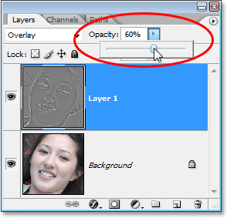

Lower the opacity of "Layer 1" until the smoothing and softening appears more natural.

With my opacity lowered, the softening now looks much better:

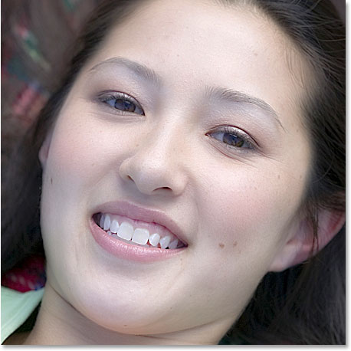

The skin softening now looks more natural after lowering the opacity of "Layer 1".

Notice how the minor amount of softening over her eyes and mouth has become almost completely unnoticeable at this point, while her skin is nice and smooth. If "almost completely unnoticeable" isn't quite good enough for you and you want to make absolutely certain there is no softening at all over those areas, continue on to the next step.

Also, throughout this tutorial I've been referring to this technique as a way to smooth and soften skin. At the moment, we're actually softening the entire photo. We haven't done anything yet to limit the softening to only the person's skin. You may very well like the effect of having the entire photo softened, and if that's the case, there's no need to remove the effect from the rest of the image. If you do want to limit the softening to just the skin, continue on.

#### Step 6: Add A Layer Mask To "Layer 1"

To completely remove any softening from the important details in the woman's face, I'll need to use a layer mask. To add a layer mask, again make sure "Layer 1" is selected and then click on the Layer Mask icon at the bottom of the Layers palette:

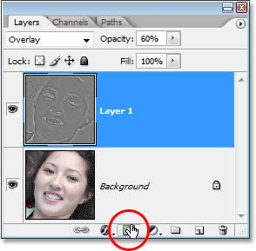

Click on the Layer Mask icon at the bottom of the Layers palette.

Nothing happens to the image in the document window, but we can see in the Layers palette that we now have a layer mask thumbnail added to "Layer 1":

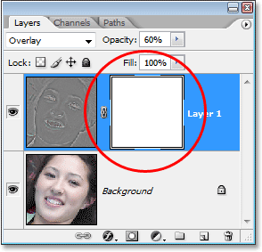

The Layers palette in Photoshop showing the layer mask thumbnail.

#### Step 7: Select The Brush Tool

We're going to paint on the layer mask, and for that, we need the Brush Tool, so either grab it from the Tools palette or press the letter B on your keyboard to select it with the keyboard shortcut:

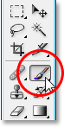

Selecting Photoshop's Brush Tool from the Tools palette.

#### Step 8: Set Your Foreground Color To Black

Since we need to paint with black, we'll need to set our Foreground color to black, since the Brush Tool paints with whichever color we have our Foreground color currently set to. By default, whenever we have a layer mask selected (which we currently do), Photoshop sets the Foreground color to white, while setting the Background color to black. We can easily swap them by pressing the letter X on the keyboard. As we can see in the Foreground and Background color swatches near the bottom of the Tools palette, we now have black as our Foreground color (the top left square) and white has become our Background color (bottom right square):

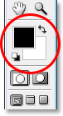

The Foreground and Background color swatches in the Tools palette.

#### Step 9: Paint Over The Details In The Face To Hide The Softening Effect

With our Brush Tool selected and black as our Foreground color, we can now paint away the softening effect over any areas where we don't want it. Painting with black on the layer mask doesn't actually "remove" the effect, it simply hides it from view. If we change our minds later and want to bring the effect back in areas where we've hidden it, all we'd need to do is paint with white over those areas to reveal the effect once again.

If you need more information about layer masks, be sure to check out our [Understanding Layer Masks](http://www.photoshopessentials.com/basics/layers/layer-masks/) tutorial in the [Photoshop Basics](http://www.photoshopessentials.com/basics/) section of the website.

Using a small, soft-edged brush, I'll paint over the woman's eyes and mouth to completely hide the softening effect from those areas. You can change the size of your brush at any time by pressing the left bracket key on your keyboard to make the brush smaller or the right bracket key to make it larger. Also, you can control how soft or hard the edge of the brush is with your keyboard. Hold down your Shift key and press the left bracket key to make the brush edges softer, and hold down Shift and press the right bracket key to make the edges harder. Here, I'm painting over the woman's eyes with my brush:

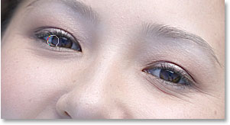

Paint with black over the face details to completely remove the softening effect from those areas if needed.

I'll continue painting away any softening effect over her mouth, especially her teeth since we don't want them to appear soft, and maybe over the bottom of her nose and her eyebrows as well. If we look at the layer mask thumbnail, we can see all the areas where I've painted with black:

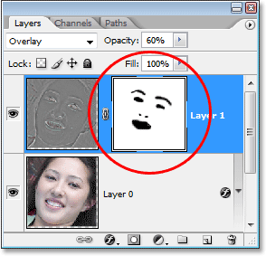

The layer mask thumbnail showing the areas that have been painted with black on the layer mask.

And here's what my image now looks like. The areas I've painted over are now completely free of any softening, even though it was very subtle to begin with:

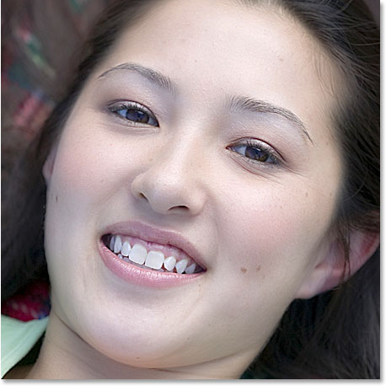

The woman's eyes, mouth, bottom of her nose and eyebrows now no longer have any softening applied to them.

#### Step 10: Paint Away The Effect From The Rest Of The Image

As I mentioned a moment ago, you don't have to limit the softening effect to only the skin if you like how the effect looks when applied to the entire photo. But if you do want to limit the softening and smoothing to just the person's skin, simply use your Brush Tool and with black still as your Foreground color, paint over everything in the photo except for the person's skin.

In my case, my photo is cropped tightly around the woman's face so there isn't much else in the photo for me to paint over, but I'll go ahead anyway and paint with black around the rest of the photo. We can see by looking again at the layer mask thumbnail in the Layers palette that I've now painted with black all around her face, removing the softening effect from everywhere except her skin:

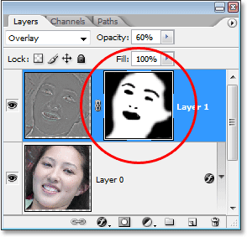

The layer mask thumbnail once again, this time showing black around everything except the woman's face, limiting the softening effect to only her skin.

And here, with the softening and smoothing effect now being applied only to the woman's skin, is my final result:



The final result.

And there we have it! That's how to easily smooth and soften skin with Photoshop! Check out our [Photo Retouching](http://www.photoshopessentials.com/photo-editing/) section for more Photoshop image editing tutorials!

http://www.photoshopessentials.com/photo-editing/page/8/